eForms Existing Legacy Users First Time Logon Steps
12/9/2021
Table of Contents
1 Background 1
2 Walk Through Steps 1

Background
This document outlines the steps that users with existing user ID’s and from the original eForms application need to take to log into the new “Modernized” eForms application for the first time. All users will need to reset their password when logging into the new eForms application for the first time. Once users have successfully reset their password, they should log into the new eForms and update their user information.
Users should contact the ATF help desk if the following forgot password steps aren’t working for them, or after resetting their password they aren’t able to login properly. The ATF Helpdesk can be reached at 1-877-875-3723.

Walk Through Steps
- When an existing eForms user visits the new eForms site for the first time, they will be presented with the standard home screen that they are familiar with.
- Users should click the “Forgot Password” button on the right-hand side of the home screen.
  - Users will then reset their password and be able to login to the ITEM eForms application. If users experience issues resetting their passwords, they should then contact the ATF help desk for further help.
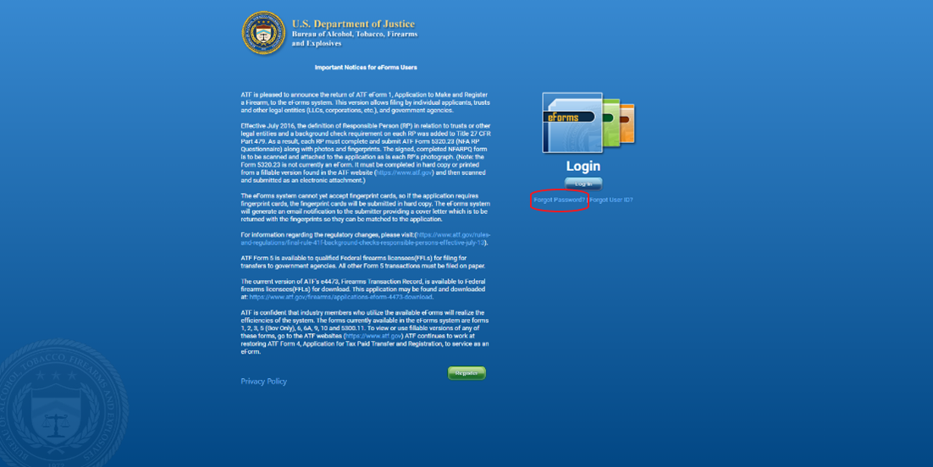
- Once users have reset their password, they should receive this screen and click “Log In” to be taken to the next screen.
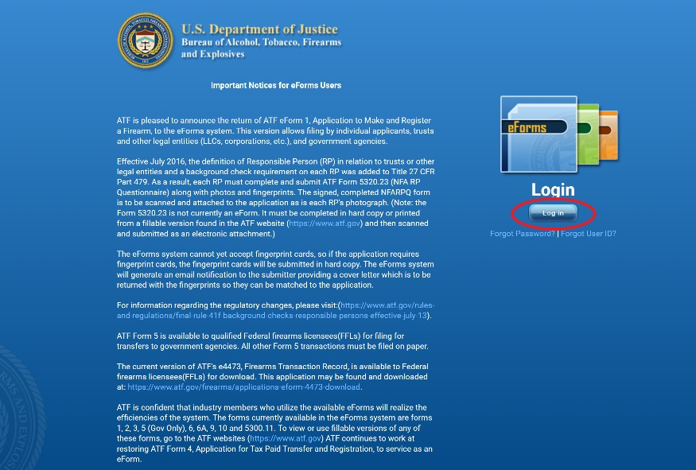
- Users should read the disclaimer presented on the screen. If they understand and agree with the conditions, they should proceed by clicking the “Accept & Log In” button at the bottom of the screen.
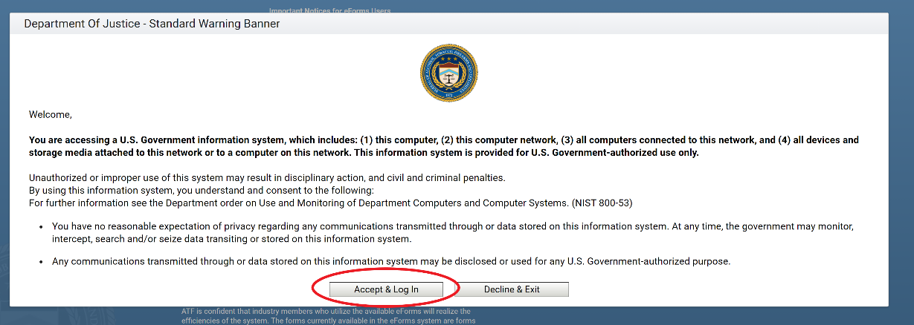
- Users should then enter their Legacy eForms username and password into the respective boxes.
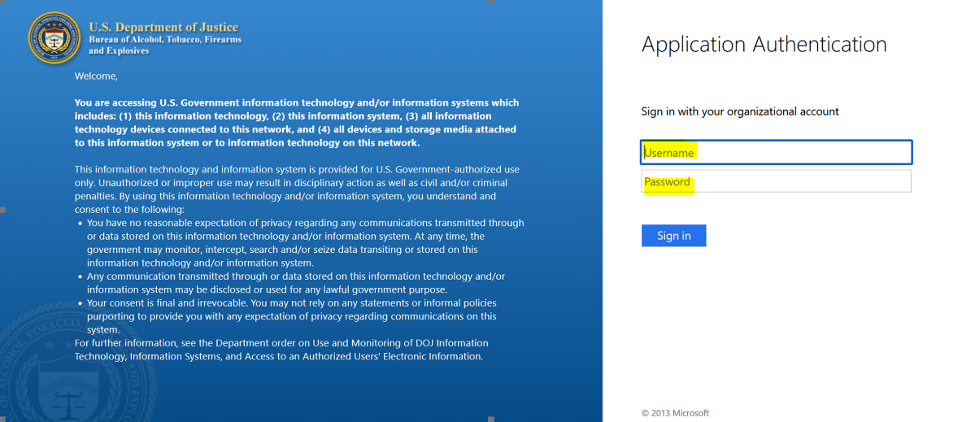
- Users should then click the “Sign In” button.
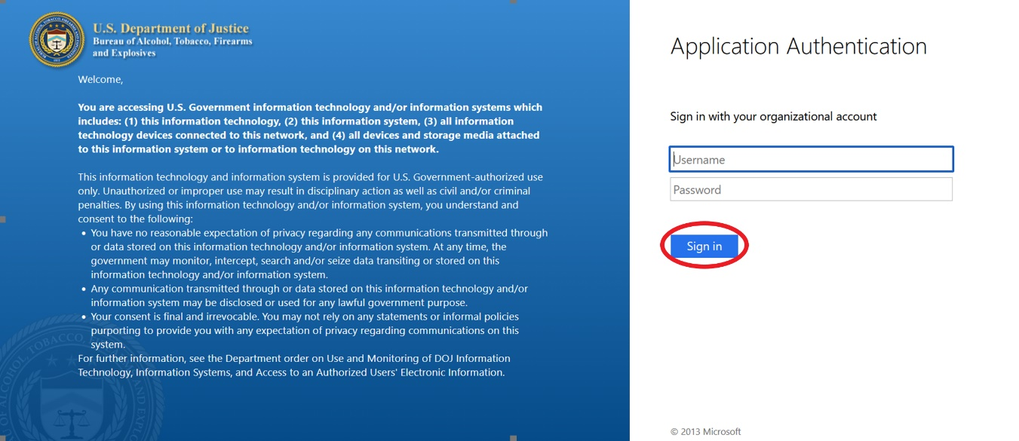
PLEASE NOTE: THE FOLLOWING STEPS ARE ASSUMING THAT THE LOG IN WAS SUCCESSFUL (i.e. The Legacy user was able to use their Legacy credentials to log into ITEM eForms). If the user was unsuccessful, they should contact the ATF help desk for additional help.
- Users will then be brought to a page titled "Please update your user profile information to continue to eForms”, where they will need to fill in any required information that was not pulled from the Legacy database. For example, in the image below, the Email, First Name, and Last Name were not automatically populated but are required (as noted by the ‘*’ next to the field name). Thus, the user must enter these fields in order to proceed.
NOTE: This page is triggered when there is no PIN stored in the database, as original eForms did not use a PIN.
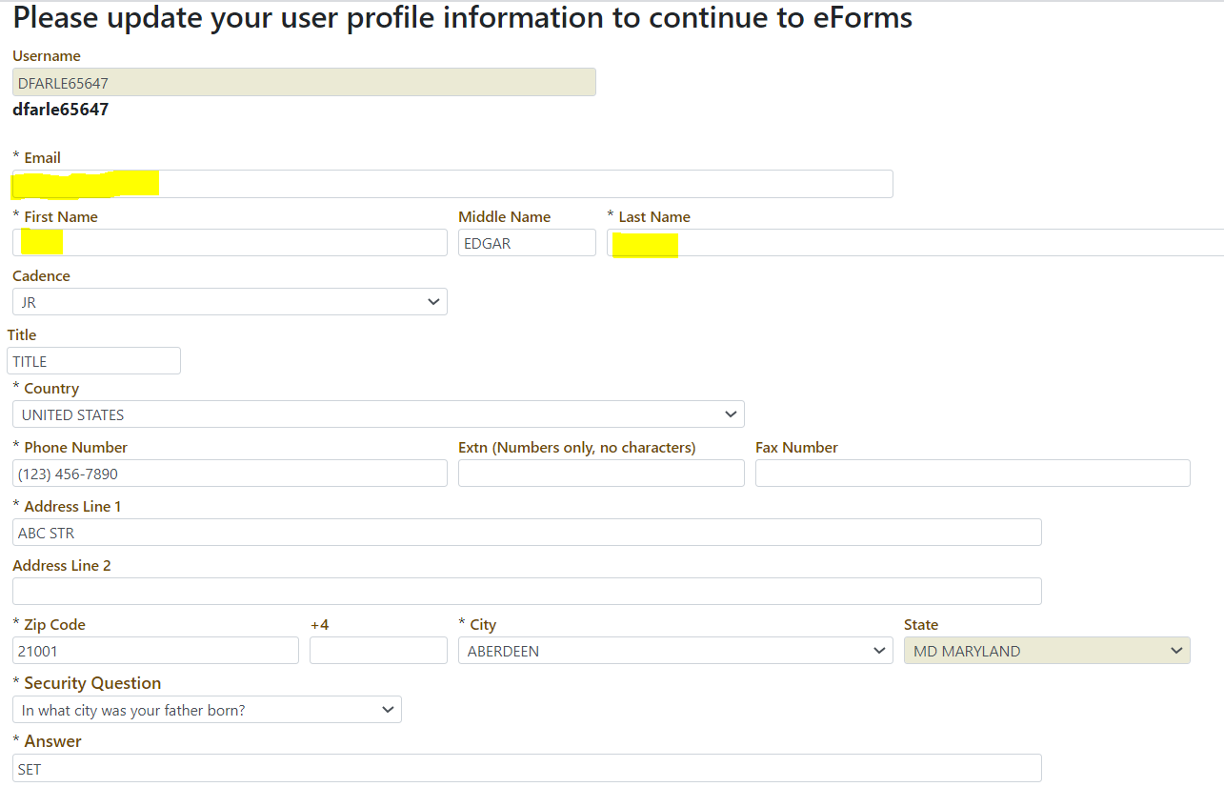
- Users of the original eForms users do not have a PIN so they will need to set one before moving on. The user will need to enter a four-digit pin into the first box and confirm that same pin in the second box.
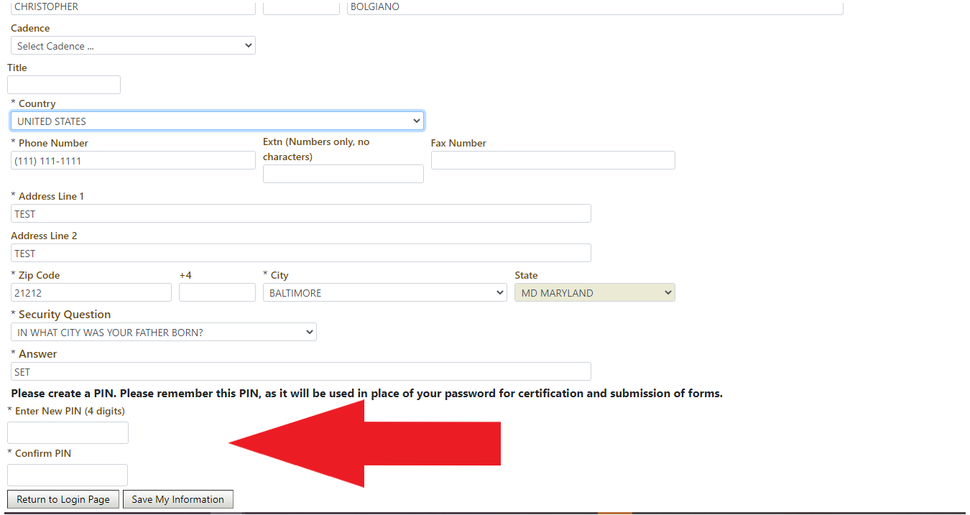
- Users will then need to click the “Save My Information” button.
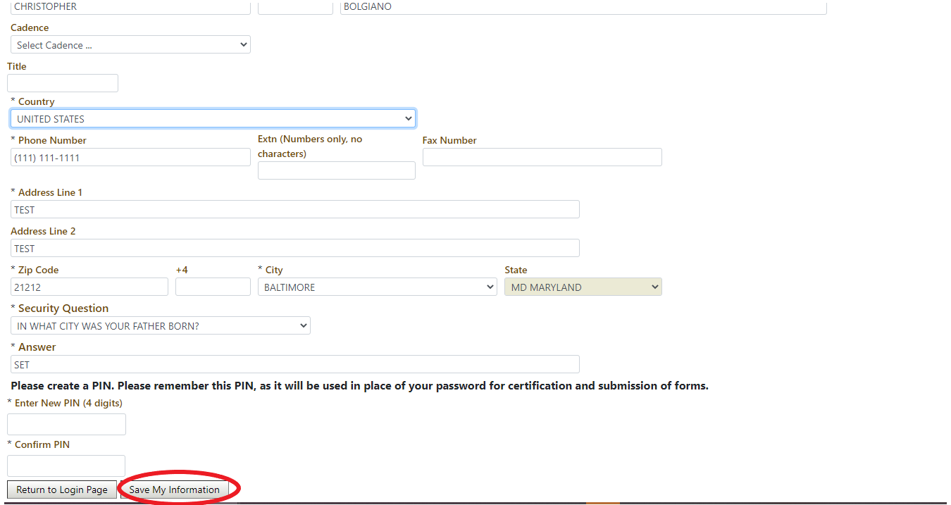

- Users will then be brought to a page titled "Rules of Behavior”, where they will need to accept or deny. If the user chooses to deny they will not be allowed to log into the system.

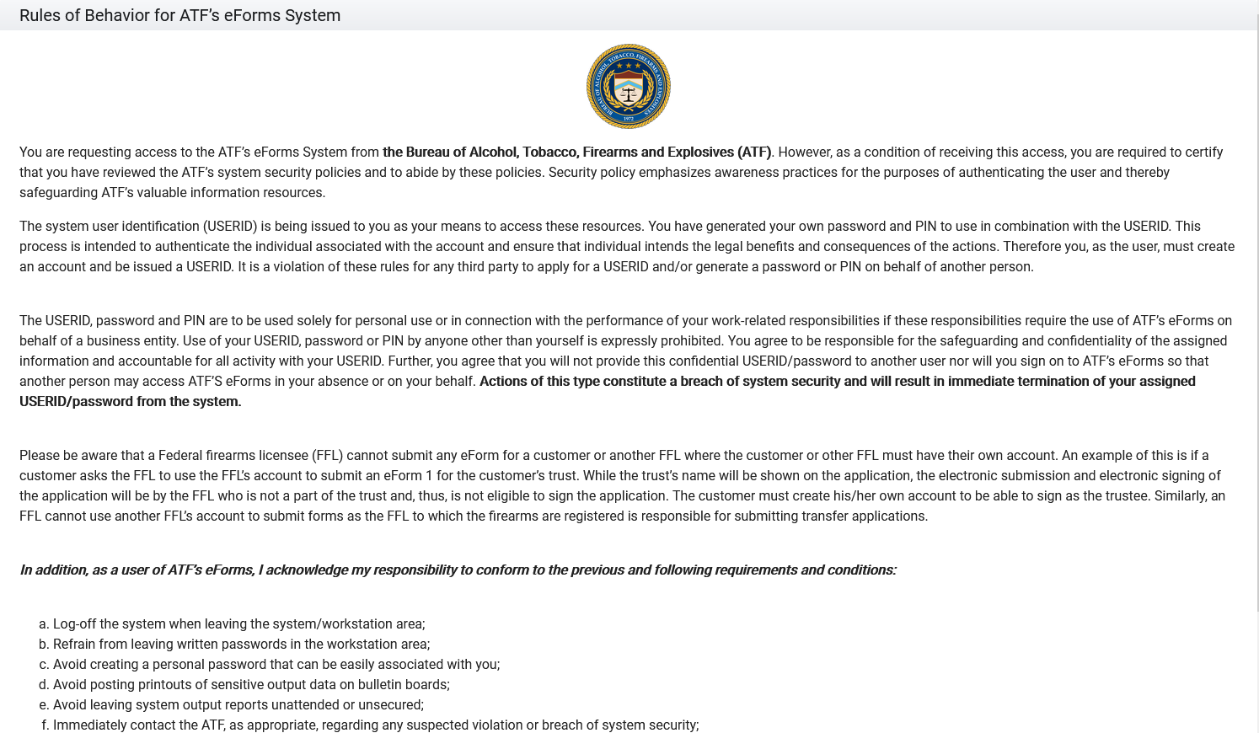

- Users will then see the screen below, indicating that they were successfully logged into the new eForms and can use the app. You will notice that all your existing eForms transactions have been migrated to the new version of eForms.
