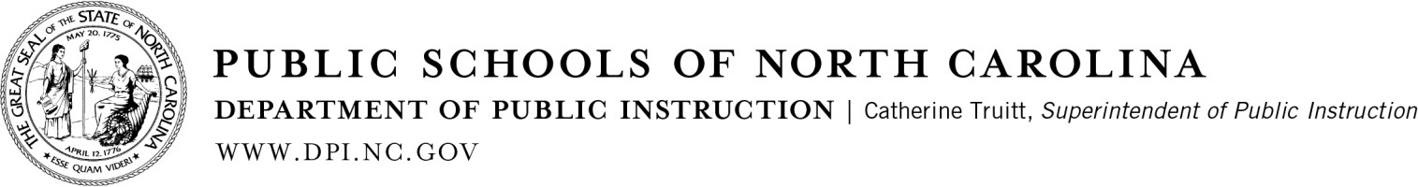

TO Superintendents
Charter School Directors Finance Officers Technology Directors

FROM Vanessa Wrenn, Chief Information Officer 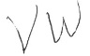

DATE May 17, 2022

HOME BASE OPT-IN TOOL AND PRICING FOR 2022-23

The North Carolina Department of Public Instruction (NCDPI) is pleased to announce that the full suite of Home Base is still available for the 2022- 2023 school year at an opt-in price of $1/ADM. Included in this price is Schoolnet, the Instructional Improvement System, and the use of a local Professional Development Office in NCEES, the Educator Evaluation System.

PowerSchool, #GoOpenNC, and the NC Educator Effectiveness System are also included in Home Base at no cost. PowerSchool is the official student information system used statewide by the public and charter schools of North Carolina for storing and managing student data, and #GoOpenNC is North Carolina’s open educational resource and collaborative platform.
The NC Educator Effectiveness System (NCEES) components (Evaluation and Professional Development) are based on the North Carolina Professional Teaching Standards. These tools are designed to promote effective leadership, quality teaching, and student learning, while enhancing professional practice and leading to improved instruction. (Please note: Local PD Offices are only made available to PSUs when opting into Home Base at $1/ADM.)

Other Home Base Products available through convenience contracts are Canvas, Imagine Math, Learning.com and Transcend. Brief descriptions of these products are given below:

- Canvas is a learning management system that provides a robust, flexible platform for curriculum content and digital tool integration.
- Canvas Studio is a video engagement add-on for Canvas LMS that allows for video creation, management, and analytics. It is available for an additional $1 per user with a startup fee for new users.
- Imagine Math is a tool used to help students build confidence in learning and solving Math problems for grades 3-8.
- Learning.com is a tool designed to encourage student growth in computational thinking, digital citizenship and online safety, visual mapping, databases, and computer fundamentals. Learning.com is available to Tier 1 schools at no cost. Please contact Home Base for more information.
- Pearson Transcend is a computer-adaptive interim assessment add-on within Schoolnet designed to empower the learning experience by testing students only on content that has been taught. It uncovers insights of where students need help the most by measuring and tracking the students progress. Transcend is made available to grades 3 – 8 at an additional cost of $4 per ADM. For more information, please reach out to the Home Base Team at home_base@dpi.nc.gov.

All price quotes are good for the 2022-23 school year. Prices are based on state appropriated funding and are subject to change in subsequent years. If you are interested in learning more, please email us at Home_Base@dpi.nc.gov or visit our Home Base Opt-in website.

Access to the Home Base Opt-in Tool is available at https://schools.nc.gov/homebaseaccess. Only district finance officers and charter school principals may request access to the online opt-in tool for their district/school. When submitting a request, you are confirming that district/school leadership supports the decision to opt in. If your PSU currently has access to Schoolnet and NCEES Local PD Offices and is planning to continue use for the 2022-23 school year, you must indicate planned usage for school year 2022- 23 by June 15. Otherwise, your access will be discontinued on July
1. After access request is approved, an invoice will be generated within the opt-in tool and emailed to the email recipient within the tool.

Providing school districts and charter schools access to robust digital content is a priority for DPI. Through the Digital Learning Initiative, we are collaborating with state partners to bring additional digital content to Home Base in the 2022-23 school year.

Checks should be made payable to North Carolina Department of Public Instruction (TIN # 561492826), with “Home Base 2022-23” in the memo line. Please mail the invoice and check to:
NC Department of Public Instruction
Cash Management and Collections
6336 Mail Service Center
Raleigh, NC 27699-6336
Payment is due August 31, 2022.
Thank you for collaborating with us to offer powerful, integrated digital learning tools to improve learning opportunities for all students and educators across North Carolina. We hope to see 100 percent district opt-in.

If you have questions concerning the opt-in process, please contact Yolanda Wilson, Home Base Opt-in Administrator, at yolanda.wilson@dpi.nc.gov. You may also visit our Home Base Opt-in FAQs for additional information.

VW/yw

c: Catherine Truitt Alexis Schauss
Rob Dietrich
Matthew Mayo
Dave Machado

