Export Control Joint Unit Symposium,

London 4th October 2022

Venue: Leonardo Royal Hotel, London Tower Bridge

Agenda

Tea, Coffee and Reception 08:30
Part one – plenary session – Trinity Suite
- Welcome and introduction 0915
- Trading in a changing world 0920
  - Keynote speaker - Shainila Pradhan, Director ECJU
  - Followed by talks from ECJU’s MoD, FCDO, Policy and Transformation teams
- Questions from Part One talks 1035
- Industry Panel 1045
  - Advice on how ECJU and its industry partners can help in a time of change
  - Comprising of industry experts from TechUK, Make UK, ADS Group and the IOE&IT
  - A selection of questions asked on your Application Forms (Section E).
- Intro to Workshops 1110
Tea and Coffee - Exporter Village – Basement 2 1115
Part two – workshops
- There will be a choice of one-hour workshops, run three times. See below for topics.
- Please indicate your choice of three workshops on your application form. (Section D)
First Workshop session 11:45
Lunch and networking – Exporter Village – Basement 2 12:45
Second workshop 13:45
Tea and Coffee – Basement 2 and Floor 1 14:45
Third workshop 15:10
Plenary wash-up – future working -Trinity Suite 16:20
Day ends 16:30

Workshop topics.

Please select 4 options and rank them in order of preference (3 preferred and a reserve).
- The Strategic Export Licensing Criteria and the application assessment process.
Led by ECJU’s FCDO team - Bartholomew Suite, Floor 1

- Protecting classified information and material: MOD Form 680s (with an exercise), exhibition clearances and Private Venture security grading
Led by ECJU’s MOD team - Prescot Suite, Floor 1
- Understanding unnecessary delays to licence applications and how to get them right first time. Led by ECJU’s Licensing Unit. - Harpley Suite, Floor 1

- HMRC Workshop: Why Goods are Intercepted by Customs, Enforcement Action, and Outcomes. Led by HM Revenue & Customs - Sidney Suite, Floor 1

- Compliance Unit Workshop: Working with Open Export Licences
Led by the ECJU’s Compliance Unit - Beaumont Suite, Floor 1
- Update on the modernising of ECJU’s services and the future system for processing licences - including the LITE project.
Led by the Transformation and LITE project teams. - Trinity Suite, Basement 2
- ITAR Beginners Workshop
Brinley Salzman – EGADD - Ludgate Suite, Basement 2

- ITAR Intermediate Workshop
George Grammas - Partner at Squire Patton Boggs - America Suite, Basement 2

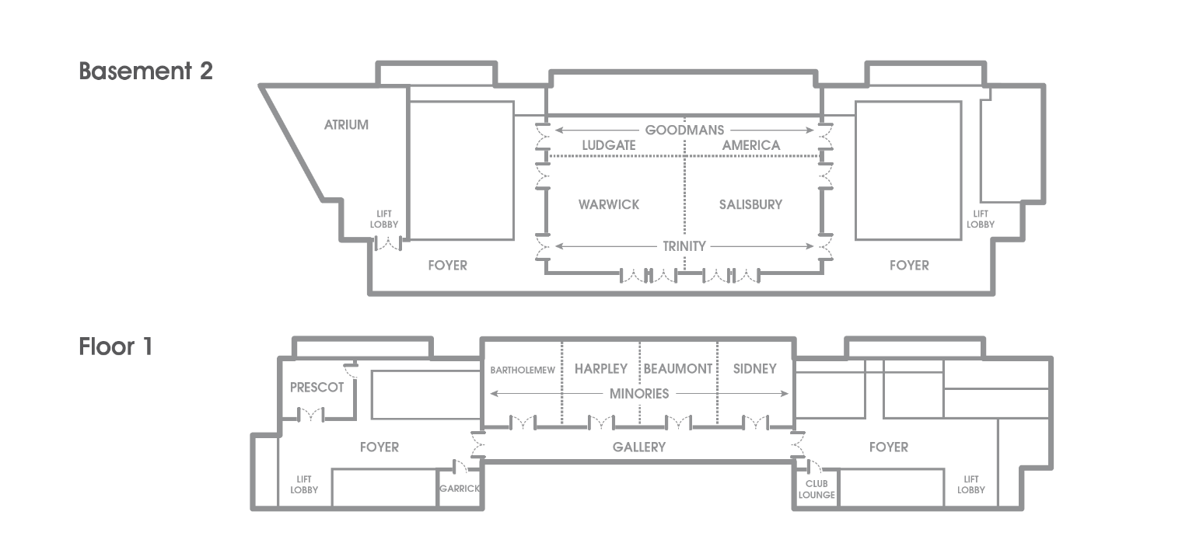
If you have any questions, please contact Denise.Carter@trade.gov.uk.

