

**Skype Meetings for external users**

**How to join a Skype meeting when you are an external user and do not have the Skype for Business Software**

* Open the meeting appointment from the calendar on your email.
* You will see a link within the text of the meeting notes stating **“Join Skype Meeting”;** click on the link.

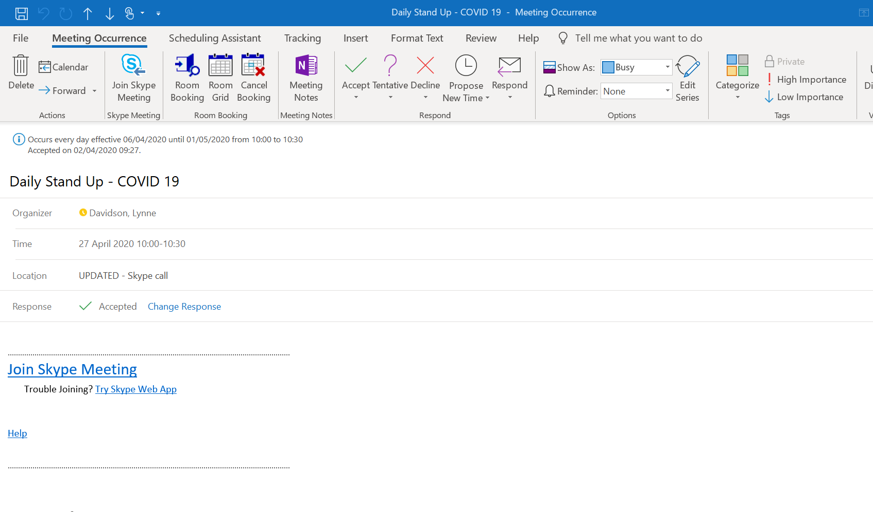

* The window below will open:

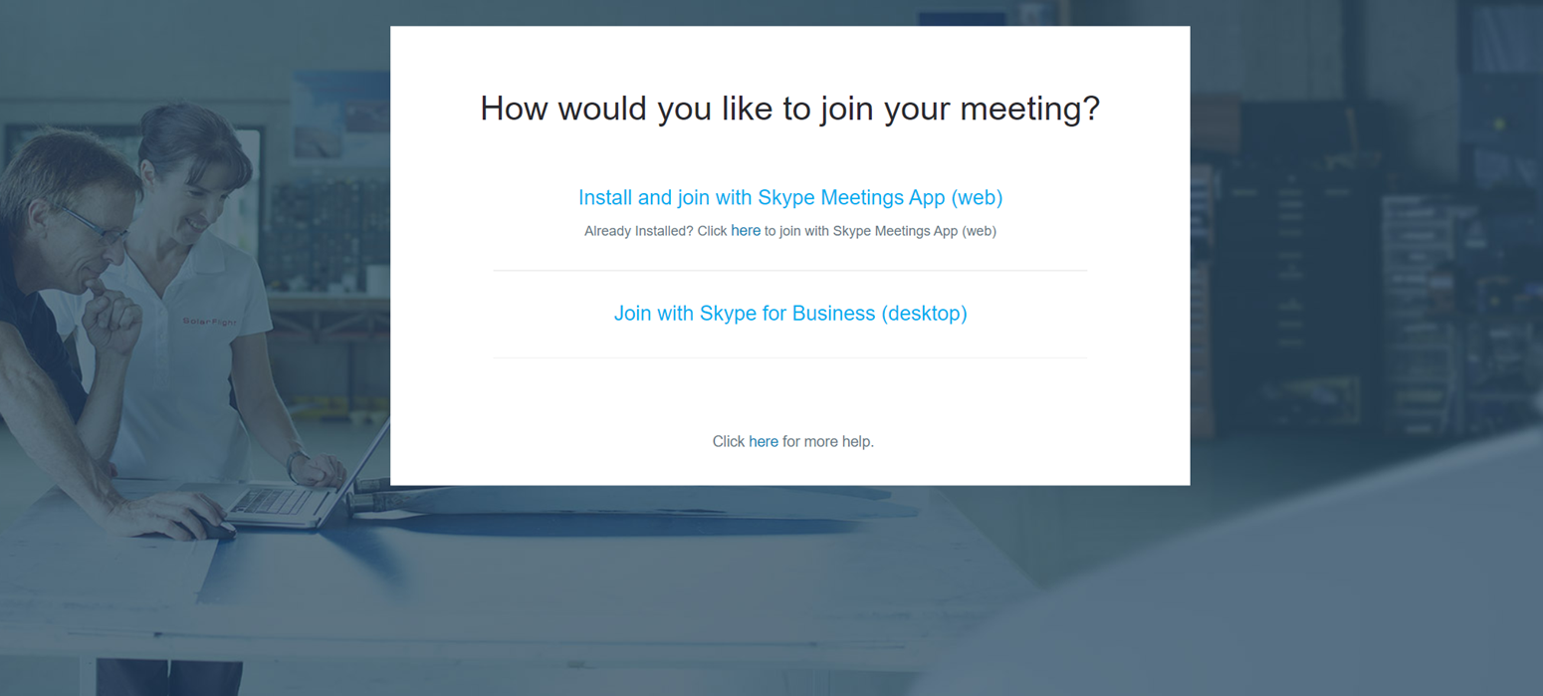

* Click on the **“Install and join Skype Meetings App (Web)"** link.
* Skype web app is downloaded to the Taskbar as shown in the screenshot below:

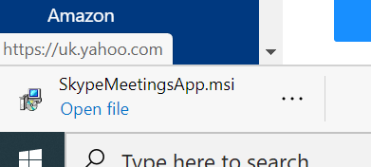

* Clicking on the **'Open File'** link which will initiate the installation and when it has completed, the window in the screenshot below will be shown:

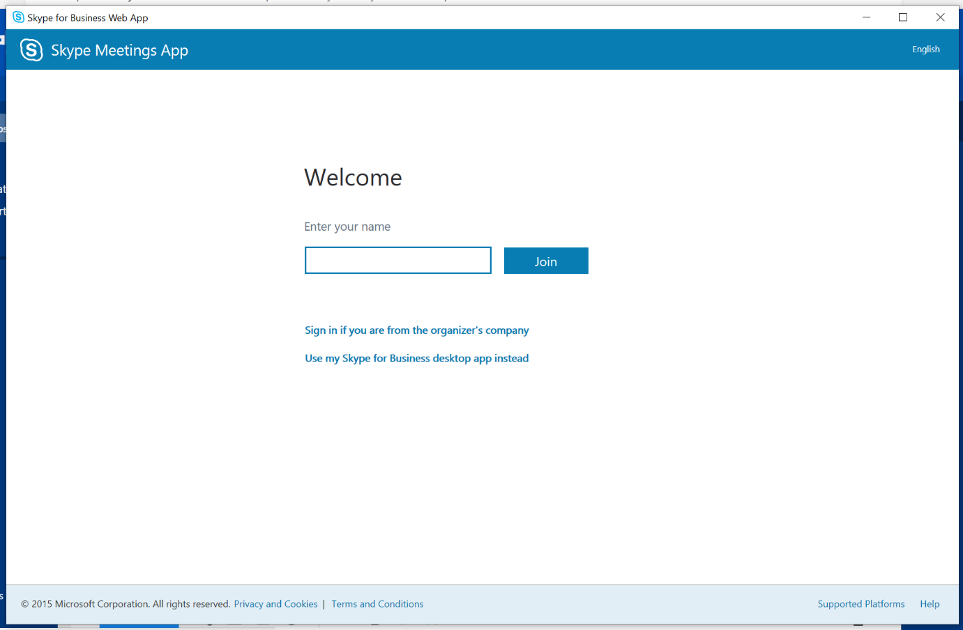

* **Enter your name** and then click on **“Join”** button.
* You will then see the screen below:

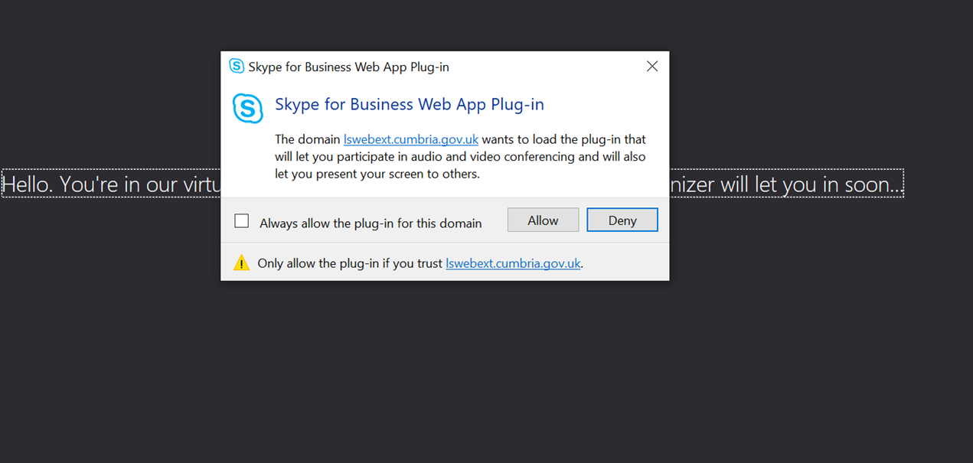

* Click on the **“Allow”** button.
* You will then get the below screen letting you know that you are in the lobby waiting to be allowed in by the Meeting Organiser:

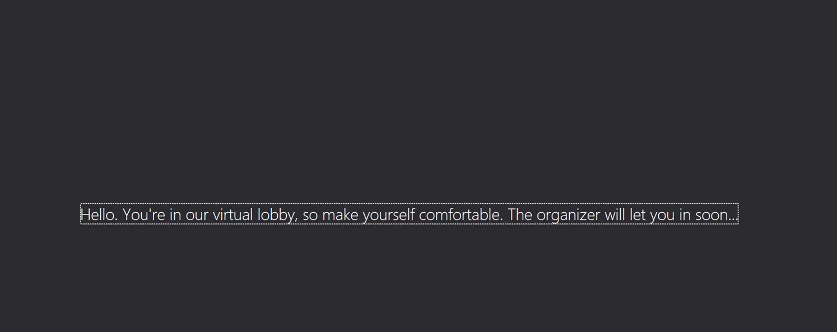

* The Meeting Organiser will see you come into Lobby and then allow you to join the Skype Meeting.
* **Please make sure that you ‘unmute’ your microphone to be heard and allow video to be enabled to be seen.**

**Queries and Support**

If you do experience any issues in setting up External skype for Business meetings please run through this guide again. If the issue still persists, please contact the ICT Service Desk on **01228 226000.**