FCC Emergency Broadband Benefit Outreach Toolkit
For schools and districts

This toolkit includes:

Template letter verifying free and reduced price lunch or school breakfast participation for Non-Community Eligibility Provision Schools 2
Sample NSLA/FERPA Consent Form for the Emergency Broadband Benefit Program 4
Fact Sheet (English) 8
Información para el Consumidor (Español) 9
Sample Newsletter Blurb (English) 10
Posible anuncio en boletín (Español) 10
Sample Tweets (English) 11
Tweets de muestra (Español) 11
Sample Facebook Posts (English) 12
Muestras para publicar en Facebook (Español) 12
Social Media Graphics 13

Additional Information

- Digital copies of this Outreach Toolkit, Template Letter, and Sample Consent Form are available at: https://tech.ed.gov/broadband/ebb/
- Additional outreach toolkit materials from the FCC, including in Arabic, Amharic, Burmese, Chinese (Traditional), French, Haitian Creole, Korean, Portuguese, Russian, Somali, Tagalog, and Vietnamese are available at: https://www.fcc.gov/emergency-broadband-benefit-outreach-toolkit
- Additional social media graphics from the FCC are available at: https://www.fcc.gov/emergency-broadband-benefit-social-media-images
- Emergency Broadband Benefit Program information from the FCC available at: https://www.fcc.gov/broadbandbenefit and from USAC available at: https://getemergencybroadband.org/

Template letter verifying free and reduced price lunch or school breakfast participation for Non-Community Eligibility Provision Schools

[School/District Letterhead]

XXXX XX, 2021

Dear Parent/Guardian,

This letter confirms that the following child(ren) in your household is/was (are/were) eligible for free or reduced price school meals under the National School Lunch Program (NSLP) or the School Breakfast Program (SBP) during the 2019-2020 and/or the 2020-2021 school year:

Child’s Name: _____________________________ School: ____________________________

Child’s Name: _____________________________ School: ____________________________

Child’s Name: _____________________________ School: ____________________________

Eligibility for monthly internet service discount
Because your child is eligible for free or reduced price meals under the NSLP or SBP, you are eligible for the Federal Communications Commission’s (FCC) Emergency Broadband Benefit Program (EBB Program). The EBB Program is a temporary federal program to help eligible households pay for internet service during the pandemic. The EBB Program provides a monthly discount of not more than $50 per month on broadband service and associated equipment (for example, a modem) for eligible households and not more than $75 per month for households on qualifying Tribal lands. If the participating household chooses an eligible plan that costs $50/month or less, the household will receive that service for free, at least until the EBB Program ends.

Each participating household may also be reimbursed up to $100 for one connected device—a laptop, desktop, or tablet computer—where available from a participating broadband provider, as long as the household contributes more than $10 and less than $50 towards the cost of the device. Each participating household is limited to a single device discount.

How to apply
To apply, you can fill out an application (either online, by mail, or through a participating service provider) and submit a copy of this letter as documentation verifying your child/children receives school meal benefits through the NSLP or SBP.

If you have questions about the EBB Program, your eligibility to participate, or to find information about participating providers near you, please visit GetEmergencyBroadband.org, call 833-511-0311, or email EBBHelp@usac.org.

Sincerely,

School official name
School official title

Sample NSLA/FERPA Consent Form for the Emergency Broadband Benefit Program

[School/District Letterhead]

Disclosure of Information Protected by the National School Lunch Act (NSLA) and the Family Educational Rights and Privacy Act (FERPA) by _____ [(1) Insert school or school district name]______ to _____[(2) Insert name of participating provider(s)]_____, the Federal Communications Commission (FCC), and the Universal Service Administrative Company (USAC) to Verify Eligibility for the FCC’s Emergency Broadband Benefit Program

In general, Federal law requires that a parent/guardian or “eligible student” (as defined under FERPA) provide written consent before a school or school district may disclose personally identifiable information from the education records of a student including personally identifiable information from the National School Lunch Program (NSLP) school meal application maintained by a school, school district, or a party acting on their behalf, to a third party.*

About the Emergency Broadband Benefit Program (EBB Program)
The FCC’s EBB Program is a temporary federal program to help eligible households pay for internet service during the pandemic. Households with a child who is approved to receive free or reduced price meals under the NSLP or the School Breakfast Program (SBP), including children who attend schools participating in the U.S. Department of Agriculture’s Community Eligibility Provision (CEP), are eligible for the EBB Program. This includes any child who currently receives benefits during the 2020–2021 school year or did so in the 2019–2020 school year. USAC administers the EBB Program under the direction of the FCC. Visit GetEmergencyBroadband.org for more information.

Purpose of this form
Signing this form will allow your child’s, or your, school or school district to let a participating internet provider, the FCC, and USAC know if your child has, or you have, been approved to receive NSLP or SBP free or reduced price school meals and thus if your household is eligible for the EBB Program. You do not have to sign this form, but if you do not, the school or school district cannot disclose the listed information to a participating provider, the FCC, or USAC. You may still participate in the EBB Program by providing information directly to the participating provider, the FCC, or USAC. You can find more information about applying for the EBB Program at GetEmergencyBroadband.org.

I, __________________________________ [Parent/Guardian and “Eligible Student” (as defined under FERPA) name(s)], agree to allow _____[(3) Insert school or school district name]_____ to give or confirm my child’s, or my, free or reduced price eligibility status to _____[(4) Insert name of participating provider(s)]_____, the FCC, and the USAC only to confirm if my household qualifies for the FCC’s EBB Program. I give permission for _____[(5) Insert school or school district name]_____ to give only the following information regarding my child’s, or my, free or reduced price school meal eligibility status, as needed:

- The student’s name;
- The student’s home address, and phone number or email address;
- If the student qualified for free or reduced price school meals in the 2019–2020 school year, the 2020–2021 school year, or both – including free meals through the Community Eligibility Provision;
- The name(s) of the program(s) that the student’s household participates in, such as free or reduced price meals through the NSLP or SBP; and
- The name(s) of the program(s) that the school participates in, such as the Community Eligibility Program (CEP), which allows schools to serve meals free to all children who go to the school.

____________________________________
Signature of Parent or Guardian

Date: _______________________________

____________________________________
Signature of Eligible Student (18 years or older), if needed

Date: _______________________________
*The Family Educational Rights and Privacy Act (FERPA) (20 U.S.C. § 1232g; 34 CFR Part 99) requires written consent before an educational agency (e.g., school district) or institution (i.e., school) may disclose personally identifiable information from the education records of a student to a third party, unless an exception to FERPA’s general consent requirement applies. Private K-12 schools that do not receive federal funds from a program administered by the U.S. Department of Education are not subject to FERPA.
The National School Lunch Act (NSLA) has confidentiality and disclosure requirements (42 U.S.C.1758(b)(6); 7 CFR Part 245.6) that explain the restrictions on the disclosure and use of information obtained from an application for free or reduced price meal benefits, as well as the criminal penalties for improper release of information. The confidentiality of the information on the school meals application includes the free or reduced price eligibility status of the student and the household’s income information.
Under FERPA, an eligible student means a student who is 18 years of age or older or attends an institution of postsecondary education. In general, under FERPA, an eligible student would need to give written permission for a school or school district to disclose personally identifiable information from their education records. Under the NSLA’s confidentiality provisions, the parent or guardian of an eligible student must also give written permission for a school to give someone else information about the eligible student qualifying for free or reduced price school meals, if the eligible student qualified using the parent or guardian’s household and income information.
A parent, guardian, or eligible student may revoke his or her or their written permission for a school or school district to disclose personally identifiable information from education records at any time. A request to revoke permission should be in writing, signed, and sent separately to _____[(6) Insert point of contact at school or school district]_____.

Instructions for Schools and School Districts
A-1. When might our school or school district need to use this form?

The template consent form is for schools and school districts that choose to facilitate the Emergency Broadband Benefit (EBB) Program sign up process for students and their families who are eligible to participate in the EBB Program. Alternatively, students and families who are eligible to participate in the EBB Program may choose to directly sign up for the EBB Program through their preferred participating provider or through the Lifeline National Eligibility Verifier (National Verifier) application process, which is administered by the Universal Service Administrative Company (USAC). Visit GetEmergencyBroadband.org for more information.

It is possible for a school or school district to verify the eligibility of students and their families for the EBB Program; however, there are several important considerations:
- Protecting student privacy. In accordance with student privacy requirements under the Family Educational Rights and Privacy Act (FERPA) and the National School Lunch Program (NSLP), a school or school district that initiates sign up for students who are eligible to participate in the EBB Program must obtain written consent to share student participation in the NSLP or the School Breakfast Program with a participating provider, the Federal Communications Commission (FCC), and the USAC.
- Working with participating providers. To verify eligibility, schools would need to work directly with the participating provider or providers in their area, and those providers may need to seek additional authorization from the FCC to operate their own verification process with the school’s information. Schools interested in facilitating the EBB Program sign up process should check with their local providers to confirm that the providers have the ability to operate this type of verification process.
A-2. Instructions for adapting the template consent form
- Fill in the numbered and highlighted blanks in the template consent form above:
  - Insert the name of the school or school district that is distributing this form.
  - List the name(s) of participating provider(s) with whom you are working directly.
School Tip: Use USAC’s Companies Near Me tool to confirm the participating provider(s) offering service in your area. Some participating providers may not have coverage in all parts of your community, so it is important to check with the provider(s) listed for your area zip code(s) to confirm they offer service to a particular address.
  - Insert the name of the school or school district that is distributing this form.
  - List the name(s) of participating provider(s) with whom you are working directly.
  - Insert the name of the school or school district that is distributing this form.
  - List a point of contact at your school or school district that the parent or guardian can contact to revoke permission.

- Put the adapted consent form on school or school district letterhead.

Place Holder for Partner's Logo.

Fact Sheet (English)

The Emergency Broadband Benefit is a temporary FCC program to help families and households struggling to afford broadband internet service during the COVID-19 pandemic.

The Emergency Broadband Benefit provides:

- Up to $50/month discount for broadband service;
- Up to $75/month discount for households on qualifying Tribal lands; and
- A one-time discount of up to $100 for a laptop, desktop computer, or tablet purchased through a participating provider if the household contributes more than $10 but less than $50 toward the purchase price.
The Emergency Broadband Benefit is limited to one monthly service discount and one device discount per household.

Who is Eligible?

A household is eligible if a member of the household meets one of the criteria below:
- Has an income that is at or below 135% of the Federal Poverty Guidelines or participates in certain assistance programs, such as SNAP, Medicaid, or Lifeline;
- Receives benefits under the free and reduced-price school lunch program or the school breakfast program, or did so in the 2019-2020 school year;
- Received a Federal Pell Grant during the current award year;
- Experienced a substantial loss of income due to job loss or furlough since February 29, 2020; or
- Meets the eligibility criteria for a participating broadband provider’s existing low-income or COVID-19 program.
Check out www.fcc.gov/broadbandbenefit for a Consumer FAQ and other program resources.

Three Ways to Apply

- Contact your preferred participating broadband provider directly to learn about their application process.
- Go to GetEmergencyBroadband.org to apply online and to find participating providers near you.
- Call 833-511-0311 for a mail-in application, and return it along with proof of eligibility to: Emergency Broadband Support Center
P.O. Box 7081
London, KY 40742

Call 833-511-0311
or find more information about the Emergency Broadband Benefit at www.fcc.gov/broadbandbenefit

Información para el Consumidor (Español)

El Beneficio De Emergencia Para Internet (EBB) es un programa temporal de la FCC que ofrece ayuda a los hogares con problemas para pagar sus servicios de Internet durante la pandemia.

Este beneficio te proporciona:
- Máximo $50 de descuento al mes para tu servicio de Internet.
- Máximo $75 de descuento al mes para hogares elegibles en Territorios Tribales.
- Un descuento único de hasta $100 por una computadora portátil, computadora de escritorio o una tableta electrónica a través de un proveedor participante.

El Beneficio De Emergencia Para Internet se limita a un descuento mensual por un servicio de conexión y a un descuento único por la compra de un equipo, por cada hogar.

¿Quién es elegible?

Podrás participar en este programa si un miembro de tu hogar:
- Tiene un ingreso igual o menor al 135% del nivel federal de pobreza o participa en ciertos programas de asistencia social.
- Recibe beneficios en la escuela bajo el programa de almuerzo o desayuno gratuito o reducido.
- Recibió una beca Federal Pell Grant para la Universidad durante el año en curso.
- Experimentó una pérdida sustancial de ingresos debido a la pérdida de su empleo o a la suspensión de su trabajo, sin sueldo, a partir del 29 de febrero de 2020.
- Cumple con los criterios de elegibilidad exigidos por un proveedor participante en un programa de bajos ingresos o en un programa COVID-19 ya existente.
Para obtener más información, llama al 833-511-0311 o visita www.fcc.gov/bandaanchaprestacion
Tres formas de solicitar el beneficio:
- Contacta a tu proveedor de Internet preferido directamente. Pregunta si participa en el programa EBB o utiliza nuestros servicios en línea para encontrar una empresa participante en tu localidad.
- En línea. Usa la solicitud en el sitio web: GetEmergencyBroadband.org
- Por correo. Imprime la solicitud en inglés o español. Complétala y envíala con tu comprobante de elegibilidad a: Emergency Broadband Support Center
P.O. Box 7081
London, KY 40742

Para obtener más información, llama al 833-511-0311 o visita www.fcc.gov/bandaanchaprestacion

Sample Newsletter Blurb (English)
For use in partner newsletters or email campaigns

The Federal Communications Commission has launched a temporary program to help families and households struggling to afford Internet service during the COVID-19 pandemic. The Emergency Broadband Benefit provides a discount of up to $50 per month toward broadband service for eligible households and up to $75 per month for households on qualifying Tribal lands. Eligible households can also receive a one-time discount of up to $100 to purchase a laptop, desktop computer, or tablet from participating providers.

Eligible households can enroll through a participating broadband provider or directly with the Universal Service Administrative Company (USAC) using an online or mail in application.
You can learn more about the benefit, including eligibility and enrollment information, by visiting http://www.fcc.gov/broadbandbenefit, or by calling 833-511-0311

Posible anuncio en boletín (Español)
La Comisión Federal de Comunicaciones ha dado inicio a un programa temporal que ofrece ayuda a los hogares con problemas para pagar sus servicios de Internet durante la pandemia de COVID-19. El Beneficio De Emergencia Para Internet (EBB) te proporciona máximo $50 de descuento al mes para tu servicio de Internet; máximo $75 de descuento al mes para hogares elegibles en Territorios Tribales y un descuento único de hasta $100 por una computadora portátil, computadora de escritorio o una tableta electrónica a través de un proveedor participante.

Los hogares elegibles pueden inscribirse directamente a través de alguno de los proveedores de Internet participantes o a través de la Universal Service Administrative Company (USAC, por sus siglas en inglés), en línea o por correo.

Para obtener más información sobre este programa, incluyendo tu elegibilidad y cómo inscribirte, llama al 833-511-0311 o visita www.fcc.gov/bandaanchaprestacion

Sample Tweets (English)
The Emergency Broadband Benefit provides discounts for households struggling to afford #broadband service during the #COVID19 pandemic. [@yourname] & @FCC want you to know more. Find out if you qualify & how to apply: fcc.gov/broadbandbenefit #DigitalDivide #BroadbandForAll (274 characters)
We’re spreading the word about @FCC’s Emergency Broadband Benefit, which provides discounts for #broadband service and devices to families struggling to stay connected during the pandemic. Learn more about the program here: fcc.gov/broadbandbenefit #DigitalDivide #BroadbandForAll (279 characters)
Enrollment for the Emergency Broadband Benefit is now open. You may be eligible for a discount of up to $50 per month on your #broadband service, or up to $75 per month if you live on qualifying Tribal lands. Details here: fcc.gov/broadbandbenefit. #DigitalDivide #BroadbandForAll (279 characters)
***Eligible households can also receive a one-time discount of up to $100 for a laptop, desktop computer, or tablet purchased through a participating provider.
*** indicate that the proceeding tweet will be tweeted in a series.

Tweets de muestra (Español)

El Beneficio De Emergencia Para Internet (EBB) descuenta el servicio de #Internet a hogares elegibles por la pandemia de #COVID19. [@yourname] y la @FCC quieren informarte. Revisa tu elegibilidad e inscríbete: fcc.gov/bandaanchaprestacion #DigitalDivide #BroadbandForAll [271 characters]

Estamos difundiendo el Beneficio de Emergencia Para Internet de la @FCC que descuenta un servicio de #Internet y un equipo a hogares con problemas para pagar servicio de Internet durante la pandemia.Visita fcc.gov/broadbandbenefitl #DigitalDivide #DigitalDivide #BroadbandForAll [280 characters]

Ya se abrió la inscripción de hogares elegibles al Beneficio De Emergencia Para Internet (EBB). Un descuento máximo de $50 en #Internet o de $75 en Tierras Tribales. Hay más información en: fcc.gov/bandaanchaprestacion #DigitalDivide #BroadbandForAll [252 characters]

***Los hogares elegibles también pueden obtener un descuento único de hasta $100 por una computadora portátil, computadora de escritorio o una tableta electrónica a través de un proveedor participante.

[*** los tweets de más arriba serán emitidos en serie]

Sample Facebook Posts (English)

The Emergency Broadband Benefit will provide a discount of up to $50 per month toward broadband service for eligible families and households who are struggling to stay connected during the #COVID19 pandemic. Qualifying households on Tribal lands can receive a discount of up to $75 per month for service. Eligible households can also receive a discount of up to $100 for the purchase of a laptop, desktop computer, or tablet from participating providers. For more info, please visit: fcc.gov/broadbandbenefit. #DigitalDivide #BroadbandForAll

The Federal Communications is asking for help to spread the word about the Emergency Broadband Benefit. This temporary program helps families struggling to afford Internet service during the COVID-19 pandemic. Having a broadband connection is essential for households gain access to jobs, healthcare services, virtual classrooms, and so much more. Visit www.fcc.gov/broadbandbenefit to learn more.

Enrollment for the Emergency Broadband Benefit is now open. The temporary benefit provides a discount of up to $50 per month toward broadband service for eligible consumers who are struggling to stay connected during the pandemic. Qualifying households on Tribal lands can receive a discount of up to $75 per month for service. See if you qualify by visiting www.fcc.gov/broadbandbenefit

Muestras para publicar en Facebook (Español)

El Beneficio De Emergencia Para Internet (EBB) es un programa temporal de la FCC que ofrece ayuda a los hogares con problemas para pagar sus servicios de Internet durante la pandemia de #COVID19. Te proporciona máximo $50 de descuento al mes para tu servicio de Internet; máximo $75 de descuento al mes para hogares elegibles en Territorios Tribales y un descuento único de hasta $100 por una computadora portátil, computadora de escritorio o una tableta electrónica a través de un proveedor participante. Para obtener más información, llama al 833-511-0311 o visita www.fcc.gov/bandaanchaprestacion. #DigitalDivide #BroadbandForAll

La Comisión Federal de Comunicaciones busca ayuda para difundir el programa de Beneficio De Emergencia Para Internet (EBB). Este programa temporal de la FCC ofrece ayuda a los hogares con problemas para pagar sus servicios de Internet durante la pandemia de COVID-19. Contar con una conexión a Internet es esencial para que las familias obtengan acceso a su trabajo, a servicios de atención de salud, a salas de clase virtuales y mucho más. Para obtener más información, llama al 833-511-0311 o visita www.fcc.gov/bandaanchaprestacion.

Está abierto el periodo de inscripciones en el programa de Beneficio De Emergencia Para Internet. Este beneficio es un programa temporal que ofrece ayuda a los hogares con problemas para pagar sus servicios de Internet durante la pandemia. Te proporciona: máximo $50 de descuento al mes para tu servicio de Internet; máximo $75 de descuento al mes para hogares elegibles en Territorios Tribales. Y un descuento único de hasta $100 por una computadora portátil, computadora de escritorio o una tableta electrónica a través de un proveedor participante. Para saber si eres elegible, llama al 833-511-0311 o visita www.fcc.gov/bandaanchaprestacion

Social Media Graphics

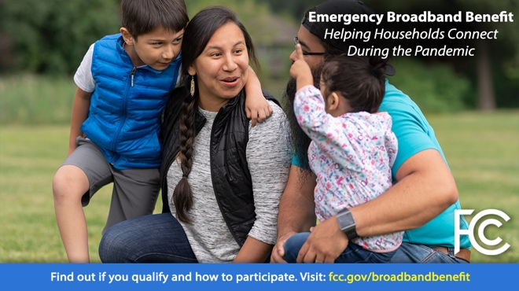

Facebook PNG (1MB)
Instagram PNG (1.7MB)
Twitter PNG (1.1MB)

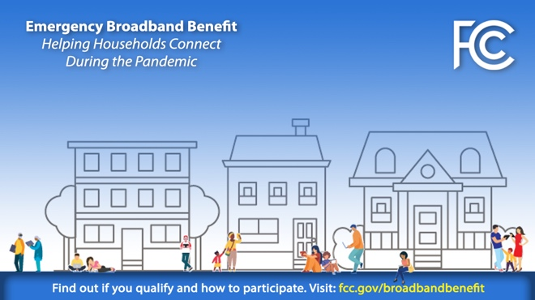

Facebook PNG (349KB)
Instagram PNG (390KB)
Twitter PNG (359KB)

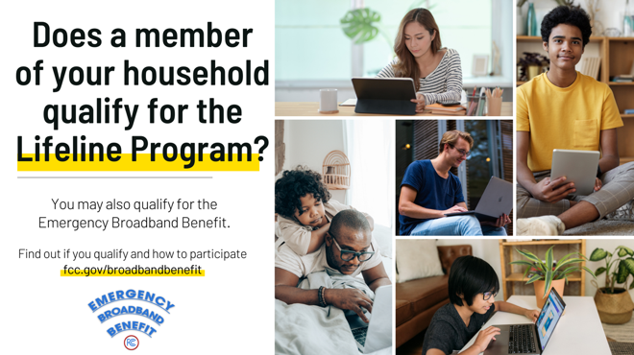

Facebook PNG (735 KB)
Twitter PNG (770 KB)

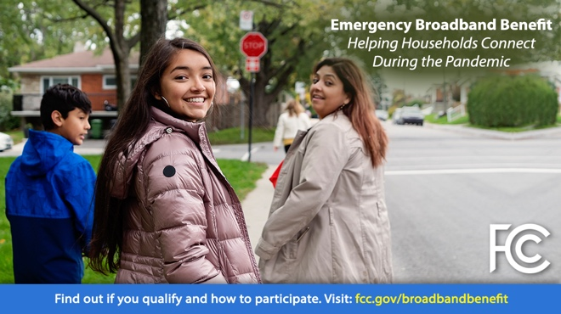

Facebook PNG (1.1MB)
Instagram PNG (1.8MB)
Twitter PNG (1.2MB)

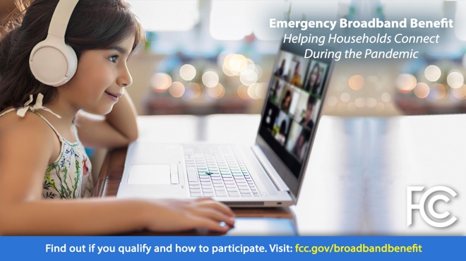

Facebook PNG (810KB)
Instagram PNG (1.1MB)
Twitter PNG (867KB)

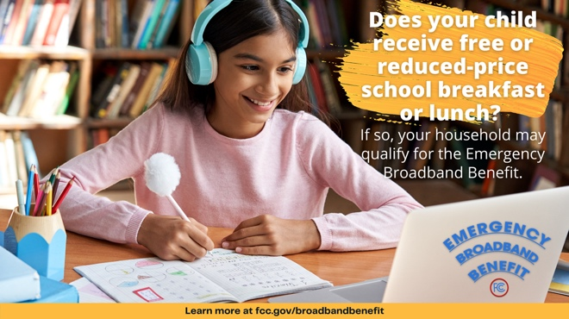

Facebook PNG (1 MB)
Twitter PNG (1.1 MB)

