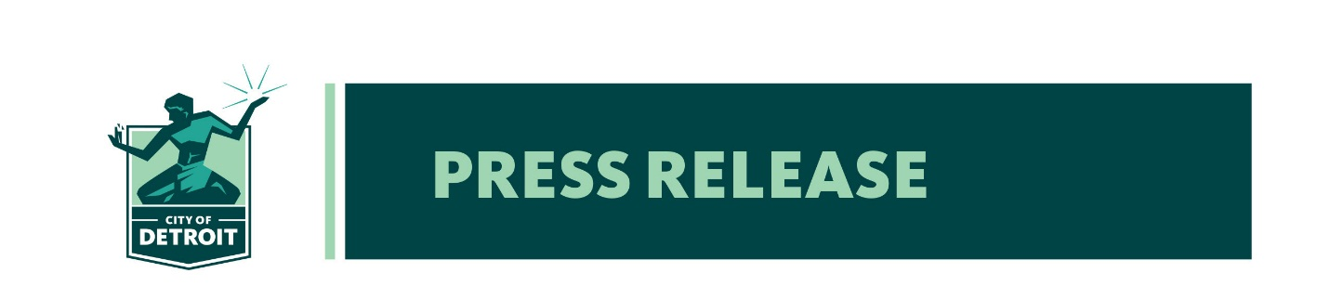
RELEASE DATE: September 1, 2021
MEDIA CONTACT: Chris Kopicko, Detroit Homeland Security & Emergency Management
(313) 418-9534

City of Detroit Seeking Residents’ Input on Community Preparedness Survey

The City of Detroit would like the input of Detroit residents on what they consider the greatest hazard preparedness needs in Detroit. Please consider taking a short but important Community Preparedness survey. The survey results will be used in updating the City of Detroit’s Hazard Mitigation Plan. Resident input is greatly valued and appreciated as we work together to reduce or prevent loss of life and property in the event of a disaster.
The City of Detroit Hazard Mitigation Plan is updated every five years. Public input is a critical component of the process to review and update the plan. The survey will be available online until September 30, 2021. In addition to the survey, two public meetings will be scheduled by the end of October to discuss hazard preparedness needs in Detroit, one on the east side and one on the west side of Detroit.
The Hazard Mitigation Plan not only prepares the city to reduce or prevent the tragic loss of life or property, but a current plan is required in order to receive potential funding from the federal Hazard Mitigation Grant Program. These grants can be used to help pay for the hazard mitigation efforts identified in the plan. To complete the short survey, please visit www.detroitmi.gov/dhsem and click on the City of Detroit Community Preparedness Survey link. Please encourage family, friends, and neighbors to also complete the survey. Community input is vital to a safe, prepared, and resilient community.

