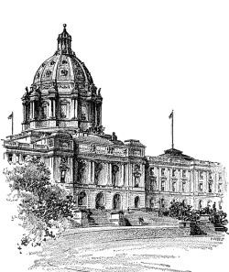
OFFICE OF THE REVISOR OF STATUTES
Minnesota Legislature

ATTORNEY

OFFICE OF THE REVISOR OF STATUTES
MINNESOTA LEGISLATURE

The Office of the Revisor of Statutes is seeking to fill a full-time attorney position/positions with 0-3 years of experience at the level of Assistant Revisor I (Level 9).
The Office of the Revisor of Statutes is a nonpartisan legislative office that provides confidential bill and administrative rule drafting and related services to all members of the legislature, executive branch agencies, and constitutional offices. The office also edits and publishes Laws of Minnesota, Minnesota Statutes, and Minnesota Rules.
Candidates must have an interest in government service and in the legislative and administrative processes, must have strong communication skills, must be nonpartisan, and must be able to work flexibly and cooperatively with many interested parties under severe time constraints.
This is a full-time, unclassified, benefits eligible position with a minimum salary of $69,958.
Please see the job description for more details: https://www.revisor.mn.gov/employment/
A cover letter, resume, and writing sample must be received by 4:30 p.m., Friday,
November 19, 2021, at the Office of the Revisor of Statutes, 700 State Office Building, 100
Rev. Dr. Martin Luther King Jr., Blvd., St. Paul, MN 55155-1297, or by fax to (651) 296-0569, or by email to jobs@revisor.mn.gov

An Equal Opportunity Employer

700 State Office Building, 100 Rev. Dr. Martin Luther King, Jr. Blvd., St. Paul, Minnesota 55155-1297 Phone: (651) 296-2868 Fax: (651) 296-0569 TTY: 1-800-627-3529

