ATF’s eForms New Users First Time Logon Steps
12/8/2021
Table of Contents
1 Background 1
2 Walk Through Steps 1

Background
This document outlines the steps that new users log into ATF’s Modernized eForms application for the first time. All users will need to reset their password when logging into the ATF’s eForms application for the first time.

Walk Through Steps
- When a new user visits the ATF eForms site for the first time, they will be presented with the standard home screen that is consistent for all users.
- Users should click the green “Register” button on the of the home screen. Users may have to use the scroll button to see it.
  - Once users click on the “Register” button they will then be presented with the “User Registration” screen for completion.
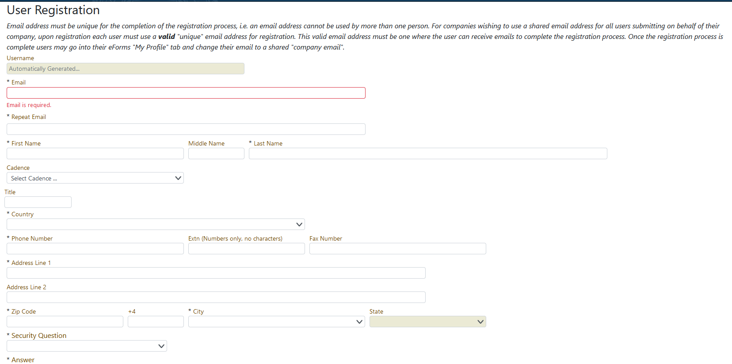
- This screen will require information which will aide in uniquely identifying the user such as name, email address, phone number, and address. It will also require the user to provide information which will allow ATF to create a “secured account” such as the selections of a secret question, and answer, password, and a 4-digit PIN. Once users have completed the first name, and last name fields and move to the next field, a unique Username/ID will be created at the top of the screen, we suggest that you jot this number down for your future reference. Once the user has completed the “User Registration” and clicked on the “Register” button at the bottom of the screen, the user will be taken back to the eForms landing page and the user will receive an email that will confirm your registration and provide your user ID. The new user can now user that user Id and the password that they created during the registration process to log into eForms, on the login screen by clicking on the login button that is indicated below.
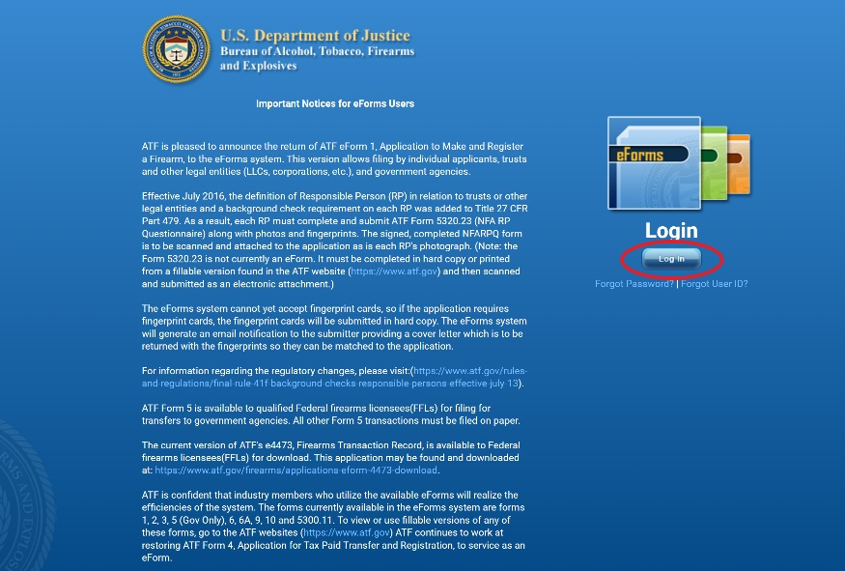
- Users should read the disclaimer presented on the screen. If they understand and agree with the conditions, they should proceed by clicking the “Accept & Log In” button at the bottom of the screen.
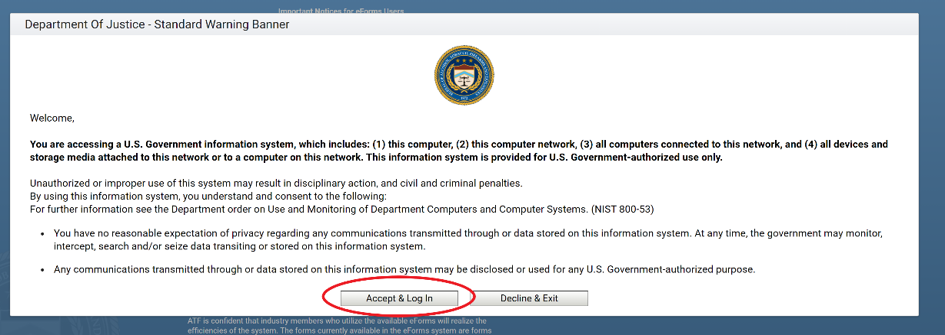
- Users should then enter their username/ID and password into the respective boxes.
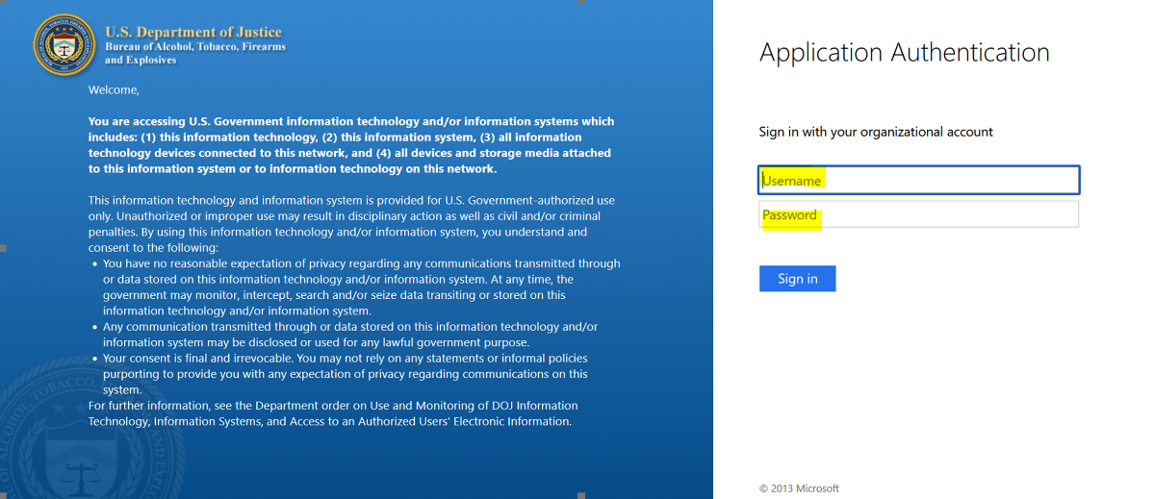
- Users should then click the “Sign In” button.
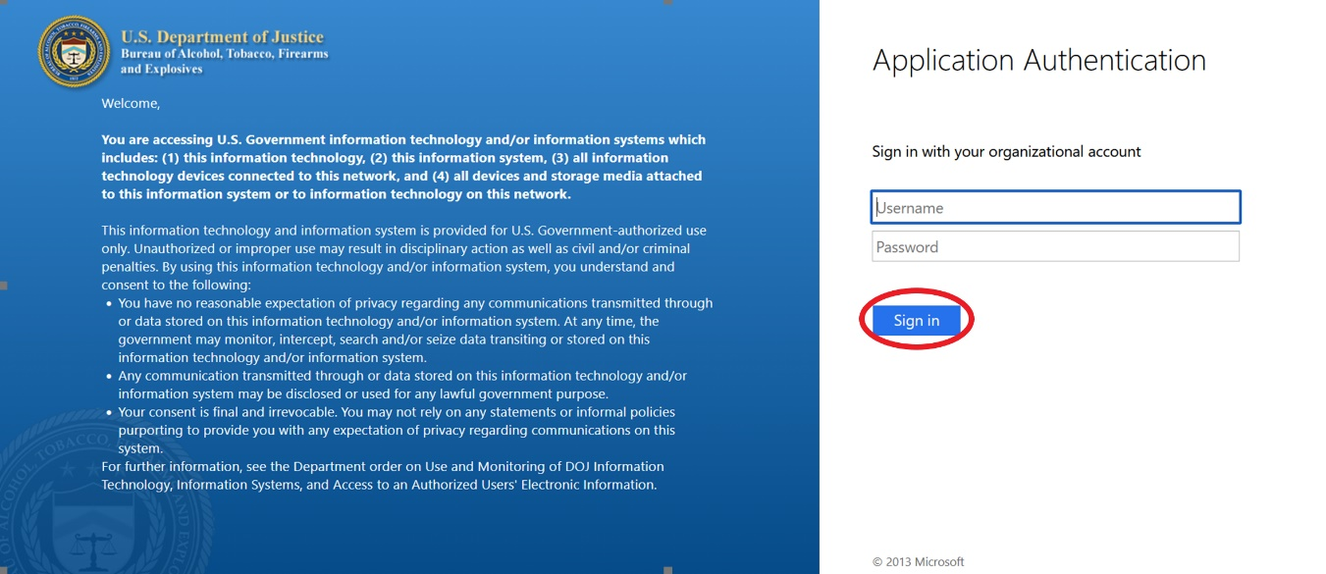

PLEASE NOTE: THE FOLLOWING STEPS ARE ASSUMING THAT THE LOG IN WAS SUCCESSFUL If the user was unsuccessful, they should contact the ATF help desk for additional help at 1-877-875-3723.

- Users will then be brought to a page titled "Rules of Behavior”, where they will need to accept or deny. If the user chooses to deny they will not be allowed to log into the system.

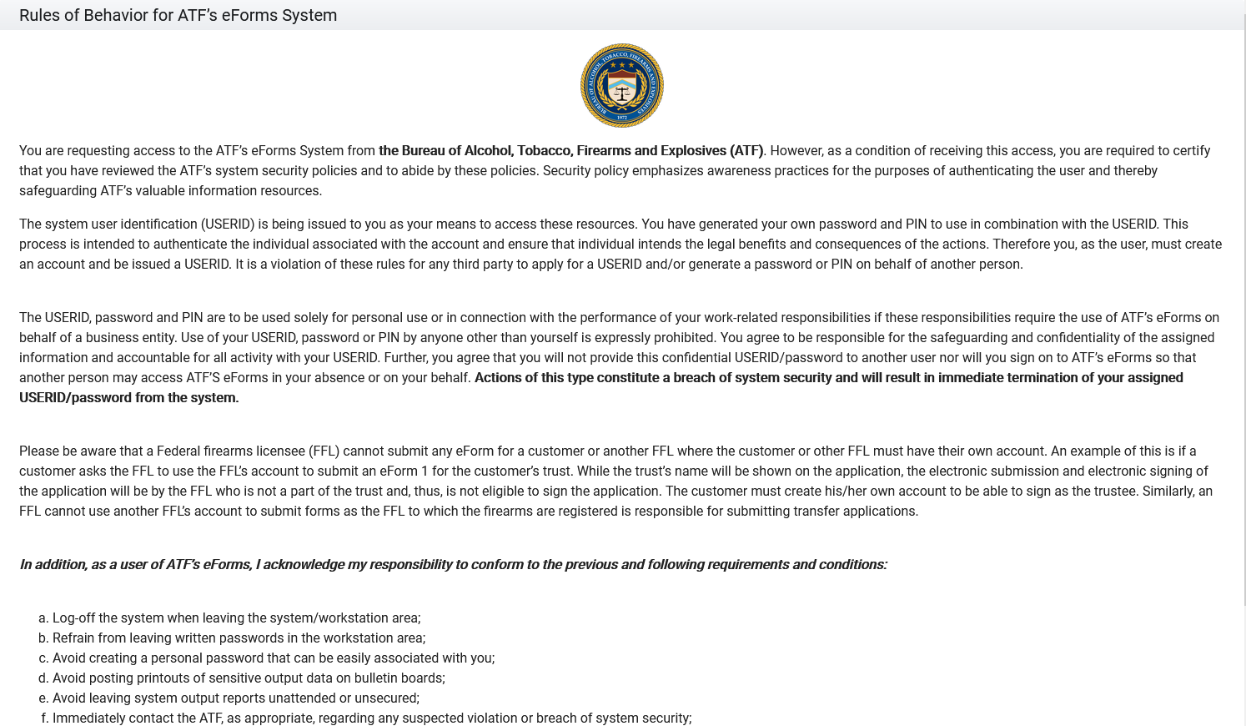

- Users will then see the screen below, indicating that they were successfully logged into ATF eForms and can use the app by clicking on the form they wish to submit.

