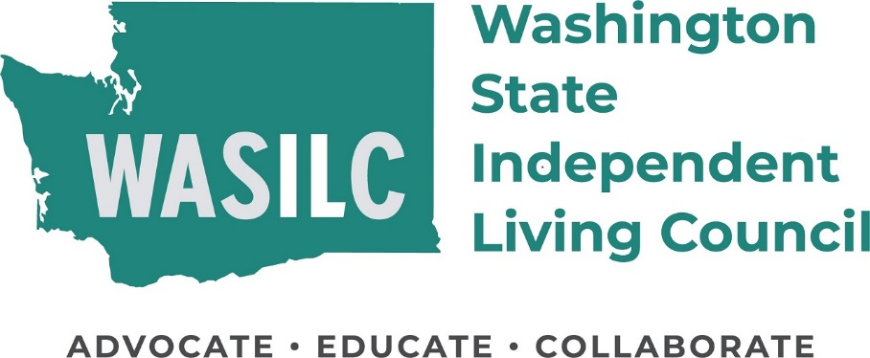

WASILC is seeking new council members

WHO WE ARE
The Washington State Independent Living Council (WASILC) is an eleven-member Council appointed by the Governor. Their goal is to assist individuals with disabilities to achieve their maximum potential within their families and communities to achieve and maintain independent living.
APPLY
Apply to serve directly through the Washington Governor’s Boards and Commissions: https://www.governor.wa.gov/boards-commissions/boards-commissions/apply-serve-board-or-commission.
If you want support in completing the application, or to just learn more, please contact WASILC Executive Assistant Rebecca Rodriguez:
Email wasilc@dshs.wa.gov
Phone 360 584 8399 (text, video, voice)

