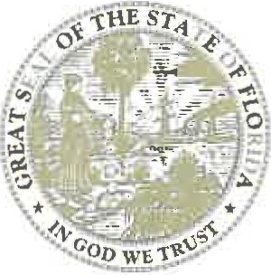
RON DESANTIS
GOVERNOR

SAFE BOATING WEEK IN FLORIDA

WHEREAS, residents and tourists alike take to the Sunshine State's waterways to enjoy boating, fishing, sailing, and swimming; and

WHEREAS, recreational boating is a staple of our state's lifestyle, tourism, and economy; and

WHEREAS, Florida is committed to ensuring the safety of all residents and visitors to our great state; and

WHEREAS, safe boating on our waterways begins with operator awareness and preparation, and it is important that Floridians are aware of potentially life-saving tips before boating including: wearing life jackets, staying sober while operating, attending boating safety education courses, participating in free boat safety checks, and carrying lifesaving emergency distress and communications equipment; and

WHEREAS, the Florida Fish and Wildlife Conservation Commission is committed to protecting Florida's natural resources and people through proactive and responsive law enforcement services, including enforcing boating rules and regulations, coordinating boating safety campaigns and education, managing public waters and access to them, conducting boating accident investigations, identifying and removing derelict vessels, and investigating vessel identity theft and fraud; and

WHEREAS, Safe Boating Week in Florida is an opportunity to bring awareness to life-saving tips and promote safe boating so Floridians can continue to experience the beauty of our waterways in the "Boating Capital of the World."

NOW, THEREFORE, I, Ron Desantis, Governor of the State of Florida, do hereby extend greetings and best wishes to all observing May 22 - 28, 2021, as Safe Boating Week in Florida.

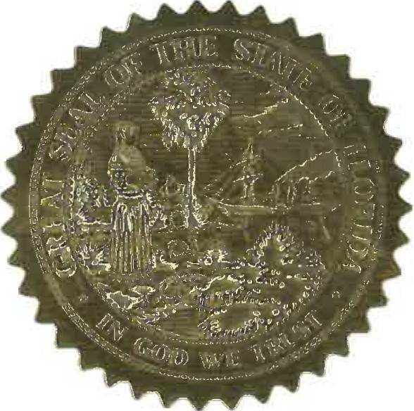
IN WITNESS WHEREOF, I have
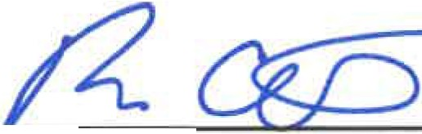
hereunto set my hand and caused the Great Seal of the State of Florida to be affixed at Tallahassee, the Capital, this 22nd day of May, in the year two thousand twenty-one.

Governor

THE CAPITOL
TALLAHASSEE, FLORIDA 32399 • (850) 717-9249 www.FLGo v.com

