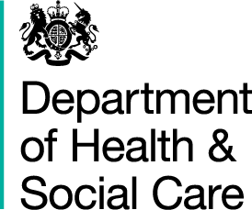

*From Department of*

*Health and Social Care*

*39 Victoria Street*

*London*

*SW1H 0EU*

*020 7210 4850*

[To: Adult Social Care Providers]

28 May 2021

Dear colleagues,

Last Spring, we were in the midst of the very worst days of the pandemic.

Today, thanks to your unwavering dedication, your willingness to adapt to the highest standards of infection prevention control, and the success of the biggest mass vaccination programme in our history, we are in a much better place.

Adaptability has been one of your greatest strengths. Throughout the pandemic, you have embraced many changes to daily practice, always keeping in mind the needs of the people you support. Recently and most importantly, you have supported the vaccination roll-out as part of your work to protect those in your care.

All of this against the backdrop of an increased workload: covering shifts for absent colleagues, working while children are off school, and coping with your own grief, anxieties and personal caring responsibilities. We take none of this for granted and remain deeply grateful for your continued commitment.

We’ve seen the challenges you’ve overcome, how you’ve adapted and supported each other as well as those you care for. Now we can be much more optimistic about managing this pandemic, further easing restrictions and eventually restoring our lives to something closely resembling normality.

You have been there when your residents, clients and colleagues needed you most. With free PPE guaranteed until March 2022 and free access to mental health and wellbeing support specifically for health and care workers, we intend to be there for you too.

We hope you know how much we appreciate your professional and personal efforts.

Thank you.



Minister for Care, Secretary of State, Chief Nurse and Chief Social Worker.