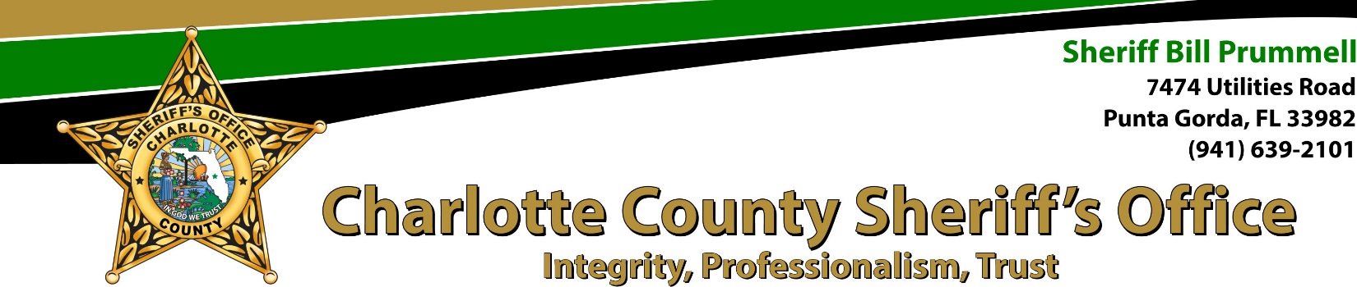

DATE: 09/20/2023 CCSO CASE #: 2304-003647

***Wanted Person - Possibly Armed***

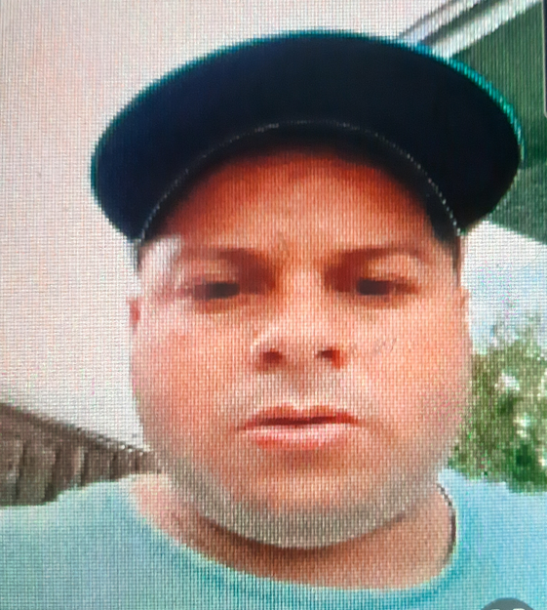
Picture as of 09/20/2023
Yosmel Betancourt Morales 01/10/1990
LKA: 4805 Lehto Ln. Apt. B Lake Worth FL

The Charlotte County Sheriff's Office and FHP Cargo Theft Task Force have an active warrant for Yosmel Bentancourt Morales for the Charges of RICO, Conspiracy to Commit RICO and Grand Theft over $100,000. All known addressed have been checked. If located, take any and all cell phones as evidence.

Sgt. Christopher Kearney Det. Ronald Chandler III
ckearney@ccsofl.net ronchandler@ccsofl.net
Cell: 941-769-2718 Cell: 941-787-4049
Charlotte County Sheriff's Office
7474 Utilities Rd. Punta Gorda, FL 33982
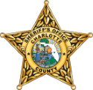
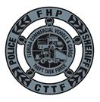

Sgt. George Seiler
georgeseiler@flhsmv.gov
Cell: 813-244-5307
FHP CTTF
402 S. Kentucky Ave. Suite 200
Lakeland, FL 33801

