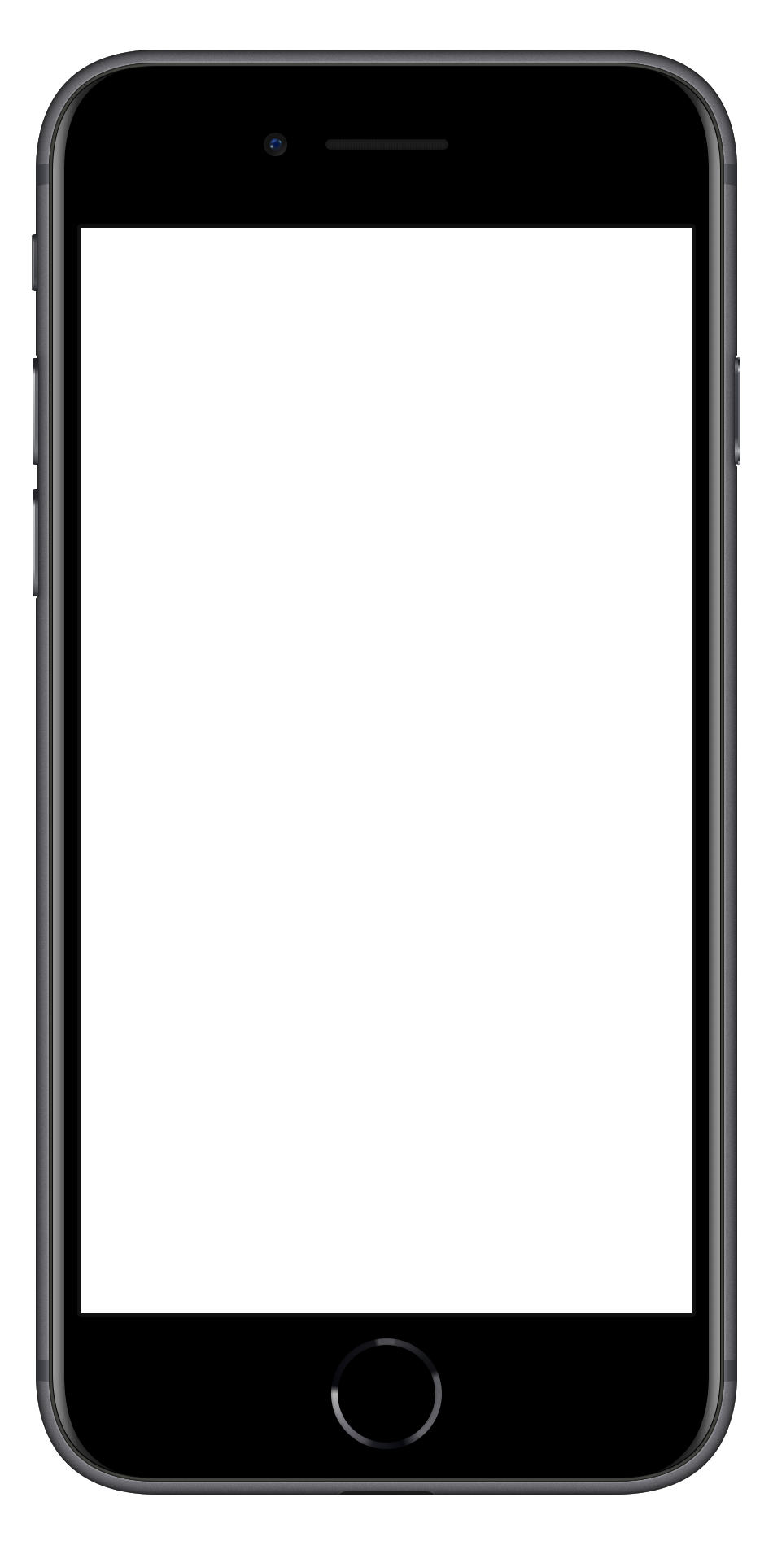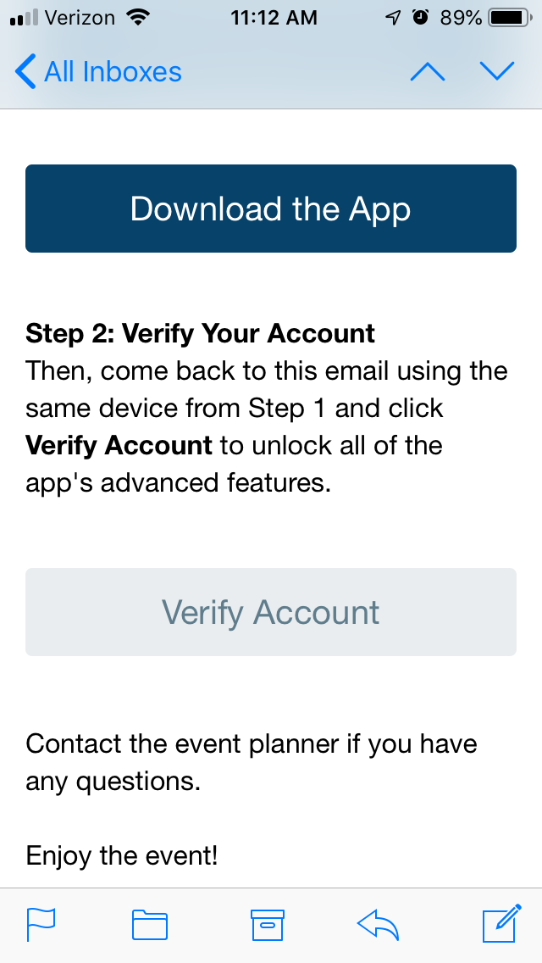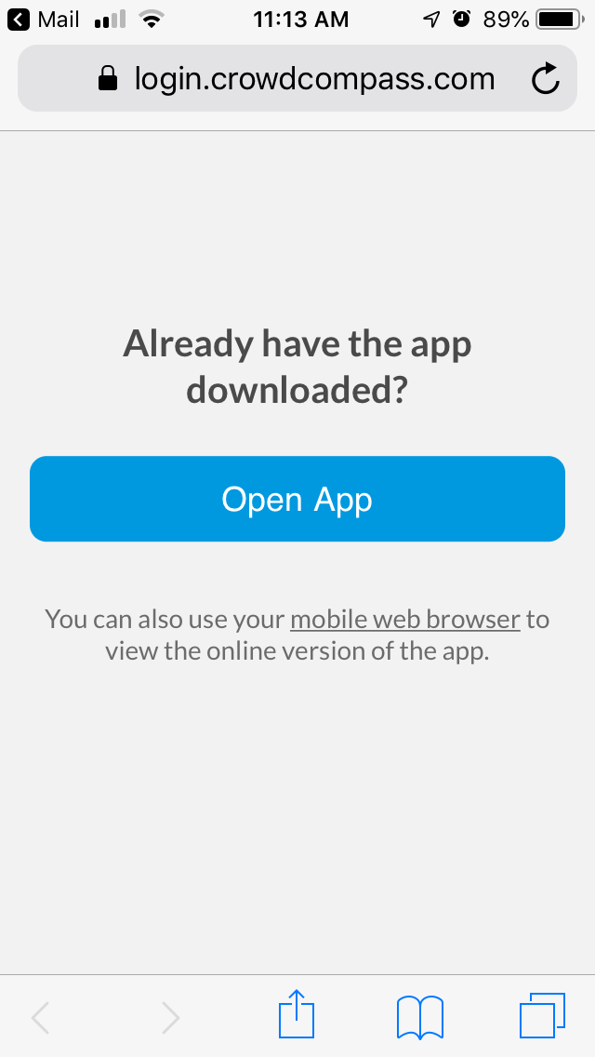

**1 Return to your Invitation.** Once the app has finished installing, open your invitation email again.

Click **Verify Account**.

**2 Confirm your Verification.** Click **Open App** to complete the verification and unlock all the app features!

**Verify your account**

**1 Find your Invitation.** Check your email for an invitation message from CrowdCompass.

**2 Download the App.** Click **Download the App** to be taken to the App Store or Google Play Store depending on your device type. Click **Get** or **Install** to start downloading the app on your device.

**Download the app**

**Logging In Via Invitation**