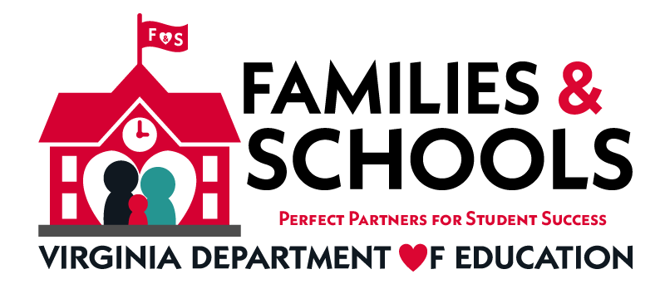

Family Engagement in Education Month
Governor Ralph S. Northam, Superintendent of Public Instruction
Dr. James F. Lane and the Virginia Department of Education recognize
November as Family Engagement Month in the
Commonwealth of Virginia.

The importance of parental engagement in schools is well documented. Over 30 years of research shows that one of the most effective ways to increase student achievement is for parents to be actively involved in the education of their children.

November is Family Engagement Month in Schools
The Virginia Department of Education is committed to improving parent and family involvement for all students including students with disabilities. We believe that family school collaboration is essential to student success.
Check out the following links for resources:

- Virginia PTA
- Department of Defense: Special Needs Parent Tool Kit – Birth to 18
- Guidance for Military Families with Students in Special Education
- National Standards, Goals, and Indicators for Family School Partnerships
- Parent Education Advocacy Training Center (PEATC)
- Tips and Strategies for Increasing Parent and Family Involvement in Virginia Schools
- Title I – Parent Involvement
- US Department of Education: Family and Community Engagement
- Virginia Family Special Education Connection
- Center for Family Involvement (VCU, Partnership for People with Disabilities)
- National PTA Standards for Successful Family-School Partnerships

Family Engagement Resources that Can Support the National PTA Standards for Family-School Partnerships
These standards offer a framework for how families, schools, and communities should work together to support student success.

PTA Standard 1- Welcoming All Families
- Center for Schools & Communities: Building. Strengthening. Transforming. How We Can Work Together

- Creating a Welcoming Environment at Your School (Domain 1) in
101 Ways to Create Real Family Engagement by Steven M. Constantino, Ed.D

- Education World: Does Your School’s Atmosphere Shout “Welcome?”

- Edutopia: Five-Minute Film Festival: Parent-Teacher Partnerships

- Family Friendly Schools

- Families in Schools- Building Partnerships for Student Success (available in Spanish)

- Recorded Webinar- Stories from the Field: Successful Practice in Engaging Families During COVID-19

- One Voice- Blog postings on Family Engagement

PTA Standard 2- Communicating Effectively
- Chapter 8- Principle #2: Communicate Effectively and Build Relationships Engage Every Family by Steven M. Constantino, Ed.D

- Family Engagement: Collaborating with Families of Students with Disabilities (IRIS Module)

- Connect Online Course- Better Together: Powerful Family Partnerships (Frank Porter Graham Child Development Institute)

- Edutopia: 19 Proven Tips for Getting Parents Involved at School

- Edutopia: Family Engagement: Resource Roundup
- Global Family Research Project

- I HAVE A QUESTION…What Parents and Caregivers Can Ask and Do to Help Children Thrive at School (A Parent Checklist) (U.S. Department of Education)

PTA Standard 3- Supporting Student Success
- Beyond the Bake Sale: The Essential Guide to Family-School Partnerships (Book)

- CBM at Home (Florida Center for Reading Research - Florida State University and Center on Teaching & Learning)

- Classroom Diversity: An Introduction to Student Differences (IRIS Center Module)

- COVID-19 Toolkit: Supporting Individuals with Autism through Uncertain Times (Autism Focused Intervention Resources & Modules, AFIRM) (Available in English, Polish, Swedish, Chinese, Italian, Japanese, Arabic, Mandarin, Spanish & Czech), National Professional Development Center (NPDC) on ASD

- Dual Language Learners with Disabilities: Supporting Young Children in the Classroom (IRIS Center Module)

- Edutopia: The Beginners’ Guide to Connecting Home and School

- Effective School Practices: Promoting Collaboration and Monitoring Students’ Academic Achievement (IRIS Center Module)

- Evidence-Based and Promising Practices to Support Continuity of Learning for Students With Disabilities (OSEP)

- Joining Together to Create a Bold Vision for Next-Generation Family Engagement: Engaging Families to Transform Education (Oct. 23, 2018)

- National Center for Families Learning (NCFL)

- National PTA: One Voice- Blog postings on Family Engagement

- National PTA: Parent’s Guide to Student Success

- Parents: Supporting Learning During the COVID-19 Pandemic (IRIS Module)

- Understood: Working with your child’s teachers

- Webinar Transcript- Bringing Families to the Table: Family Engagement for Struggling Students (National Center on Intensive Intervention)

PTA Standard 4- Speaking up for Every Child
- Aligning and Integrating Family Engagement in Positive Behavioral Interventions and Supports (PBIS) Concepts and Strategies for Families and Schools in Key Contexts

- Center for Family Involvement (VCU, Partnership for People with Disabilities)

- National PTA Standards for Family-School Partnerships

- PACER Center: Champions for Children with Disabilities

- ParentAdvocates.org

- PEATC: Parent Educational Advocacy Training Center

PTA Standard 5- Sharing Power
- Chapter 7- Principle #5: Empower Every Family by Steven M. Constantino, Ed.D

- CONNECT Module 4: Family-Professional Partnerships (Early Childhood)

- Joining Together to Create a Bold Vision for Next-Generation Family Engagement: Engaging Families to Transform Education (Oct. 23, 2018)

- National PTA Standards for Family-School Partnerships

- Parent Toolkit (available in Spanish)

- PTA: You are Key to Your Child’s Success

PTA Standard 6- Collaborating with Community
- Chapter 9- Principle #5: Engage the Greater Community by Steven M. Constantino, Ed.D

- Cultural and Linguisitic Differences: What Teachers Should Know (IRIS Center Module)

- National Association for Family, School, and Community Engagement

- National Education Association (NEA): The Power of Family School Community Partnerships (2011)

- Parent Engagement Toolkit (America’s Promise Alliance)

Compiled by the Virginia Department of Education’s Family Engagement Network (FEN)
Updated October 2020 - available on TTAC Online or
Virginia Family Special Education Connection

