**Instructions if you have an eSLA account Injury and Illness Report: (**if you are unsure please contact Breanna Rheinschmidtfor assistance. [**Breanna.Rheinschmidt@wisconsin.gov**](mailto:Breanna.Rheinschmidt@wisconsin.gov)

1. Login to your eSLA account. [https://esla.wi.gov](https://esla.wi.gov/?utm_medium=email&utm_source=govdelivery)
2. On the **Permit Tab**, Select “**New Application**.”

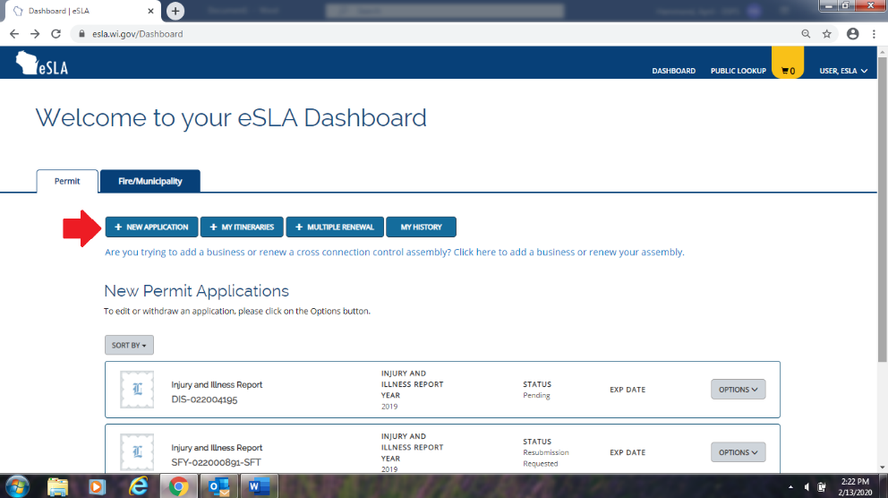

1. Complete the Application, selecting the following -with the exception of choosing the applicable account: 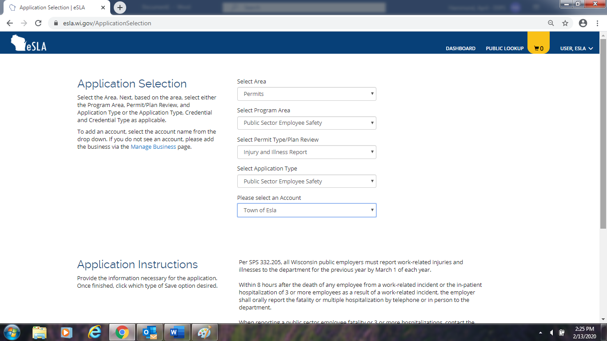

Select your municipality in the dropdown.

1. Continue through the Data entry process entering your name and email on the next page. Note- When entering your Public Address- Make sure to Check the Box. 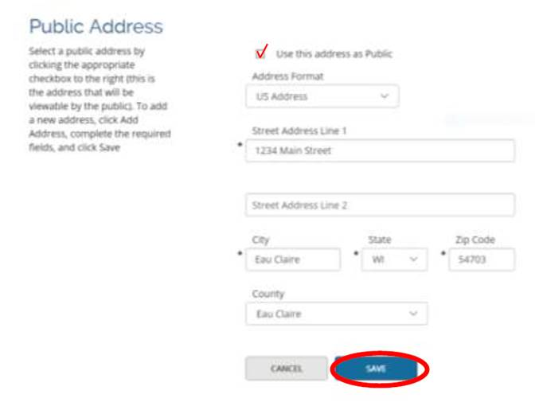
2. Enter in your Average Number of Employees and Total Hours Worked.
3. Enter the total number of cases for each category. **Please note: The Total Number of Cases must equal the Total Number of Injury and Illness Types reported.**
4. Enter the total number of days for each category.
5. Enter the total number of Injury and Illness Types for each category. **Please note: The Total Number of Injury and Illness Types must equal the Total Number of Cases reported.**
6. You can print your submitted report by selection **Options** and choosing **Print Report**

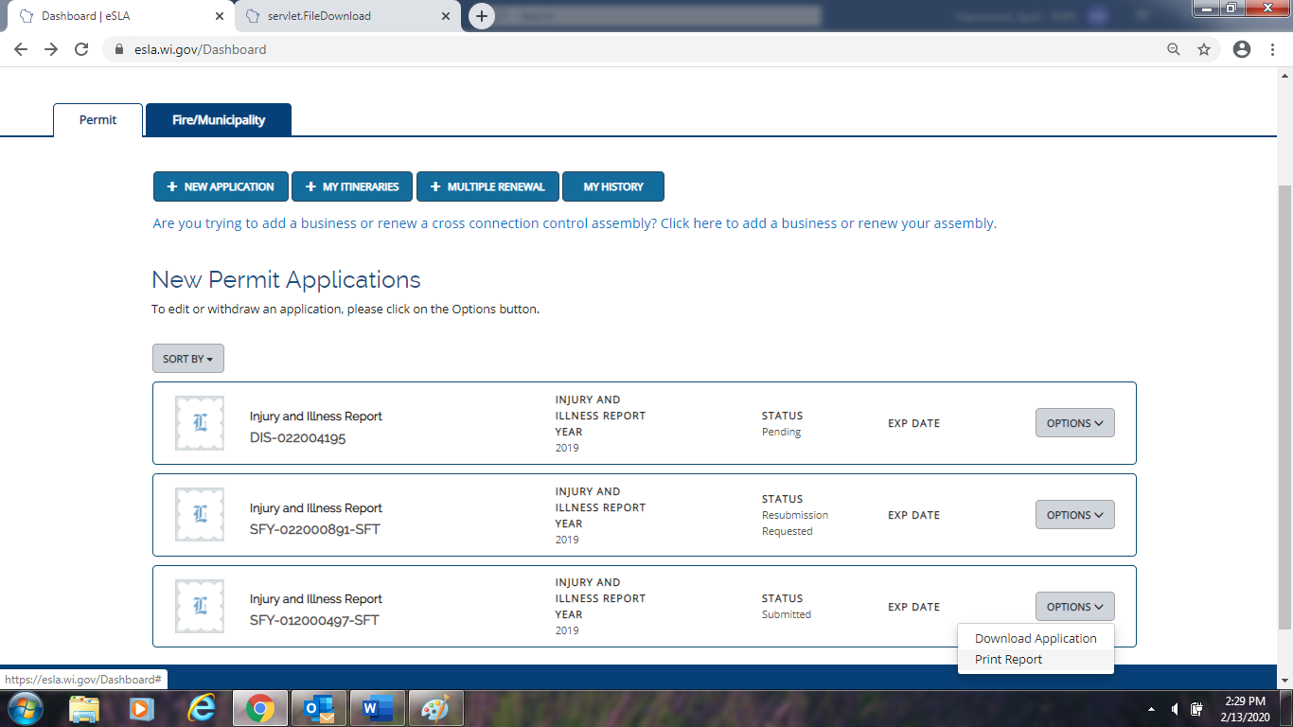

Please reach out for any other questions.