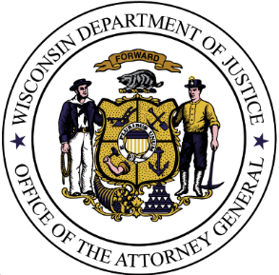
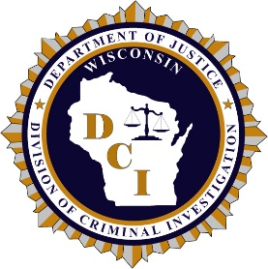
Wisconsin Department of Justice
Division of Criminal Investigation (DCI)

21-4849: New Berlin OID
Michael P. Wolski

Download Link: https://widoj.sharefile.com/d-s1ecfcf00e2ec494daf90fe49310c3bf5

Photographs:
- 21-4849 – 1 Helm Inspection
- 21-4849 – 6 Schingten Inspection
- 21-4849 – 8 Morris inspection
- 21-4849 – 11 Hendricksen Inspection
- 21-4849 – 21 Halliday Inspection
- 21-4849 – 29 Crossroads Church 20210622
- 21-4849 – 29 Crossroads Church 20210623
- 21-4849 – 29 Crossroads Church North lot 20210622
- 21-4849 – 29 Crossroads Church North lot 20210623
- 21-4849 – 32 WSCL Photos
- 21-4849 – 37 Residential Photos
- 21-4849 – 44 Romenesko Inspection

Audio/Video Recordings:
- 21-4849 – 29 Crossroads Church 062221 2055 hrs
- 21-4849 – 29 Crossroads Church 062221 2157 hrs
- 21-4849 – 29 Crossroads Church 062221 2200 – 2300 hrs
- 21-4849 – 29 Crossroads Church North Lot 2055 hrs
- 21-4849 – 29 Crossroads Church North Lot 2158 hrs
- 21-4849 – 29 Crossroads Church North Lot 2159 – 2300 hrs
- 21-4849 – 38 NBFD Radio
- 21-4849 – 39 911 call
- 21-4849 – 39 NBPD Dispatch

