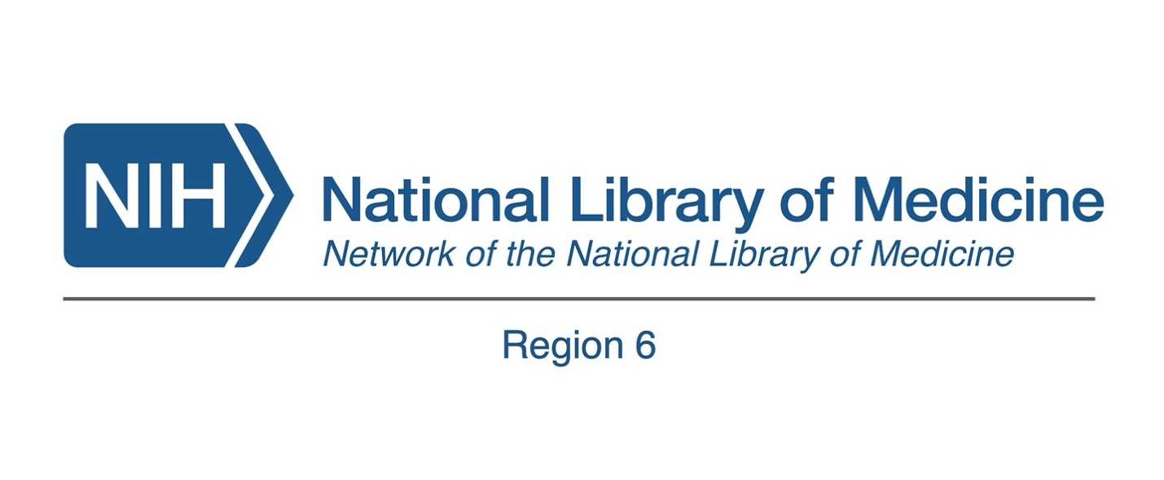
- Name
- Email address
- Stakeholder Advisory Group members must live and/or work in the state for which the advisory group serves. For which state are you applying?
- Illinois
- Indiana
- Iowa
- Michigan
- Minnesota
- Ohio
- Wisconsin
- Please indicate what type of organization or professional role you represent.
- State library
- Public health
- Public library
- Health professional
- health sciences / hospital library
- nonprofit / faith-based
- Other (please specify)
- Which of the following underrepresented populations / areas does your organization serve? Please check all that apply.
- Children (0-12 yrs.)
- Teens (13-18 yrs.)
- Adults (19-64 yrs.)
- Seniors (65+ yrs.)
- LGBTQIA+
- Women
- Rural
- Suburban
- Urban
- HIV/AIDS
- Maternal Health
- NIH Helping to End Addiction Long-term (HEAL) Initiative
- Opioids
- Vaping
- Socioeconomically Disadvantaged Populations
- Alaska Natives
- American Indians
- Asians/Asian Americans
- Blacks/African Americans
- Hispanics/Latin Americans
- Native Hawaiians
- Other Pacific Islanders

Please answer the following questions in 1,000 characters or less
- Why do you want to serve on the State Advisory Group?
- Please describe any experience you have participating in NNLM programs
- What experience, if any, do you have performing outreach to underserved or underrepresented populations/areas?
- What strengths will you bring to the State Advisory Group?
- Is there anything you would like to add?
- Please upload your C.V.
- By submitting this application, I attest that I have reviewed the SAG Charter and will contribute actively to the Charge through April 30, 2026.

