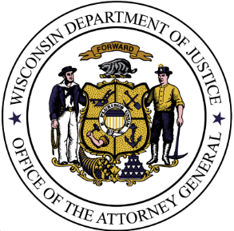
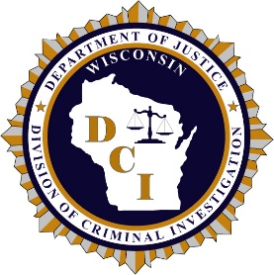
Wisconsin Department of Justice
Division of Criminal Investigation (DCI)

21-862: Village of Kewaskum OID
Nicholas S. Pingel

RELATED DIGITAL RECORDS FOR PUBLIC RELEASE

Download Link: https://widoj.sharefile.com/d-s66f434c47f9d4ffe8548b154daed87a2
Photographs:
- 21-862 – 6 Drone Photos
- 21-862 – 6 Mapping Photos Thursday
- 21-862 – 6 Mapping Photos Wednesday
- 21-862 – 6 PIX 4D
- 21-862 – 6 WSCL Photos LL
- 21-862 – 6 WSCL Photos PT
- 21-862 – 10 Miller Inspection
- 21-862 – 11 Seibel Inspection
- 21-862 – 12 Gonzalez Inspection
- 21-862 – 15 Anderson Inspection
- 21-862 – 16 Goodman Inspection
- 21-862 – 19 Uhan Inspection
- 21-862 – 20 Martinez inspection
- 21-862 – 21 Ausloos Inspection
- 21-862 – 23 Thompson Inspection
- 21-862 – 24 Ball Inspection
- 21-862 – 36 Shotgun Casing
- 21-863 – 39 Jones Inspection
- 21-862 – 40 Vanderheiden Inspection

Audio/Video Recordings:
- 21-862 – 6 DJI_0545
- 21-862 – 6 DJI_0546
- 21-862 – 6 DJI_0548
- 21-862 – 6 DJI_0552
- 21-862 – 6 DJI_0553
- 21-862 – 6 DJI_0833
- 21-862 – 6 DJI_0834
- 21-862 – 37 Larson Body Cam
- 21-862 – 37 Squad 1 front
- 21-862 – 37 Squad 1 rear
- 21-862 – 37 Squad 2 front
- 21-862 – 37 Squad 2 rear
- 21-862 – 48 Inspire DJI_0015
- 21-862 – 54 911 Call 1
- 21-862 – 54 911 Call 2
- 21-862 – 54 911 Call 3
- 21-862 – 54 Radio 1
- 21-862 – 54 Radio 2
- 21-862 – 54 Radio 3
- 21-862 – 54 Radio 4
- 21-862 – 54 Radio 5
- 21-862 – 54 Radio 6
- 21-862 – 54 Radio 7

