Registration Instructions for WIC/FHV Nutrition Webinars
Registration will be completed at the Minnesota Department of Health (MDH) Learning Center. Each individual staff member will need to log in or follow the instructions to create their own account and register for the WIC/FHV Nutrition Webinars.
Please note: MDH moved to a new learning platform on Oct. 20, 2020. If you had an account on the previous MDH learning center platform your account information was copied to the new system however, your old password will need to be reset. When logging on to the new system, you will get a login error; simply click on “forgot password” to reset your previous password.
Step 1: Click on the instruction page for information on how to create an account on the MDH learning center:
Minnesota Department of Health (MDH) Learning Center (Instructions Page) (https://www.health.state.mn.us/about/tools/learningcenter.html)
Step 2: Click on the Login Screen image to create an account in the MDH learning center:
MDH LMS-My Absorb (login-on page) (https://minnesota.myabsorb.com/#/login)
Step 3: Log on to the MDH learning center and search for “WIC”, you should see the WIC/FHV Nutrition Webinar registration there.
Search “WIC”
Step 4: Complete your registration for the webinar by clicking “Enroll” below the Session(s) information. This will enroll you in the event.
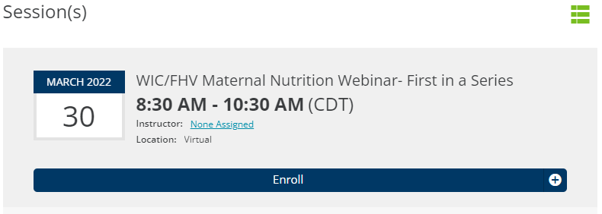
Questions: Please contact Carole Kelnhofer at carole.kelnhofer@state.mn.us
Minnesota Department of Health - WIC Program 85 E 7th Place, PO BOX 64882, ST PAUL MN 55164-0882; 651-201-4444, wic.health@state.mn.us, www.health.state.mn.us; To obtain this information in a different format, call: 651-201-4444

