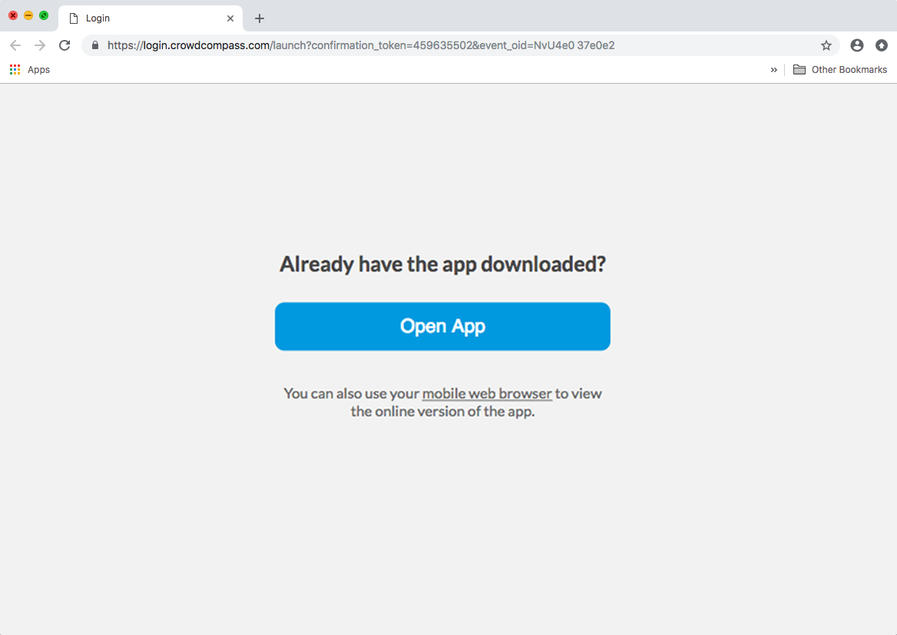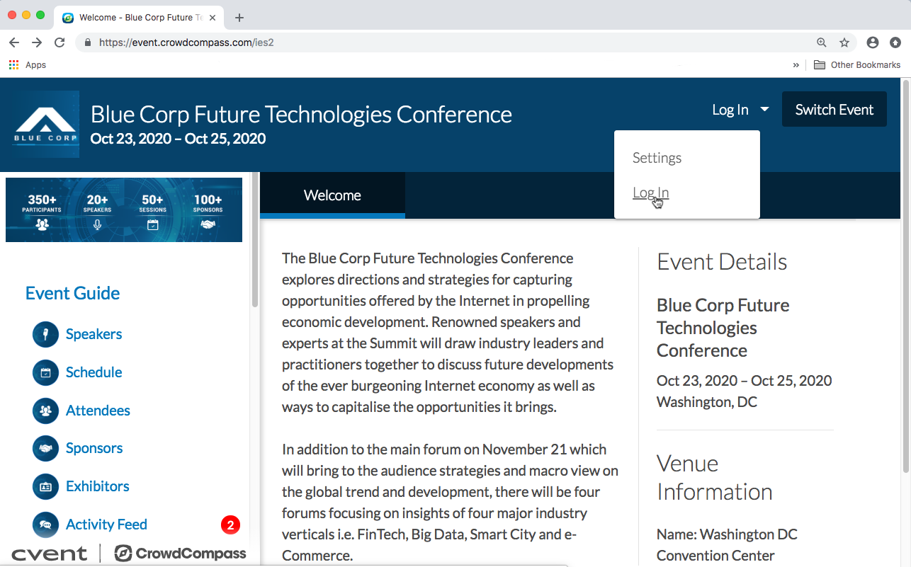

**1 Open the OEG.** Access the web version of the app using this URL: *[Enter your event’s URL here. Found in the Marketing Resources section of the EventCenter]*. Click **Log in** in the top right, then **Log In** once again from the dropdown.

**2 Enter your deets.** Enter your first name, last name, and email address. Then tap **Next**. We’ll send you an email or text message to verify your account. We just want to make sure it’s you.

**3 Verify your account.** Access your verification email or text message. You’ll see it includes your six-digit verification code.

Return to the log in page and enter the verification code, then tap **Verify** to log in.

**Through a URL**

**1 Open your invitation email.** Access your invitation on the device that you plan to bring to the event.

Tap **Verify Account**.

**2 Activate your account.** Underneath the Open App button, click **mobile web browser** to complete the verification via the Online Event Guide.

**Through the invitation**

**Logging In Via the Web**