WhatsApp
Installation Guide

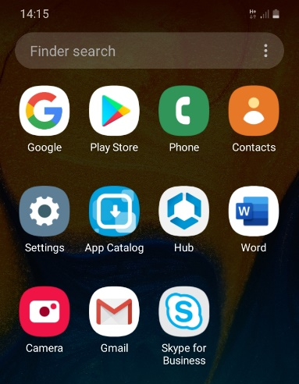
Step 1 – Opening the Play Store: Unlock your phone and select the Play Store Application. If you are unable to find the Play Store search ‘Play Store’ in the Finder search.

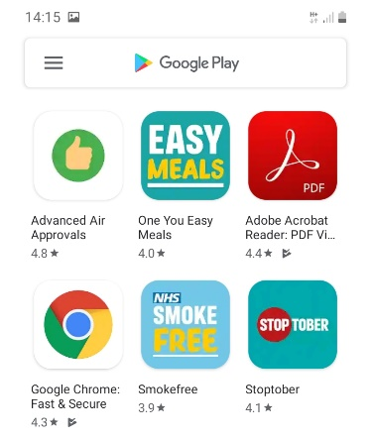
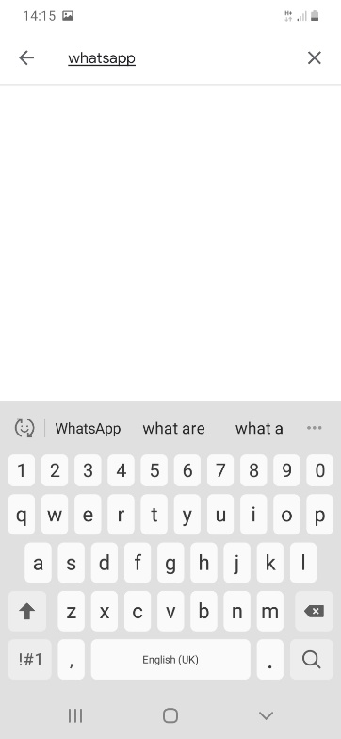
Step 2 – Searching for WhatsApp: When you are in the Play Store, select the three horizontal lines in the top left of the first picture. Type ‘whatsapp’ and search by selecting the magnifying glass on your keyboard (shown in second picture).

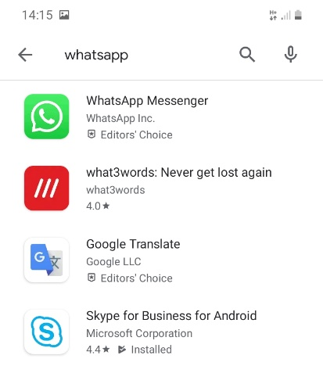
Step 3 – Selecting WhatsApp: Once you have searched WhatsApp, the first option should look like the application in the picture across.

Step 4 – Installing WhatsApp: Click on the WhatsApp application and it will take you to the option to install. Click the Install button and it will start to install the app onto your mobile phone. Please note, you may be prompted to enter a Google account password upon app installation. This password is Gm@1I#12

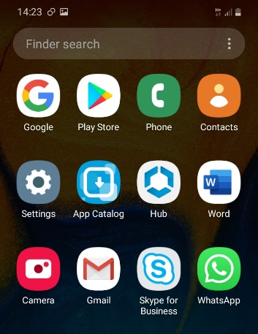
Step 5 – How you know it’s installed: Once you have completed Step 4 you will be able to see WhatsApp on your phone screen.

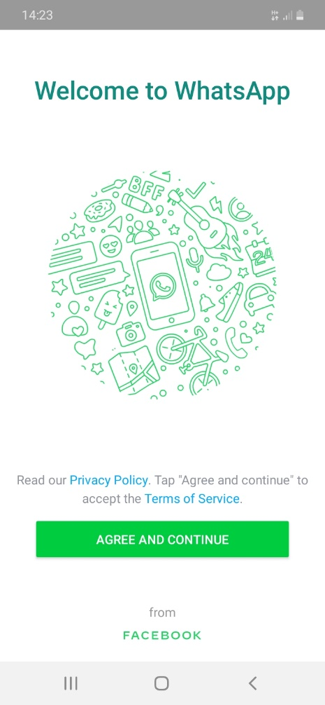
Step 6 – Setting up WhatsApp: WhatsApp requires you to set it up to work on your phone. If you click on the WhatsApp application, you will see this screen. To move onto the next step, click ‘Agree and Continue’.

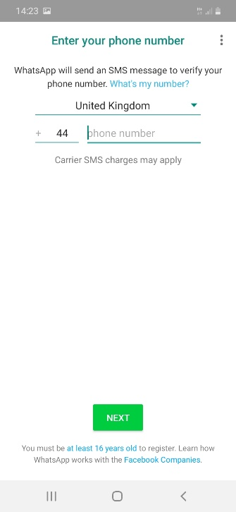
Step 7 – Setting up WhatsApp continued: After you have selected Agree and Continue you will need to input your work phone number. Once you have inputted your number select ‘next’.

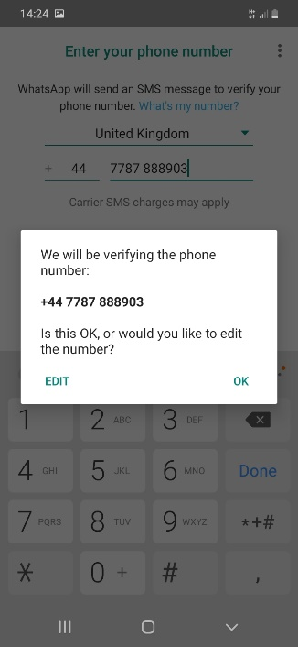
Step 8 – Inputting your number continued: Once you click next you will be prompted to check the number you have inputted. If you are happy with this select ok, if not select edit and repeat Step 7.

Step 9 – Setting up WhatsApp continued: After you have completed Step 8 this pop up will appear. Select ‘NOT NOW’.

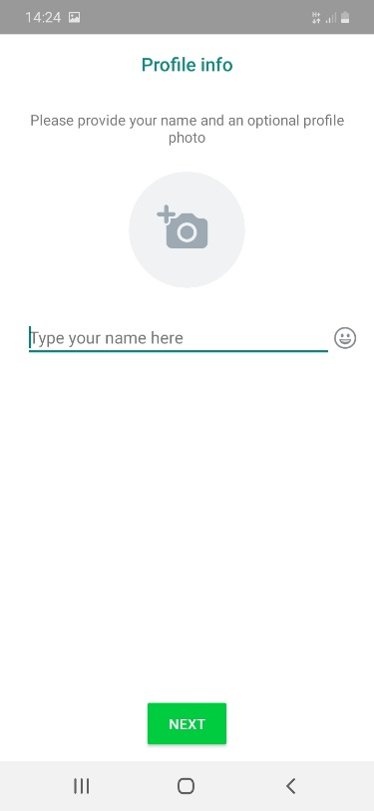
Step 10 – Setting a profile name: For colleagues to be able to see who is messaging in WhatsApp you are able to input your name. This makes it easier when talking in group chats. Type your name and then select ‘next’.

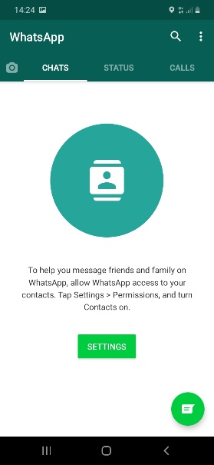
After you have completed Step 10 you are now set up and ready to start using WhatsApp. To start messaging a colleague click on the speech bubble in the bottom left.

Queries and Support
If you do experience any issues in setting up WhatsApp, please run through this guide again. If the issue still persists, please contact the Service Desk on 01228 226000.

