Registering for VPN

To enable you to work from home you need to register a device with Google Authenticator. To do this follow the below instructions.

- Go on to InTouch via Internet Explorer and click on the Favourites at the Star in the top right hand corner.
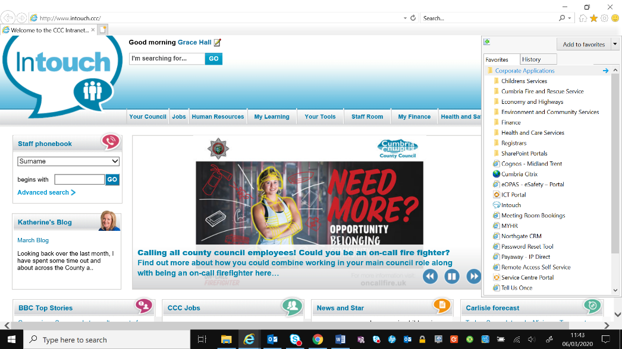

- Once you have clicked on Favourites you then need to click on Corporate Applications.

- Once you have clicked on Corporate Applications you then need to scroll down until you see Remote Access Self Service and click on here.

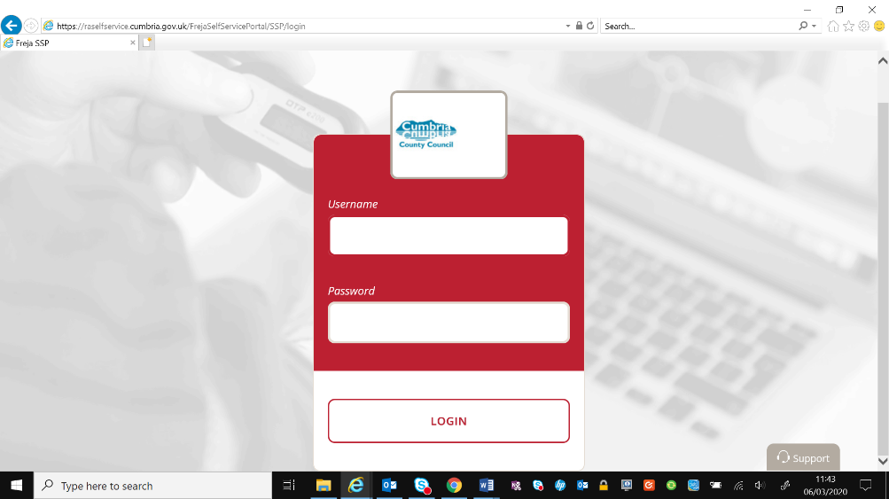
- You will then get a log in page, you need to enter your username and password that you use to access your laptop and click on login.

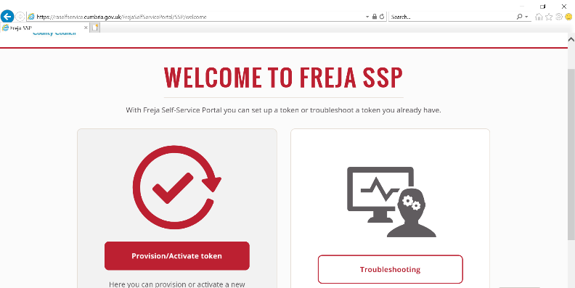
- Once you have logged in you will then get 2 options. You need to click on Provision/Activate Token.

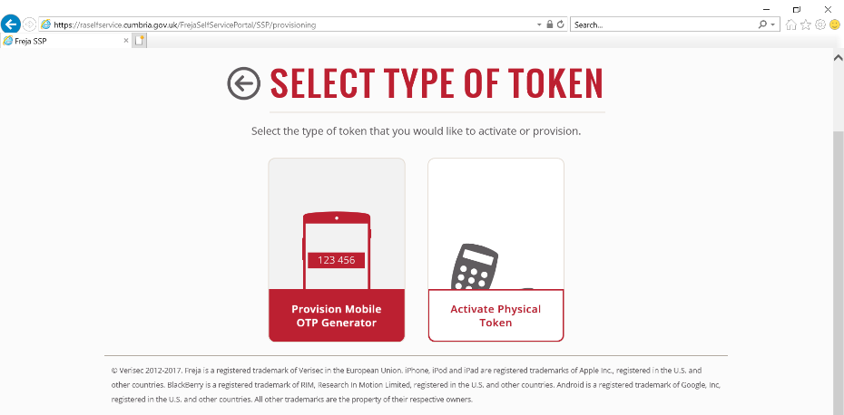
- You then need to select the token you have. If you are using a mobile phone you need to click on Provision OTP Generator.

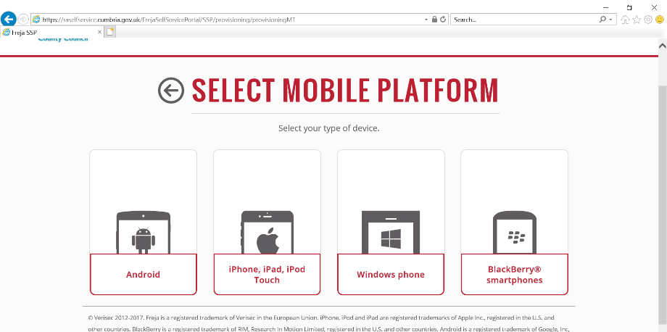
- You then need to click on the kind of device you are using. If your CCC mobile is a Samsung you need to click on Android, if on the top of your phone it says Microsoft you need to click on Windows Phone.

- You will then get the below screen. You need to think of a 4 digit number you be able to remember and enter this in New Pin and Confirm Pin. Next you will need to open the Authenticator App on your phone to complete the remaining box.
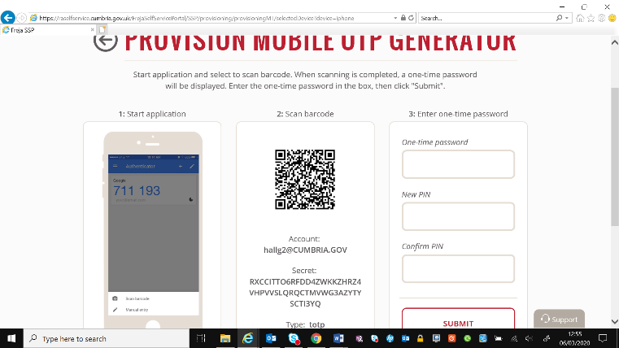

- You will need to start up the Authenticator App on your phone and follow the instructions on your phone.
You will then have a generated number you need to put into One Time Password on your laptop.
Tap on Scan Barcode and take a picture of the barcode on your screen.

Tap on begin.
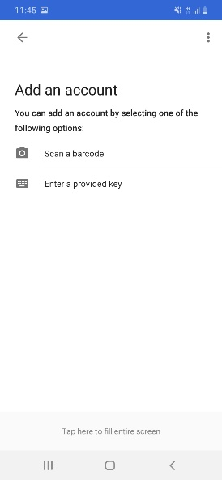
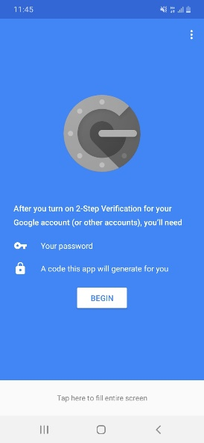

- Once you have done this click on Submit and you will get a confirmation message saying it has been done.

