Frequently asked questions about the updated national self-isolation guidance
A member of staff or pupil has COVID-19. How long should they isolate for?
The national guidance on the isolation period for people who test positive for COVID-19 has been updated. This guidance applies to all staff, children and young people who usually attend an education or childcare setting.
Anyone who tests positive for COVID-19 must complete a period of self-isolation. Their isolation period starts immediately from when their symptoms started, or, if they do not have any symptoms, from when their positive LFD or PCR test was taken, whichever test was taken first. Their isolation period includes the day their symptoms started (or the day their test was taken if they do not have symptoms), and the next 10 full days.
Under the new guidance, people now have the option to end their self-isolation period early (from day 7) if they receive 2 consecutive negative LFD tests, taken at least 24 hours apart. This process is summarised below:
- They can take an LFD test on the sixth day of their isolation period, and another LFD test 24 hours later, on day 7. If both these test results are negative, and they do not have a high temperature, they may end their isolation immediately after the second negative test result.
- If an LFD test is positive, they must continue to isolate and wait a further 24 hours before taking the next LFD test. They can take further tests on subsequent days during their isolation period – days 7, 8, 9 or 10.
- If two of these LFD tests taken 24 hours apart on consecutive days are negative, they can leave self-isolation immediately after the second negative result if they do not have a high temperature. Daily LFD testing can then stop.
A helpful flow chart, taken from the national guidance is shown below.
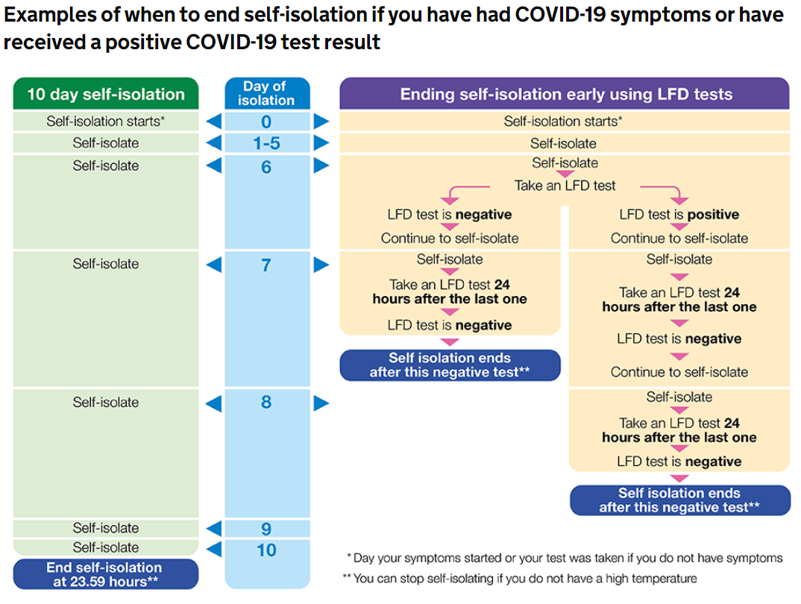
For example, if the person who has tested positive reports that their symptoms started at any time on the 15th of the month (or if they don’t have symptoms, the first positive COVID-19 test was taken on the 15th), they may take an LFD test on the 21st and 22nd (24 hours apart). If the LFD test results are negative on the 21st and 22nd, and they do not have a high temperature, they may end their isolation period after the negative test result on the 22nd.
Anyone who is unable to get LFD tests during their isolation period, or who does not want to use them, should complete 10 full days of isolation.
Anyone who initially does not have symptoms, but is isolating because of a positive test, who then goes on to develop COVID-19 symptoms within their isolation period, must start a new isolation period from the day their symptoms started.
What are the risks of leaving isolation early after two negative LFD tests?
National modelling suggests that a 7-day self-isolation period, when combined with 2 consecutive negative LFD tests starting on day 6 and taken 24 hours apart, has nearly the same effect as a 10-day self-isolation period without LFD testing.
After 10 days self-isolation, 5% of people will still be infectious. Ending self-isolation after 7 days and two negative LFD tests results in a similar level of protection. The two negative test results are critical to safely supporting the end of self-isolation up to day 10, as per the national guidance. If self-isolation ended on day 7 without LFD testing, modelling suggests that 16% of people would still be infectious.
What if the staff member or pupil with COVID-19 does not want to conduct LFD tests from day 6, or cannot get hold of any?
This additional LFD testing is optional. Anyone who is not able, or does not want to, take the option of additional LFD testing from day 6 of the isolation period should complete 10 full days of isolation. They do not need to have a negative LFD test to leave isolation if they have completed their 10 full days of isolation.
Anyone who still has a high temperature after 10 days, or who is otherwise unwell should stay at home and seek medical advice.
Does the new guidance on ending isolation early with two negative LFD tests apply to children under the age of 5?
Yes, the new guidance applies to children under the age of 5. However, LFD testing may not be appropriate for very young children, and it should be carried out at the discretion of the parent or guardian.
Do settings need to see proof of negative LFD tests?
Staff, children, and young people should report any LFD test results on the national website. Education settings are not required to ask for proof of negative lateral flow tests before allowing people to return to the setting.
Are there any changes to the isolation period for contacts of cases?
The recent changes to the national guidance on isolation periods apply only to people who have tested positive for COVID-19. The self-isolation period for unvaccinated contacts of positive cases remains unchanged.
The national guidance says that people with COVID-19 who want to end isolation early (after two negative LFD tests), should try to limit their contact with other people. How does this apply to education settings?
Under the national guidance, those who end their self-isolation period before 10 full days are strongly advised to:
- limit close contact with other people outside their household, especially in crowded, enclosed or poorly ventilated spaces,
- work from home if they are able to,
- wear a face covering in crowded, enclosed or poorly ventilated spaces and where they are in close contact with other people,
- limit contact with anyone who is at higher risk of severe illness if infected with COVID-19,
- follow the guidance on how to stay safe and help prevent the spread.
It is suggested that this advice is followed until 10 full days after the isolation period started.
However, it is acknowledged that it will not be possible for some staff, children, and young people to follow all this advice if attending their education setting.
We know that LFD tests are very good at identifying people who have high levels of coronavirus and are most likely to pass on infection to others. Therefore, the risk of children and staff still being infectious if they have two negative LFD tests after day 6 of their isolation period is low.
Education settings should continue with their baseline measures to prevent the spread of COVID-19. These include:
- Encouraging vaccination for eligible staff and students
- Supporting twice weekly LFD testing for staff and secondary school age children who don’t have symptoms
- Encouraging staff and children to adhere to respiratory and hand hygiene measures
- Encouraging the use of face masks as per the national guidance
- Ensuring adequate ventilation
- Maintaining appropriate cleaning regimes
We have provided an information sheet about a useful interactive tool that may help settings to visualise the different ways in which COVID-19 can be spread and how a combination of control measures can reduce the risk. This will be shared on the Cumbria County Council webpage.
What if the LFD test on day 10 is still positive?
The national guidance says that even if people have a positive LFD test result on the 10th day of their self-isolation period, they should not take any more LFD tests after this day. They can leave self-isolation once they have completed 10 full days of isolation if they don’t have a high temperature.
The guidance suggests that if there are concerns about people leaving self-isolation because of a positive LFD test on day 10, people could choose to adhere to the following advice until 14 days after the start of their self-isolation period:
- limit close contact with other people outside their household, especially in crowded, enclosed or poorly ventilated spaces,
- work from home if they are able to,
- wear a face covering in crowded, enclosed or poorly ventilated spaces and where they are in close contact with other people,
- limit contact with anyone who is at higher risk of severe illness if infected with COVID-19,
- follow the guidance on how to stay safe and help prevent the spread.
However, it is acknowledged that it may not be possible for some staff, children, and young people to follow all this advice if attending their education setting. This may be particularly relevant to staff and children in early years and primary school settings.
Therefore, if education settings are aware of staff or students who have a positive LFD test on day 10 of their isolation period, and they are concerned about them returning to the setting the next day, a risk assessment should be undertaken. This should consider the ability of the individual to follow the advice above, and the implications for safe staffing levels if they don’t return.
If the risk is considered to be high (for example if the individual is unable to limit close contact with others), settings may choose to ask the individual to stay at home and continue to take daily LFD tests up until day 14 of the isolation period. Once a single negative LFD test result is received, they can return to the setting immediately, and stop daily LFD testing. This is the approach taken for health and social care staff. However, it is not enforceable; if the individual wants to return to the setting after completing 10 full days of isolation, they are able to do so. Anyone who is still self-isolating on day 14 can return to the setting on day 15 and should not continue daily LFD testing after this point. This is because they are very unlikely to be infectious. They are advised to wait at least 7 days before resuming routine twice weekly LFD testing (if applicable).
Alternatively, settings may feel that the risk of the individual returning to the setting after 10 full days of isolation is low (for example, if they are able to maintain a 2-metre distance from others). In this case, they can return to the setting with appropriate mitigation measures.
If settings require support with their risk assessments, they should contact the EIPC team.
Should staff and pupils routinely LFD test if they have previously tested positive via PCR within the past 90 days?
The guidance has now changed and staff (across all educational settings) and students in secondary schools and colleges who have tested positive via PCR can now restart routine LFD testing within 90 days of their positive PCR test.
This is in addition to any LFD testing carried out during the isolation period. It is suggested that twice weekly LFD testing re-commences around 14 days after the positive PCR test.
A PCR test is only required during the 90 days following a positive PCR test result if the individual
- develops new symptoms of COVID-19
- is advised to get a PCR test by NHS Test and Trace
- is required to take a PCR test upon entry into the UK
- receives a positive LFD result on routine testing (for example during twice weekly LFD testing or if they are LFD testing because they are a household contact of a positive case).

