McNair Elementary & McNair Upper
Arrival and Dismissal Procedures

One of the most important things we do at both McNair ES and McNair Upper ES is to ensure the safety of our students, families, and staff during arrival and dismissal. To help us develop procedures for all students at both schools, we worked with FCPS’ Office of Safety and Security to design routes for arrival and dismissal that keep safety at the forefront. Below are the procedures for our McNair Community. Please make sure to read them carefully and to follow established routes for the safety of all!

I Plan to Drive My Child to School.
The parking lot between the elementary and upper buildings will be blocked off during school hours (8:00 a.m. - 4:00 p.m.) to prevent cut-through traffic. Parents who plan to use Kiss & Ride at either school must register for a Kiss and Ride tag. Information about how to obtain one will be fanned out in a News You Choose message to families. Families can also register for one at Open House. Registration facilitates dismissal at both schools. Here is the link to register to use our Kiss and Ride:
https://forms.gle/9EDLD6XSh2HqSQak8 or scan here with your mobile device:

It’s important to note that Kiss & Ride takes time. Plan thoughtfully and arrive in a timely manner to ensure your child arrives at school to begin his/her school day on time. The Kiss & Ride procedures are as follows:

McNair Elementary (Kindergarten-2nd Grades) Only:
Enter the Kiss & Ride lane from Thomas Jefferson Drive. Loop around the school and follow the directions of staff. You will be directed to pull forward and a staff member will open the door for your child when it is time to be released from the car. To maintain safe entering and exit from vehicles, your child must be seated on the passenger side of the car as they will exit from the right side only. Please ensure your child is prepared to buckle/unbuckle their seatbelt independently. Parents must stay in their vehicles at all times. Please wait for staff directions before letting students exit the vehicle. Kiss & Ride cars will exit right onto Thomas Jefferson Drive.

Please remember to not pass cars in the Kiss & Ride lane unless a staff member directs you to do so and to refrain from using your cell phone. With over 1300 students arriving at both school campuses at the same time, all attention should be focused on the procedures for safety.

Preschool based programs participate in a hand-to-hand arrival and dismissal routine. This means that preschool aged families wishing to provide transportation for their child need to utilize any street parking and cross-walks in order to walk to meet their child’s teacher at the front of the building. This ensures the safety of all of our students and families during arrival and dismissal each day.

McNair Upper (Grades 3-6) Only
Enter the Kiss & Ride from Fox Mill Road by taking a right- or left-hand turn. Loop around the school and follow the directions of staff. You will be directed to pull forward and a staff member will open the door for you child when it is time to be released from the car. To maintain safe entering and exit from vehicles, your child must be seated on the passenger side of the car as they will exit from the right side only. Parents must stay in their vehicles at all times. Kiss & Ride cars will exit onto Fox Mill Road by taking a right- or left-hand turn. This will keep Kiss & Ride traffic running smoothly.

Please remember to not pass cars in the Kiss & Ride lane unless a staff member directs you to do so and to refrain from using your cell phone. With over 1300 students arriving at both school campuses at the same time, all attention should be focused on the procedures for safety.

If you use the kiss and ride loop to drop off your child, please do not park your car in a parking spot and walk them up to our school doors to drop them off or pick them up from school. Vehicles attempting to leave during arrival and dismissal cause an unnecessary disruption to the flow of our kiss and ride process.

Families with Students at BOTH McNair Elementary and McNair Upper (Grades K-6)
Enter the Kiss & Ride from Fox Mill Road by taking a right- or left-hand turn. Loop around the school and follow the directions of staff. You will be directed to pull forward and a staff member will open the door for you child when it is time to be released from the car. To maintain safe entering and exit from vehicles, your child must be seated on the passenger side of the car as they will exit from the right side only. Parents must stay in their vehicles at all times. Kiss & Ride cars will exit onto Fox Mill Road by taking a right- or left-hand turn. This will keep Kiss & Ride traffic running smoothly.

Once dropped off, students in grades K-2 will follow staff directions and walk down to McNair Elementary and enter Door 4 by the cafeteria.

McNair Upper students will follow staff directions and walk to the upper school and enter Door 6.

Please refer to the McNair Kiss & Ride map below: 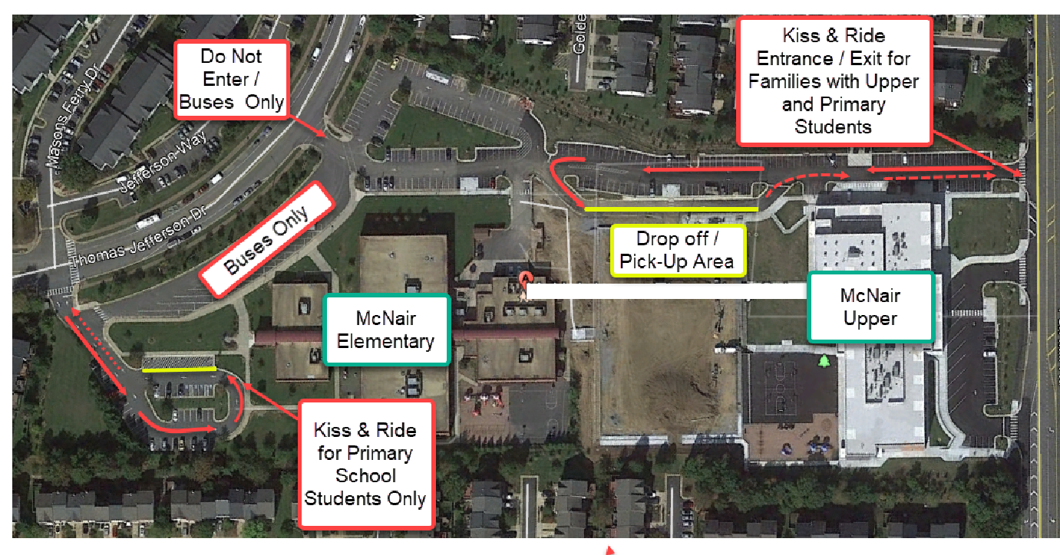

I Plan to Walk My Child to School
When walking to school, please use the designated crosswalks at both McNair Elementary and McNair Upper. It may be tempting to cross the street at convenient points, but that does not teach our young Mustangs safe crossing procedures. It is important to model safe crossing procedures for all students. Walking between cars, buses, and up the hill among bushes and trees creates a safety hazard. Moving cars, buses and other vehicles may not notice you and a serious injury may occur.

Walking students will enter and exit the building at Door 2 at McNair Elementary on the side of the building.

Walking students will enter and exit the building at Door 1 at McNair Upper.

My Child Rides a FCPS School Bus or a Daycare Van to School
All students at both McNair Elementary and McNair Upper who ride a school bus or daycare van to and from school will use the bus loop at McNair Elementary.

Bus riders and daycare riders will enter and exit the building at Door 2 at McNair Elementary on the side of the building.

Bus riders and daycare riders will enter and exit the building at Door 6 at McNair Upper.

Other Important Considerations for Parents
- Decide on arrival and dismissal plan and stick to it. Frequent switching confuses students and staff. Consistent routines are most supportive of our students.
- Staff will be present on both school campuses during arrival and dismissal to support students to safely arrive at class on-time.
- School Hours: 8:45 a.m.- 3:30 p.m.
  - Doors open for students at 8:35 a.m.
  - Students must be at their desks at 8:45 a.m.
  - Students arriving after 8:45 a.m. will be considered tardy.
    - Regular school attendance is important for the academic and social/emotional wellbeing of all students. This includes arriving to class on time. Absences and late arrivals are monitored by our Multi -Tiered System of Supports Team (MTSS) and a team member will reach out if additional information is needed or a plan for support would be beneficial.
    - Frequent tardiness or absences from school will be reported to the FCPS Attendance Officer and a plan will be developed to ensure student on time arrival.
- Dismissal Is At 3:30pm
  - All students are dismissed directly from their classroom with their teacher.
  - Bus riders and daycare riders will dismiss at 3:30 p.m.
  - Kiss and Ride students will be dismissed out of door #1 which is located at the front of our school.
  - Walkers will dismiss out of Door #2, which is located on the side of the building near the bus loop.
  - We will have a staggered dismissal starting with Kindergarten, First Grade, and finally Second Grade.
  - All pre-school aged students are dismissed at Door #1. Pre-school aged students will either ride the bus or be met, hand-to-hand, with their teacher and guardian.

- Posted Parking Signs
  - We kindly ask that you park in parking spots that do not have reserved or special parking signs. This includes handicapped signs; unless you have a DMV-issued handicap decal, administration parking, "Teacher of the Week" parking, and parking space reserved for other designated McNair Staff or FCPS county vehicles. We ask that parents and guests to our building park in either the visitors’ spaces or unmarked spaces. In turn, we ask that teachers do not park in visitors’ spaces; and leave those spots available for parents and guests to our school building. If the front parking lot is full, there is plenty of additional parking available in the side parking lot of the school.

- The front parking lot will be utilized for ONLY Kiss and Ride traffic during arrival and dismissal. The side parking lot is closed during arrival and dismissal due to safety and bus traffic.

