Coronavirus (Covid-19)

Things to do if you are staying at home
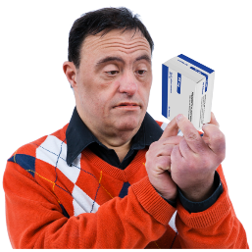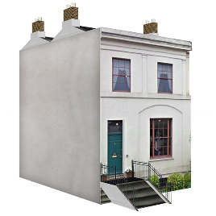 | If you have a learning disability and health conditions  To keep you well from Coronavirus  You should stay home and away from busy places as much as you can
Some people have been told to stay at home and not go out at for 14 days

Because they may have the virus or know someone who has

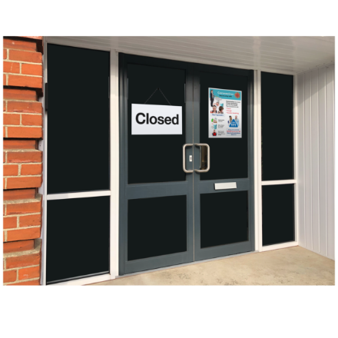 | Daycentres, drop-ins and groups are closed  Cinemas, Pubs and Libraries are closed too
 | Here are some things you could do while you are staying at home
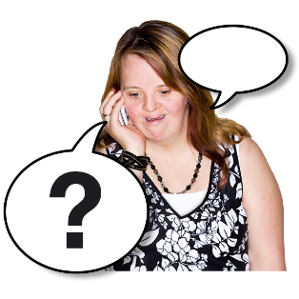 | Talk to people  Talk to someone every day
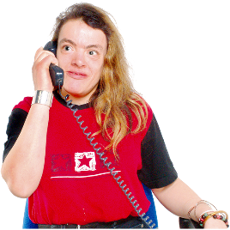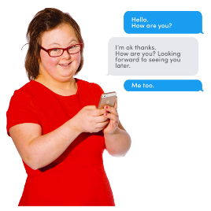 | Phone or text a friend or family
 | Use Facebook or FaceTime to talk to your friends or family
Use WhatsApp to video chat send a message or pictures with friends.

A group of friends and family can talk on WhatsApp.

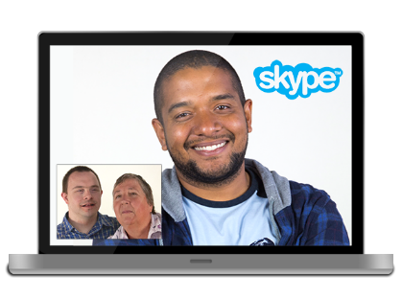 | Skype your friends or family
Use FaceTime, Skype, WhatsApp to
have a coffee and a chat with friends, you could listen to music together.

 | Ask a support worker to phone you
 | Things to do
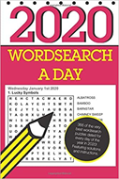 | Word searches
 | Read a book
 | Colouring and art
Gig Buddies
Coronavirus Fest

Live music and acts to keep us all entertained

https://www.facebook.com/coronavirusfest/
 | Listen to the radio and music
 | Watch, television and films
 | Play games
 | Exercise
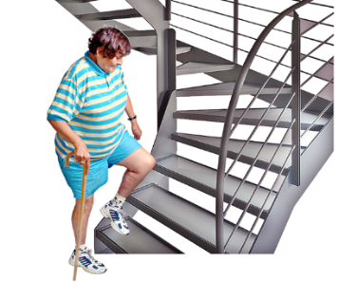 | Exercise in your house  Go up and down the stairs  Use food tins as weights
 | Dance to music
 | Take part in Joe Wicks online fitness class each morning on YouTube
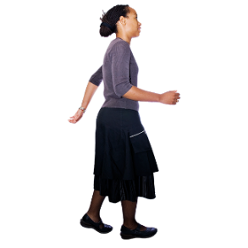 | Go for a walk, by the Sea or in a Park  You need to keep distance from other people
 | Food Shopping
- Can you ask someone to get food for you, or have it delivered?

Big, supermarkets have quiet times just for people with learning disabilities, older people and people with health conditions.

- Medication

- Make sure you have enough medication, or a way to get it.

Some chemist will deliver to your door if you ask them.

 | - Make a plan
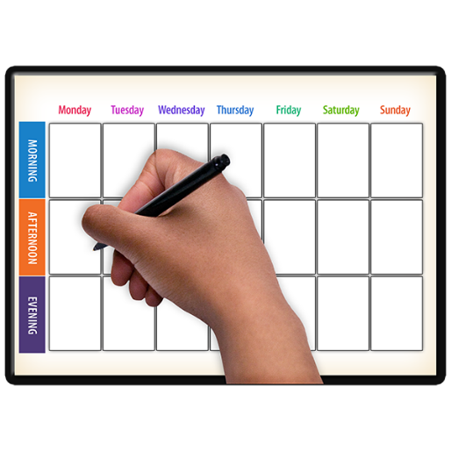 | - Make a list of things to do and people to talk to

Adapted from:
https://www.mind.org.uk/information-support/coronavirus-and-your-wellbeing/#PlanForStayingAtHomeOrIndoors

Based on easy read information from Brighton and Hove Council and adapted for West Sussex residents.

Things are changing very quickly so if you can, phone services to check the information in this leaflet is correct.

In addition, the information does not constitute a recommendation or endorsement of any organisation, resource or website listed.

