Connecting to a Wireless Network and VPN

Guidelines

Organisational Development & Workforce Training
Version: 5.0

Quick Guide
For those simply needing an aide memoir
- Turn on your laptop where you wish to work
- Connect to the local network
- When the VPN padlock on the taskbar changes to have a moving spikey line through it …
  - Right click on the padlock icon and select ‘disconnect
  - Right click on the padlock icon and select ‘connect’
- When the Endpoint Security window is displayed
  - Enter your username (if already displayed simply click on connect)
  - The initialisation stage will begin
  - Activate the passcode generator on your chosen device to obtain the six digit passcode
- When the authentication box is displayed
  - Enter your 4 digit pin code followed by the 6 digit one time code in the same box

Note:
It is advised when you are logged in using VPN that you do not change your password as you will be unable to log back in when using VPN. A Service Desk call will be required to fix this issue. Passwords should be changed when you connect to the network in CCC office using Wi-Fi or cable connection.

Connecting to a Wireless Network (WiFi)
When you first connect to the CCC network from home, the following steps will guide you through the process.
- From the Taskbar click the Network icon
- A list of available Wireless Network Connections is displayed. Select your home connection then the Connect button
- Enter your home network security key and click the OK button
- You are now connected to your home network. The next step is to connect to the County Council network using VPN.
Note:
The above steps will only happen the first time you connect to your home network. The laptop will recognise your network in the future and automatically connect.

Connecting to the CCC Network through VPN

Once you have connected to your Wi-Fi network, the next stage is to remotely connect to the Council’s network; this will allow access to the Council’s intranet/internet, emails and other programs.
This access is via a program called VPN – Virtual Private Network, which will connect you securely to the Council’s network.

Note:
There is no need to use VPN if you are in a Council environment, only when you are NOT connected to the Council network.

- From the icons on the right of the Taskbar right click on the padlock and from the menu select Connect To…. option
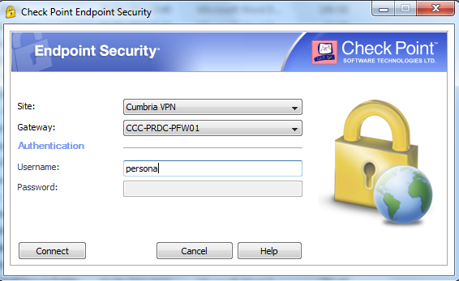
- The Endpoint Security window is displayed
  - By default the Gateway CCC-PRDC-PFW01 is shown. If there are issues connecting using this gateway, a backup option is available. From the drop down menu select CCC-FSHQ-PFW01, but the default option should always be used in the first instance.
    - Enter your username into the username field – this is only required the first time, after this your username will be displayed
  - Click Connect button.
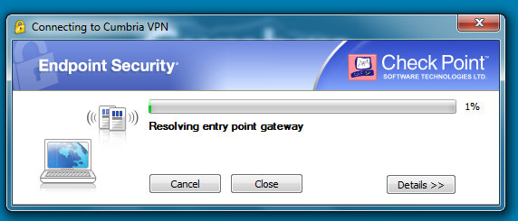
  - The window will update to show access progress.
- Once connection has been made you will need to validate yourself before access is given to the systems – this is through Secure Password (2 factor authentication).
- Another box will appear showing:
Authenticating user ‘persona’. Please fill the required input.
- The response is a composite number formed from your pin number followed by your six digit one time passcode
- Activate the passcode generator on your chosen device to obtain the six digit passcode. This passcode number will remain for 30 seconds, if you fail to enter the number within this time a new number is automatically generated.
- Click the Connect button again. The padlock will show a way line through it denoting that you are connecting to the network
- When you are connected there will be a small green ball displayed on the padlock on the taskbar
- You are now connected to the Cumbria County Council network. You can open MS Outlook to send and received emails, browse the internet and access all your files online.
- Please note that if you are connected for over 8 hours you will be prompted by the system to confirm you wish to remain connected. This is achieved by simply entering another 10 digit passcode, formed by your 4 digit pin number followed by a NEW 6 digit passcode.

Disconnect from VPN

Once you have completed your work on the CCC network you MUST ensure all programs are closed down before disconnecting from VPN then Wi-Fi

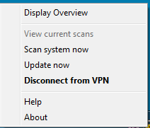
- Right click on the padlock on the taskbar
- From the menu select Disconnect from VPN
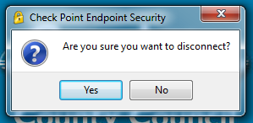
- Confirm you wish to disconnect
- You can now Shut Down your laptop.

