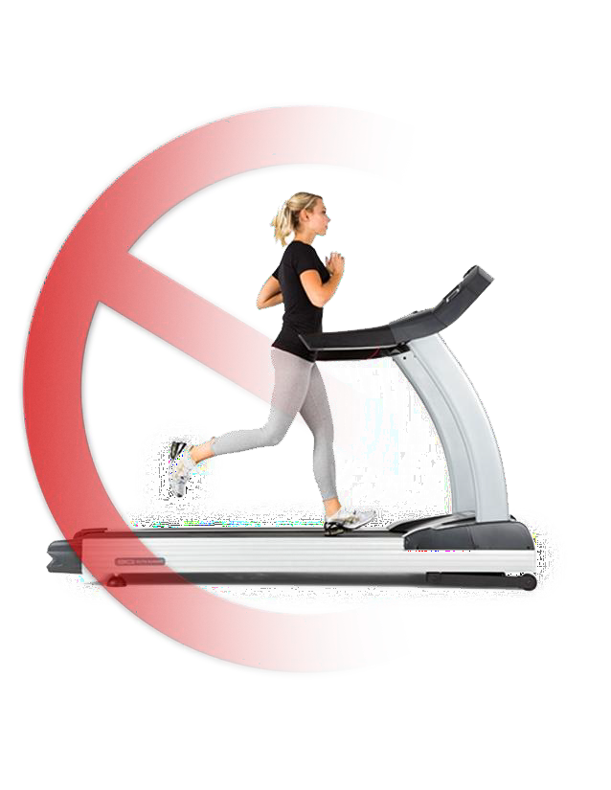
RECREATION CENTERS and POOLS
PHASE IN PLAN

Recreation Re-Opening Plan and Protocols

Background:
There are a tremendous number of resources available to guide the re- opening of recreation facilities and programs. Many of them conflict as to timeline and safety precautions, which has made putting a plan together difficult. President Trump and Governor Herbert’s plans are very fluid. Utah State Legislature has offered a more aggressive timeline, and as always, we are required in some instances to operate under a Local Health permit. With all of that in mind, below is listed a phase in program for opening Orem recreation facilities. We
will use Governor Herbert’s color terminology to describe the specific phases.

Re-opening protocols:
Included are specific protocols that will need to be put in place to keep staff and patrons safe. The facilities and programs listed are the ones that are
anticipated to open during Governor Herbert’s stabilization phase. And like most things surrounding this pandemic, this list is fluid and undoubtedly will change.

PHASED OPENING STRATEGY
Senior on-line classes

Red
Remain at current level of operation
Orange (Moderate Risk):
Parks:
Skate Park, Dog Park, Futsal, Pickle ball, tennis, pavilions, and park bathrooms with specific recommendations.
Adult and Accelerated Sports:
Refer to protocols
Fitness Center (Cardio/weights): Refer to protocols
Yellow (Low Risk):
Parks:
Playgrounds
Youth Sports and programs:
Refer to protocols
Outdoor Pools:
Appropriate protocols are being designed and will be ready when Utah/Orem reaches this stage of stabilization and we resolve the current pool issues.
Fitness Center (Classes): Refer to protocols

Green (Normal Risk):
Senior Center Adaptive Sports

Child care
Splash Pad

FAMILY FITNESS CENTER RE-OPENING PROTOCOL
 | Moderate Risk | Low Risk
General | 20 people per group | 50 people per group
 | Open to current pass holders only | Open to current pass holders only
 | 1 person per 120 square feet | 1 person per 120 square feet
 | Staff will practice social distancing, 6 feet apart. | Staff will practice social distancing, 6 feet apart.
 | Equipment will be moved or blocked, floor will be marked to encourage patrons to maintain a  10-foot distance. | Equipment will be moved or blocked, floor will be marked to encourage patrons to maintain a 6-  foot distance.
 | Staff shall instruct patrons to disinfect all equipment after each use. Staff shall also clean and disinfect all equipment  each hour. Staff shall post signage with cleaning schedule in effect. | Staff shall instruct patrons to disinfect all equipment after each use. Staff will disinfect all equipment every 4 hours or as needed. Staff shall post signage with cleaning schedule in effect.
 | Make cleaning supplies available throughout the establishment and post signs encouraging patrons to clean all equipment before and after  use. | Make cleaning supplies available throughout the establishment and post signs encouraging patrons to clean all equipment before and after  use.
 | Employees must go through symptom checking before every shift, including temperature. | Employees must go through symptom checking before every shift.
 | Employees must wear face  coverings; patrons will be encouraged to wear face coverings. | Employees and patrons will be encouraged to wear face coverings.
 | Staff will be asked to wear gloves for certain job duties. Center may consider providing gloves or recommend patrons wear gloves. | Staff will be asked to wear gloves for certain job duties. Center may consider providing gloves or recommend patrons wear gloves.
 | Patrons who choose not to comply  with disinfecting policies will be asked to leave. | Patrons who choose not to comply  with disinfecting policies will be asked to leave.
 | Patrons who are ill cannot enter  facility. | Patrons who are ill cannot enter  facility.
 | Signage will be posted to discourage high risk from utilizing facility | Signage will be posted to discourage high risk from utilizing facility
 | No live classes will be taught, fitness or aquatic
Front Desk | Cough screen will be installed and utilized.. | Cough screen will be installed and utilized.
 | Signage will be posted encouraging patrons not to touch or lean on counters.
 | Staff will be required to wear gloves. | Staff will be required to wear gloves.
 | Equipment and high touch surfaces will be disinfected every hour and between shifts. Staff will not share equipment during their shift. | Equipment and high touch surfaces will be disinfected regularly and between shifts. Staff will not share equipment during their shift.
 | Minimize transfer of paper including registrations, credit card slips, money, etc. no passes will be activated, day pass only. | Minimize transfer of paper including registrations, credit card slips, money, etc. no passes will be activated, day pass only.
 | Staff will not share equipment during their shift. | Staff will not share equipment during their shift.
 | Color coded disinfectant bottles will be checked out to ensure the correct number of patrons in each area | Color coded disinfectant bottles will be checked out to ensure the correct number of patrons in each area
 | No cash transactions allowed. | Cash transactions allowed.
Classes | Limit class size based on location to remain six feet apart  Eliminate use of equipment difficult  to clean and disinfect.  Water Fitness Class Size: Limit class  size to maintain 10' distancing.  Clean and disinfect after each class or as needed. | Limit class size based on location to remain six feet apart.  Eliminate use of equipment difficult  to clean and disinfect.  Water Fitness Class Size: Limit class  size to maintain 6' distancing.  Clean and disinfect after each class or as needed.
Cardio/Weight room | Cleaning for cardo weight room equipment may need to be more frequent depending on use. Staff may choose to keep these areas closed if staffing level is inadequate to conduct more frequent cleaning as needed.
 | Select equipment will be made available. | All equipment will be made available.
 | Patrons must maintain 10 foot  distance. | Patrons must maintain 10 foot  distance
Equipment may be moved to
enforce social distancing.
Disinfecting spray will be made available to all patrons
Large Main rooms | 25 people per class including employee | 25 people per class including employee
 | Eliminate use of equipment that is  difficult to sanitize. | Eliminate use of equipment that is  difficult to sanitize.
 | Patrons must maintain 10 foot  distance. | Patrons must maintain 6 foot  distance.
Restrooms | All high-touch surfaces will be cleaned every hour or as needed. Staff should post signage for patrons to notify staff if more frequent cleaning is needed. | May be opened if local health department protocols allow. All high-touch surfaces will be cleaned every hour or as needed. Staff should consider posting signage for patrons to notify staff if more frequent cleaning is needed.
Locker Rooms/Changing  Rooms | Closed. | May be opened if local health department protocols allow.  All high touch surfaces will be cleaned every hour or as needed.
Employee Safety | Lifeguards and other employees will need to be protected in cases of rescue. All precautions should be taken to protect the employee if they need to engage in a rescue, CPR or mouth to mouth resuscitation. | Lifeguards and other employees will need to be protected in cases of rescue. All precautions should be taken to protect the employee if they need to engage in a rescue, CPR or mouth to mouth resuscitation.
Fitness Studio | No classes taught, individual workouts | No classes taught, individual workouts
 | Eliminate equipment that is difficult to sanitize. | Eliminate equipment that is difficult to sanitize.
 | Patrons must maintain10 foot distance. | Patrons must maintain10 foot distance.
Child Care | Closed | Open if the facilities can meet cleanness standards
Gymnasium | Patrons must maintain 6-foot distance
 | Pickleball allowed for singles games only | Pickleball game allowed, both singles and doubles.
Basketball/ Racquetball/ Other group sports | Closed- Exceptions may be made for small groups that live in the same household | Open following local health department protocols  Clean every hour or as needed
Swim pools | Pools can open for lap swimming only. Only one person will be allowed per lane. No open swim or free play.  Train pool staff including lifeguards on protocols and any changes and modifications in protocols when rendering assistance to patrons | Pools are opened at a capacity that enables 6’ social distance to be maintained at all times  6’ social distancing is maintained on pool deck and in pools  Lap swimming resumes to normal capacity  Swim team and swim lessons are allowed as long as social distancing is allowed on pool deck  Train pool staff including lifeguards on protocols and any changes and modifications in protocols when rendering assistance to patrons
Pool Deck | Nobody allowed on the deck. If they are in the swimming area, then they will need to be in the pool. Chairs, benches and tables will be roped off. No outside seating will be allowed to be brought in. If lap swimming is done as part of a swimming team, coaches may be allowed on the deck, but should practice social distance protocol | Patrons can be on the deck but will need to be six feet apart
 | Nobody allowed on the deck. If they are in the swimming area, then they will need to be in the pool. Chairs, benches and tables will be roped off. No outside seating will be allowed to be brought in. If lap swimming is done as part of a swimming team, coaches may be allowed on the deck, but should practice social distance protocol | All high touch surfaces will be cleaned every hour or as needed.
 |  | Lessons available.
Track | Open with signs with social distancing requirements | Open with signs with social distancing requirements
Lounge areas | All equipment spaced 10-foot distance | All equipment spaced 10-foot distance
 | Patrons must maintain 6-foot distance. | Patrons must maintain 6-foot distance.
 | Equipment may be moved to enforce social distancing | Equipment may be moved to enforce social distancing
 | Cleaning Supplies will be provided for patrons to disinfect before and after each use. | Cleaning Supplies will be provided for patrons to disinfect before and after each use.

PROGRAMS RE-OPENING PROTOCOL
 | Moderate Risk | Low Risk
Adult Softball | Limit spectators. Must maintain 10' distance. Use signs for reminder. | Encourage physical distancing. Must maintain 6' distance. Use signs for reminder.
 | (50 or less Participants) Not including staff at facility per field.
Accelerated Softball | Require player/teams to disinfect equipment. | Require player/teams to disinfect equipment.
 | Each player (or coach) gives name and number to scorekeeper  through the fence. | Each player (or coach) gives name and number to scorekeeper  through the fence.
 | No high fives at end of game or during the game. | No high fives at end of game or during the game.
 | Spread out - players in the dugout, along fence line, in islands, stands, behind the backstop, etc. | Spread out - players in the dugout, along fence line, in islands, stands, behind the backstop, etc.
 | Exit field immediately after game | Exit field immediately after game
 | Encourage high-risk players to stay  home. | Encourage high-risk players to stay  home.
 | Scorekeeper in stands (for first inning) to get lineup card - eliminates players and staff  handling same lineup | Scorekeeper in stands (for first inning) to get lineup card - eliminates players and staff  handling same lineup
 | Gloves and sanitizer available for staff; masks recommended | Gloves and sanitizer available for staff; masks recommended
 | Staff will wipe down score controller, speaker, and time clock  after use | Staff will wipe down score controller, speaker, and time clock  after use
Third Party Sport Leagues | Cancel. | Work with organization to ensure proper operation of leagues is  viable.
Youth Sports | Postpone | Coach reads line up to scorekeeper through the fence.
 |  | No high fives at end of game or during the game.
 |  | Spread out - players in the dugout, along fence line, stands, etc.
 |  | Exit field immediately after game
Encourage high-risk players to stay
home.

Gloves and sanitizer available for
staff; masks recommended
Staff will wipe down score controller
after use
Require player/teams to disinfect
equipment.
Classes | Limit class size based on location. | Limit class size based on location.
 | Eliminate use of equipment difficult  to clean and disinfect. | Eliminate use of equipment difficult  to clean and disinfect.
 | Water Fitness Class Size: Limit class  size to maintain 10' distancing. | Water Fitness Class Size: Limit class  size to maintain 6' distancing.
Fishing | Postpone | Staff/volunteers wear gloves &  masks
 |  | Clean all supplies regularly
Encourage participants to bring their own poles. Assign poles to kids (who don’t have their own) and label them so they are using the
same equipment each time
One staff/volunteer in charge of handing out and getting back
equipment
More one on one/less group activities - eliminate large group lesson at the beginning of each
class
Eliminate end of program “fish fry”
if restrictions are still in place
Maintain 6ft distance (needed for
casting anyway)
Catch and release - no keeping fish
(instructors will let the fish go)
Track & Field | If our program can't start in May, we will need to cancel. Coaches aren't available later and other clubs who we complete with aren't  postponing

