INfluenza (flu) Outbreak
Detection & management
Guidelines for Schools and Daycare Centers

Contents

Influenza Outbreak Response and Reporting………………………………………………………………………………….………pg. 2 Outbreak Detection: Influenza in Schools and Day Care Centers……………………………………………………………. pg. 3
Appendices:
- Respiratory Illness Line List…………………………………………………………………………………………………………… pg. 4
- Specimen Collection Guidelines …………………………………………………………………………………………………… pg. 6
- Influenza Fact Sheet …………………………………………………………………………………………………………………….. pg. 7
- Letter for parents and guardians regarding influenza outbreak………………………………………………….…. pg. 8
- Letter for teachers with medically fragile students……………………………………………………………………….. pg. 9
- Cleaning and Disinfecting……………………………………………………………………………………………………………… pg. 10
- Cover Your Cough Posters……………………………………………………………………………………………………………...pg. 12
- Outbreak Prevention: Vaccination Promotion...……………………………………………………………………………. pg. 13
- Influenza Background and Definitions.…………………………………………………………………………………………. pg. 14
High-risk populations
Transmission
Symptoms
Treatment
- Additional Resources and Information.…………………………………………………………………………………………. pg. 15

Outbreak Response and Reporting
Sometimes so many people are out a school can’t function and may decide to shut down. In general, public health is not going to ask a school to close its doors and is available to help control the outbreak. Follow the steps below to help prevent the spread of illness among students and staff.
 | Tasks | Reference
 | Detect the presence of a potential outbreak  A confirmed or suspected influenza outbreak = 20% or more students with influenza like illness (ILI) within 72 hours.  ILI = fever + (cough or sore throat) | Review Outbreak Prevention and Detection
Notify
Notify the Local Health Department (LHD) within 24 hours. LHD will confirm the presence of an outbreak.
 | Track  Collect cases’ symptom profiles and identifier using the case log. | Appendix 1
 | Specimens  Encourage ill people to visit their healthcare provider for testing.  SBHC should attempt to send at least 2 specimens to the LHD for laboratory confirmation. 2 positive swab samples are needed to confirm an outbreak. | Appendix 2
 | Educate  - Distribute Influenza Background sheet to teachers and staff and parents. Ensure all are aware of the outbreak, what symptoms to look for and how to keep germs from spreading.  - Distribute Influenza outbreak letter for parents and guardians.  - Distribute Influenza outbreak letter for teachers with medically fragile students. | Appendix 3  Appendix 4  Appendix 5
 | Control Measures  - Have students stay home for 24 hours after fever is gone without using fever reducing medicines (e.g., Advil or Tylenol) and keep a distance from healthy people.  - Deep clean bathrooms and frequently touched surfaces.  - Enforce strict hand washing (supervised hand washing for younger students) and ensure access to alcohol-based hand sanitizer and sinks with soap.  - Consider limiting visitors.  - Post Cover your Cough Posters. | Appendix 6  Appendix 7
Ending an Outbreak
- Work with LHD to maintain and review the Flu Outbreak Case Log.
- The outbreak is over 8 days after the last case developed symptoms.
 | Next Steps  Outbreaks are an excellent time to promote vaccination!  Additional information is also available. | Appendix 8  Appendix 9

Outbreak Detection
Outbreaks happen in schools and daycare centers when more students and staff are out sick than expected. When many people are sick, it’s important that we take steps to keep the sickness from spreading. This toolkit is intended to be used for outbreaks of respiratory illness and influenza, or flu.
Oregon Administrative Rule 333-018-0000 requires that all outbreaks of any disease be reported to and investigated by the Local Health Department (LHD). An outbreak is defined as more cases than expected for a given population and time period.
Influenza-like illness (ILI) is defined as fever + (cough or sore throat).
A suspected influenza outbreak = 20% or more students in the same classroom with influenza like illness (ILI) or, if more widespread, 20% of the school or daycare facility within 72 hours.

If fewer than 20% of your students are ill but some have particularly severe symptoms (such as hospitalizations or physician diagnosed pneumonia), talk with your Local Health Department (LHD)

If multiple children in your facility are absent due to ILI, you may be experiencing an outbreak.

For example, if six children in a 30-person classroom or 60 children in a school of 300 are out sick with fever + (cough or sore throat), it should be reported to your LHD.

Schools and day care centers (DCCs) should encourage staff routinely to record medical reasons for school absences. This allows the school to determine quickly whether absences are due to a similar illness, such as influenza. Collecting this information is especially important during an outbreak.

For a list of county health department contact information, see
http://www.oregon.gov/oha/ph/ProviderPartnerResources/LocalHealthDepartmentResources/Pages/lhd.aspx
For a complete list of reportable diseases, see https://www.oregon.gov/oha/PH/DISEASESCONDITIONS/COMMUNICABLEDISEASE/REPORTINGCOMMUNICABLEDISEASE/Pages/index.aspx

Appendix 1: RESPIRATORY LINE LIST
Name of school or daycare center:
Staff contact: Facility type:
Date: Outbreak number assigned by LHD:
Total no. of students: Total no. of staff:
Please collect the following information for the first 10 students and staff who are out sick with flu-like symptoms. Once complete, cross out the names or identifiers from the line list and submit to the LHD.
On the other side of this form, continue to keep a tally of new onset of illness, each day, until the outbreak ends.
 | Name or  Identifier | Age | Student | Staff | Grade | Onset date | Room number | Fever > 100 F | Cough | Sore throat | Pneumonia | Vomiting | Diarrhea | Bloody stool | Rash | ED visit | Hospitalized | Vaccinated for flu | Lab Confirmed | Other Lab results | Notes
1
2
3
4
5
6
7
8
9
10
Date | Respiratory illness (e.g., Cough, sore throat, runny nose, sneezing, fever) |  | Gastrointestinal illness (e.g., Nausea, vomiting, diarrhea) |  | Other/unknown illness
 | Tally | Total | Tally | Total | Tally | Total
ABSENTEE TRACKING SHEET
Until the outbreak ends, please keep a tally of how many new students and staff are out sick each day, according to symptoms.

Appendix 2: OREGON STATE PUBLIC HEALTH LABORATORY TESTING

To confirm an outbreak of influenza, it is important to get at least 2 positive swab samples.

Here are a couple options for testing and specimen collection:

- Suggest that students and staff who are out sick visit their healthcare providers to be tested for flu. If students have been tested, report positive tests to Local Health Department (LHD)
- Work with Local Health department to:
  - Help school-based health center (SBHC) or school nurse to get a testing kit
  - Have someone from LHD do the specimen collection

Specimens will be tested at the Oregon Public Health Laboratory for free if collected by school or LHD staff.

If the SBHC or school nurse are able to collect specimens, follow the guidelines below.

Specimen Collection Guidelines
Tasks
Collect specimen(s) using nasopharyngeal or oropharyngeal (throat) swabs on a plastic shaft (wooden shaft swabs are not acceptable). Ideally, collect specimens within 3 days of illness onset and not later than 7 days after illness onset.

Detailed instructions: http://www.oregon.gov/oha/PH/LaboratoryServices/CommunicableDiseaseTesting/Documents/np-collection.pdf
Insert swabs into viral transport media. Do not submit a dry swab for testing.
Label each swab with the date of collection; and name and date of birth of the ill person.
Store specimen(s) at refrigerated temperatures pending transport.
If specimen transport cannot occur within 2-3 days of specimen collection, freeze the specimen(s), preferably at -70° C, and ship on dry ice as soon as possible.
Contact the LHD to arrange for pick up and transfer of the specimens to OSPHL.

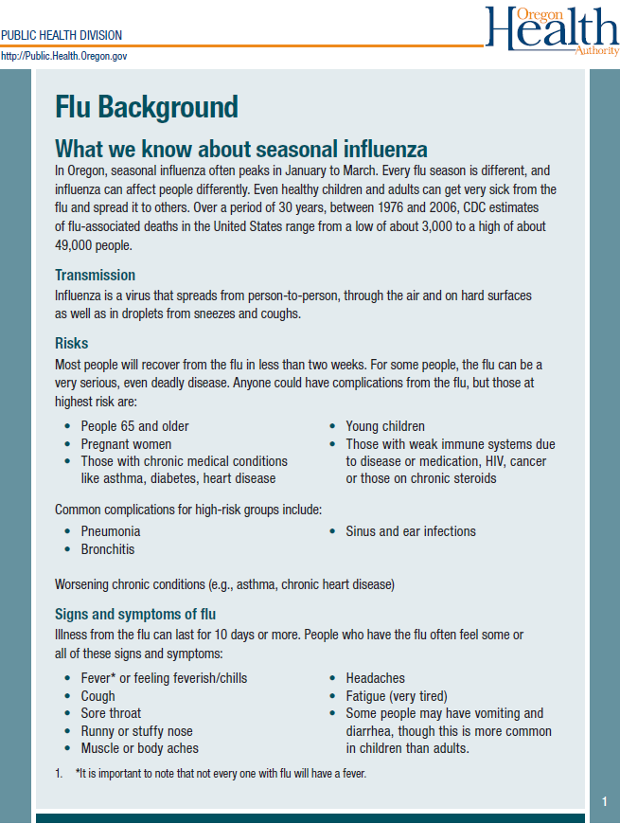
Appendix 3: INFLUENZA BACKGROUND SHEET

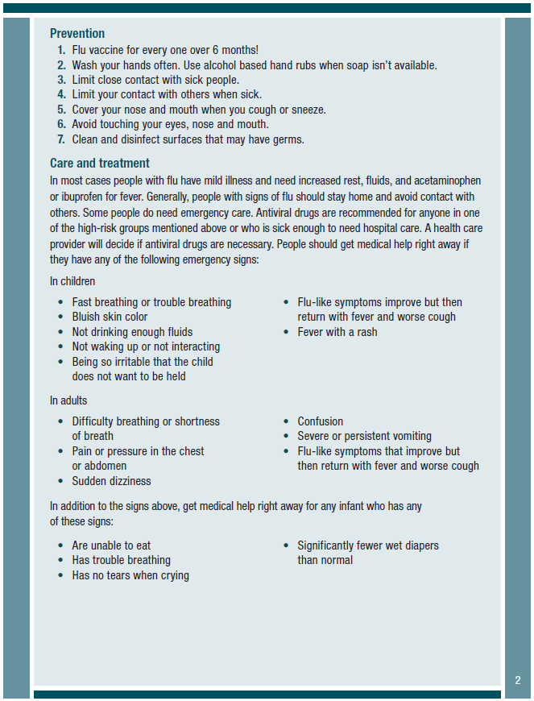Appendix 4: INFLUENZA OUTBREAK LETTER FOR PARENTS AND GUARDIANS

Dear parent or guardian of [insert school/DCC name] student,
Students at [insert school/DCC name] are missing school because they may be sick with influenza or “flu”.
Please keep your student home if they have a fever of 100ºF or higher and a cough or sore throat. Stay home until fever has been gone for 24 hours, without using fever reducing medicines (such as Advil or Tylenol).
If your child is medically fragile and is having flu symptoms, visit your healthcare provider.
They may prescribe antivirals to prevent complications.
If you haven’t already, now is a good time to consider the flu vaccine for your child and others in your home.
For more information about flu, review the Flu Background sheet included with this letter.
If you have any questions, concerns, or need help, please contact [insert county name] at [county phone number].
Thank you,
[Signature line]

PUBLIC HEALTH DIVISION
Acute and Communicable Disease Prevention Section
971-673-1111
ohd.acdp@state.or.us

Appendix 5: INFLUENZA OUTBREAK LETTER FOR TEACHERS WITH MEDICALLY FRAGILE STUDENTS

Dear, [Insert teacher name]
You are receiving this letter because you have one or more students who are medically fragile. As you may have heard, our school/daycare is having an outbreak of influenza or “flu”.
As an educator/caregiver, you play a critical role in preventing and managing outbreaks. Given the increased risk of complications for some of your students, we want you to have the information you need to prevent the spread of influenza.
If your medically fragile students have flu symptoms, encourage the parent or guardian to have the student visit their healthcare provider. They may be prescribed an antiviral medicine.
Please review the Flu Background sheet and the additional information below, encourage preventive actions in your classroom and monitor student illness and absences.
If you have questions, concerns or need help, please contact the school nurse or [insert county name]at [county phone number].
Thank you for your commitment to the health and safety of our students!
[Signature line]

Who is at a higher risk of flu complications?
- Children under the age of 5, especially those younger than 2
- Children with chronic health conditions such as:

- Asthma  - Diabetes  - Neurologic and neurodevelopmental disorders  - Chronic lung disease (such as cystic fibrosis)  - Heart disease | - Blood disorders  - Endocrine disorders  - Kidney or liver disorders  - Morbid obesity  - Metabolic disorders

- Children with suppressed immune systems such as:
  - Children receiving cancer treatment
  - Children with human immunodeficiency virus (HIV)
  - Children on chronic steroid therapy, or
  - Those with other immunosuppressive disorders

PUBLIC HEALTH DIVISION
Acute and Communicable Disease Prevention Section
971-673-1111
ohd.acdp@state.or.us

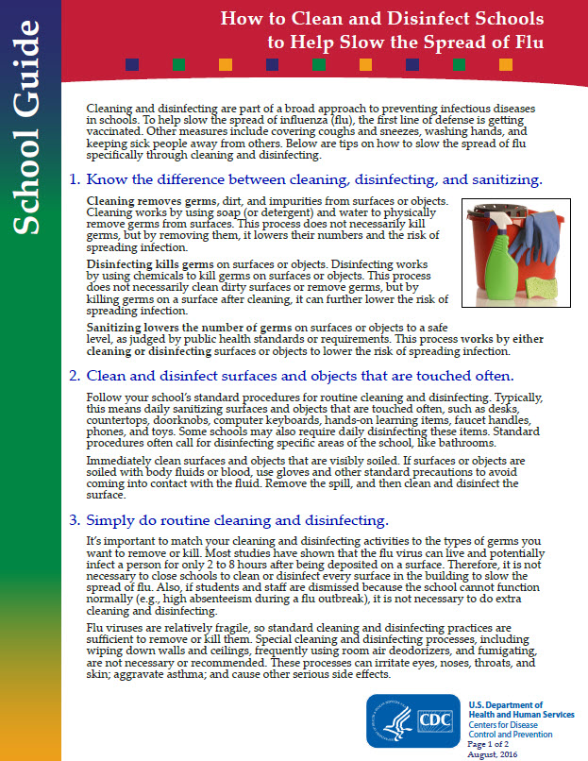
Appendix 6: INFLUENZA CLEANING AND DISINFECTION
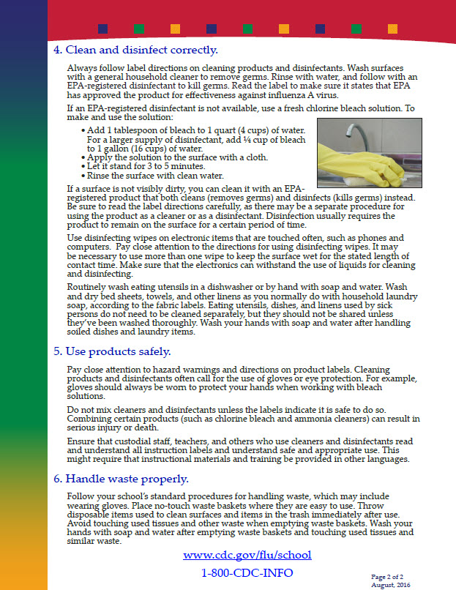

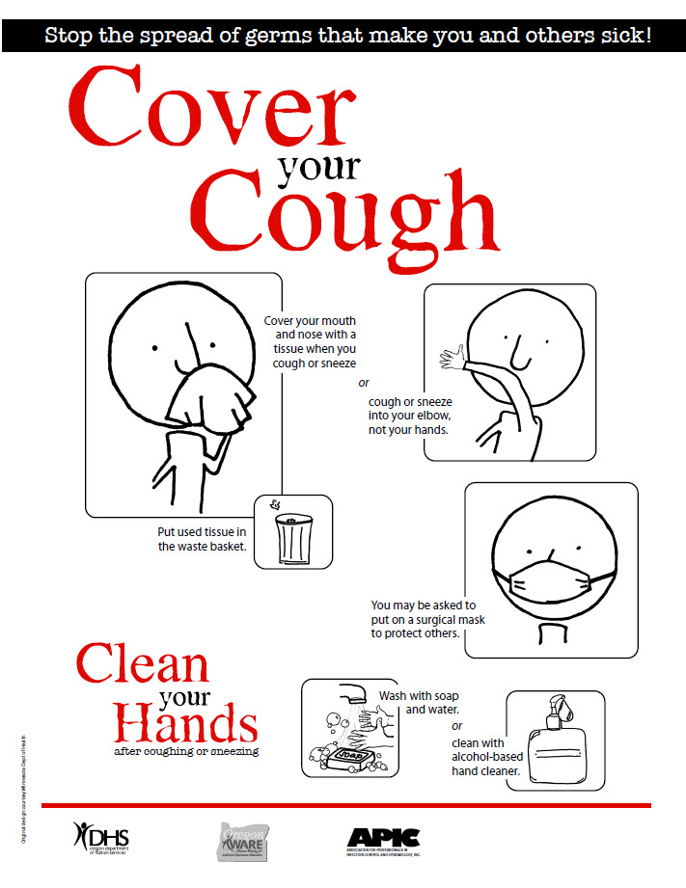
Appendix 7: COVER YOUR COUGH POSTER

Appendix 8: VACCINATION PROMOTION

An outbreak is a good time to remind students and families to get vaccinated. Vaccination is the best method for preventing the flu. The vaccine can keep you from getting the flu, make the illness less severe if you do become sick, and keep you from spreading the flu to family and other contacts.
Sample Social Media Messages
- It’s not too late to get a flu vaccine if you haven’t already! Get a flu vaccine. It is the best and most important action to protect yourself and your loved ones against flu. For more information, visit http://www.cdc.gov/flu/consumer/index.html.
- It’s not too late to get a flu vaccine! CDC recommends everyone 6 months and older get a flu vaccine every year. Flu vaccines are offered in many locations including doctor’s offices, clinics, health departments, retail stores, pharmacies, health centers, as well as by many employers and schools. Find a location near you offering flu vaccines! http://vaccine.healthmap.org/
- Still haven’t gotten your flu vaccine? Even if you have already gotten sick with one flu virus, you can still benefit from vaccination. The flu vaccine protects against three or four different flu viruses, depending on which flu vaccine you get. It’s not too late to get your flu vaccine this flu season. Learn more: http://www.cdc.gov/flu/consumer/vaccinations.htm.
- Symptoms of the flu can include fever, cough, sore throat, runny/stuffy nose, body aches, headaches, chills and fatigue. Some people may also have vomiting and diarrhea. Protect yourself and your family from the flu this year. It’s not too late to get a flu vaccine! http://www.cdc.gov/flu/about/disease/complications.htm

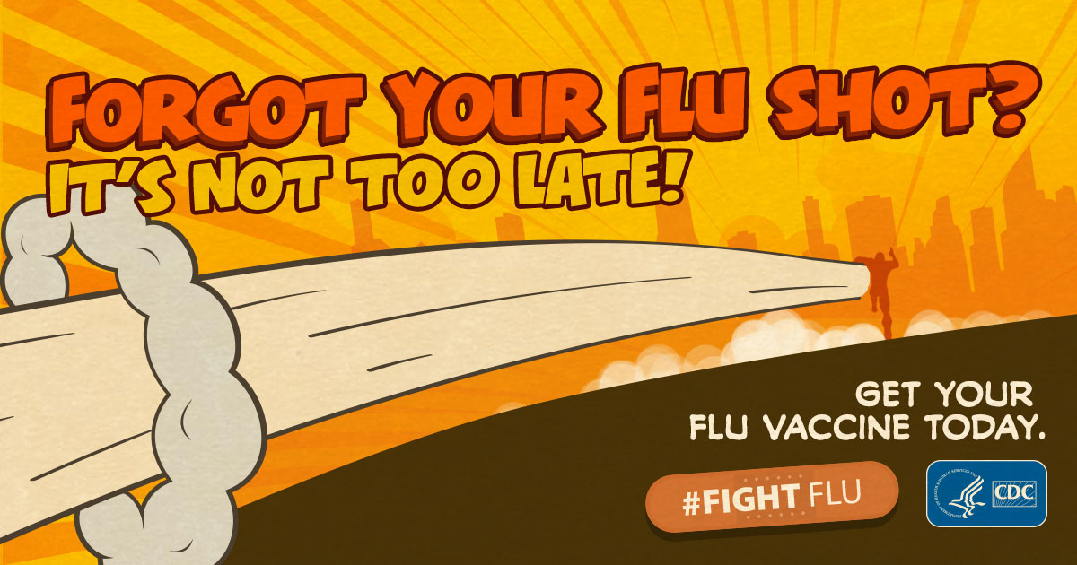
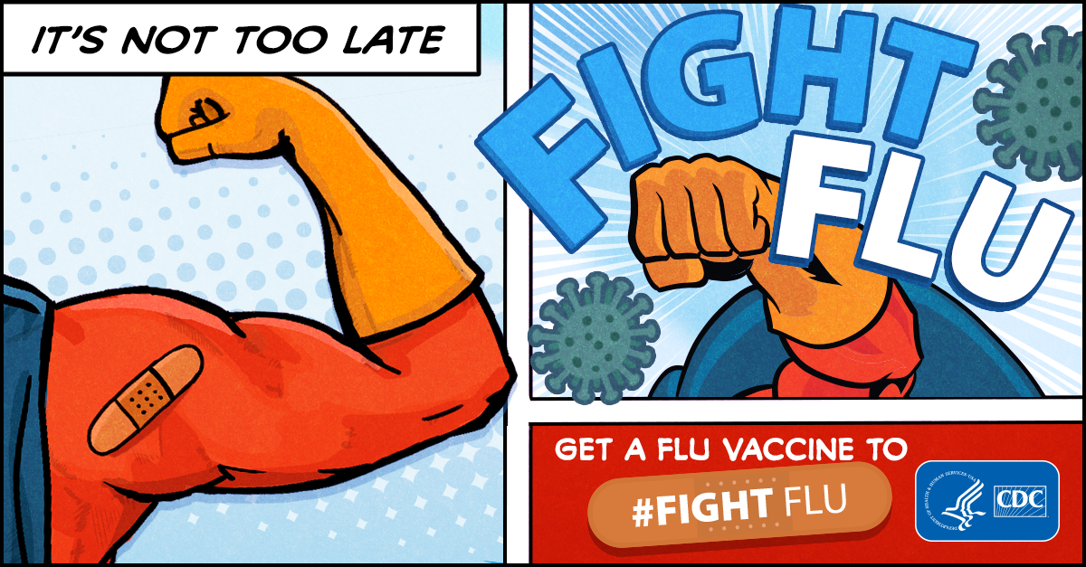

Appendix 9: ADDITIONAL RESOURCES AND INFORMATION

Influenza Background and Definitions

While Influenza, or flu, affects people of all ages each year, children are particularly vulnerable to becoming ill and at risk for developing complications. Flu can spread quickly in school and daycare settings, where children are in close contact and share space and belongings. Students can also take flu home where it can spread to adults and other family members. School and day care staff can play a critical role in preventing and managing flu outbreaks by encouraging preventive actions and monitoring student illness and absences.

High-risk groups
Some children are at higher risk for developing complications from the flu, including:
- Children under age 5, especially those younger than 2
- Children with chronic health conditions such as:

  - asthma,
  - diabetes,
  - neurologic and neurodevelopmental disorders,
  - chronic lung disease (such as cystic fibrosis),
  - heart disease,
  - blood disorders,
  - endocrine disorders,
  - kidney or liver disorders,
  - morbid obesity, or
  - metabolic disorders

- Children with suppressed immune systems such as:

  - children receiving cancer treatment,
  - children with human immunodeficiency virus (HIV),
  - children on chronic steroid therapy,
  - children on long-term aspirin therapy, or
  - those with other immunosuppressive disorders

It is especially important that children in these high-risk groups receive flu vaccines and are protected by limiting contact with sick people and encouraging frequent hand washing.

Transmission
Symptoms begin 1-4 days after someone is first exposed to someone with flu
- In healthy adults, flu viruses spread most easily in the first two days after infection, and continues to spread for 5 to 9 days.
- Children can spread illness to others easier than adults. In children, flu viruses begin spreading just before symptom onset and can persist up to two weeks after infection.
Influenza virus spreads person-to-person by two main routes:
- Droplets – large particles spread through coughing, sneezing, or talking. They can be inhaled and reach the upper airways but do not reach the lungs.
- Contact – This occurs when someone touches secretions from an infected person, either directly or on a contaminated object.

Signs and symptoms

Is it a cold or flu?
Signs and symptoms | Influenza | Cold
Symptom onset | Abrupt | Gradual
Fever | Usual | Rare
Aches | Usual | Slight
Chills | Fairly common | Uncommon
Fatigue, weakness | Usual | Sometimes
Sneezing | Sometimes | Common
Stuffy nose | Sometimes | Common
Sore throat | Sometimes | Common
Chest discomfort, cough | Common | Mild to moderate
Headache | Common | Rare

The chart above was adapted from a CDC graphic found here https://www.cdc.gov/flu/about/qa/coldflu.htm

Flu can last 10 days or more. Serious complications from flu include pneumonia, inflammation of the heart or brain, and, rarely, death. Young children, people over age 65, and those with chronic medical conditions or weakened immune systems are at increased risk.

Treatment
Most people with the flu have a mild illness and can recover with rest, fluids, and a fever-reducing over-the-counter medication such as ibuprofen. While ill, it is very important that individuals stay home and limit contact with other people to prevent spread.

If you think you have the flu you should discuss antiviral treatment with your doctor. Antiviral drugs are recommended for anyone ill with influenza who is in a high-risk group or who requires hospital care. These drugs are available by prescription only. They can reduce the severity and duration of symptoms, and decrease the risk of complications.

Some people do need emergency care for the flu. Warning signs to look for in children include:
- Fast breathing or shortness of breath
- Bluish skin color
- Not drinking plenty of fluids
- Being highly irritable, such as a small child not wanting to be held
- Flu-like symptoms that improve, but then return with a fever and a worse cough
- Fever with a rash
- Infants with any of the following symptoms should be seen by a healthcare provider immediately:

  - Unable to eat
  - Difficulty breathing
  - Has no tears when crying
  - Significantly fewer wet diapers
  - Not waking up from a nap or not interacting with others

Additional resources for schools & day care centers
Teaching children about the flu: lesson plans and activities for child care and early childhood programs, CDC: https://www.cdc.gov/flu/pdf/freeresources/updated/teachingchildrenflu.pdf
Flu Fighter Coloring Book, NFID: http://www.nfid.org/coloring-book
Ready Wrigley Activity Book, CDC: https://www.cdc.gov/flu/pdf/freeresources/family/ready_wrigley_flu.pdf
Get your school ready for pandemic flu, CDC: https://www.cdc.gov/nonpharmaceutical-interventions/pdf/gr-pan-flu-ed-set.pdf
CDC flu documents for distribution to parents in English and translations to Amharic, Arabic, Burmese, Dzongkha, Farsi, Karen, Kirundi, Nepali, Oromo, Somali, and Spanish: https://www.cdc.gov/immigrantrefugeehealth/resources/index.html

Resources for parents of school-aged children
Flu information sheet for parents & their children, CDC: https://www.cdc.gov/flu/pdf/freeresources/family/flu-information-for-parents-activity-sheet.pdf
Flu vaccine information for parents, CDC: https://www.cdc.gov/flu/pdf/freeresources/family/only-flu-shots-update.pdf
What to do if your child gets the flu, CDC: https://www.cdc.gov/immigrantrefugeehealth/pdf/seasonal-flu/what_to_do_english_508.pdf
Flu vaccine locator: https://vaccinefinder.org/
Flu guide for parents of children or adolescents with chronic health conditions: https://www.cdc.gov/flu/pdf/freeresources/updated/chronichealth_fluguide_brochure.pdf

Additional information about Influenza
Influenza, or “flu” is not a single disease. It is a family of viruses that cause similar respiratory illnesses. There are three types of influenza viruses that affect humans: A, B, and C. Each year, seasonal influenza epidemics in the United States are caused by types A and B. New or different type A viruses can cause influenza pandemics. Type A influenza can be further differentiated into subtypes by proteins on the virus’ surface: hemagglutinin (H) and neuraminidase (N), which contribute to the naming of each subtype based on which hemagglutinins and neuraminidase proteins are present.

In recent years H1N1 and H3N2 have been the main influenza A viruses circulating in the United States. In 2009, the “swine flu” epidemic was caused by a new and significantly different H1N1 strain, now called “2009 H1N1”. It replaced the H1N1 strain that previously circulated. Influenza type B viruses are not broken down into subtypes, but are categorized by lineage and strains. The most prevalent B viruses circulating in recent years are the B/Yamagata and B/Victoria lineages, named after the geographic origin. In general, type A influenza is much more common than type B influenza.

