22 Flood Mitigation Strategies Added to Reduce Flood Risk Website
ByNews EditorJanuary 29, 2024
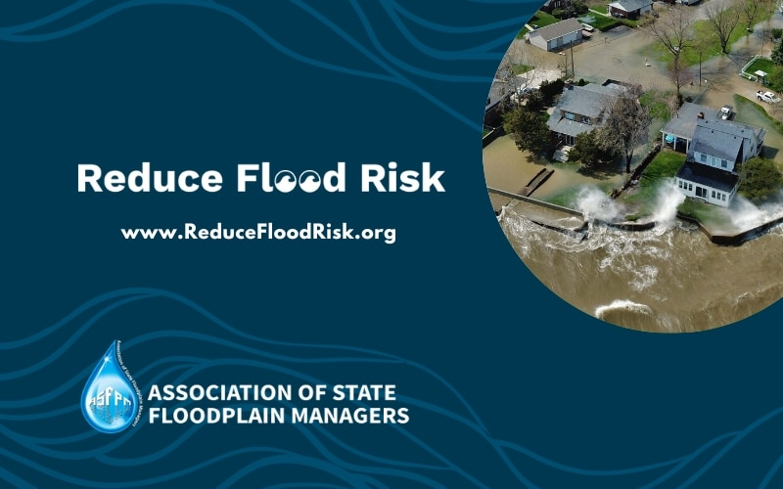
ASFPM’s flood mitigation resource library continues to work to bring flood mitigation to the masses with the addition of 22 things property owners can do to reduce flood risk, just in time for many state severe weather awareness campaigns. The new strategies range from relatively simple projects, like landscaping and plumbing improvements, to more complex engineering options, such as constructing an earthen levee or installing underground water tanks.
As you work with home and business owners looking to make informed decisions around the actions they can take this year to lower their risk of flooding, we encourage you to let them know about the Reduce Flood Risk website. Developed by ASFPM with financial support from FEMA, this interactive website demystifies flood mitigation and empowers people to protect themselves and their most valuable asset.
The Reduce Flood Risk website was launched in May 2022 and now has approximately 45 flood mitigation strategies to help property owners reduce their flood risk. Each strategy includes a detailed description of the process and its benefits, as well as photos, graphics, and links to additional resources.
To get started, people can go to ReduceFloodRisk.org, answer a series of five simple questions, and receive a detailed list of mitigation options recommended to reduce flood risk for their specific property type. The curated results can then be filtered and sorted by key attributes, such as cost, complexity, and level of required maintenance.
In addition to its decision-support engine, ReduceFloodRisk.org features a variety of resources to help property owners and renters better understand flood risk, flood insurance, financial assistance and funding options, and who to contact with any questions they have about flood mitigation. The site is completely free and users do not need to create an account to gain access to the resources.
The next step for Reduce Flood Risk is to offer mitigation strategies for communities with limited capacity and who are just starting their flood resilience journey. We plan to roll those out by next year. Please don’t hesitate to contact Jenna Moran at jenna@floods.org if you have any suggestions for how we can continue to improve the site for you and your community.

