Instructions to join an online meeting
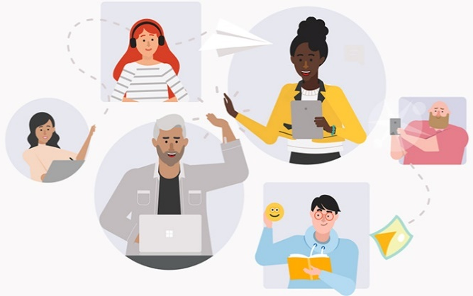
We are using Microsoft Teams for remote meetings with community. These meetings include audio, video, and screen sharing. And you don’t need to be a member of City staff (or even have a Teams account!) to join a Teams meeting. Below are instructions about how to join.
Pick one way to join from these options:
- Join using a computer and your internet
- Join using a mobile app
- Join by calling in

Join using a computer
- In the information from the City, select Join Microsoft Teams Meeting.
- That opens a web page, where you'll see two choices. Click Join on the web instead. Your browser may ask if it's okay for Teams to use your microphone and camera. Be sure to allow it if you have a microphone. If you don't have a mic, then you must call in from your phone to speak in the meeting.
- Enter your name and choose your audio and video settings. If the meeting room (or another device that's connected to the meeting) is nearby, choose Audio off to avoid disrupting. Select Phone audio if you want to listen to the meeting on your mobile phone.
- When you're ready, hit Join now.

Join using a mobile app
- In the information from the City, select Join Microsoft Teams Meeting.
- If you don't already have the Teams mobile app, you'll be taken to your app store to download it.
- Download the app and open it right from the app store page.
Teams will ask if it's okay to use your mic. Be sure to allow it so others in the meeting will be able to hear you.
- Next, you'll be given two options for joining your meeting. Choose Join as a guest.
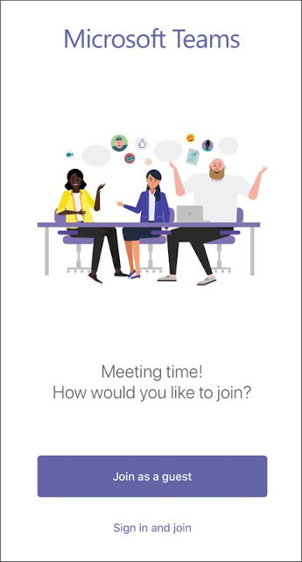
- Type your name and tap Join meeting.
- Once you're in the meeting, you can turn your video or mic on or off by tapping on the center of your screen to show the meeting controls. Tap again to hide them.
Once you've joined a meeting on the mobile app, you can:
- Tap the meeting to see the meeting header where you can return to the team channel or chat, start a chat with participants, or add people from your team to the meeting
- Tap in the meeting for the meeting controls such as audio, video, and hang up.
- Pinch to zoom in and out when someone is sharing their desktop.

Join by calling in
Another way to join is to call into the meeting. You will not be able to see if anything is being presented unless you use the computer or mobile app on a phone or tablet.
- Call the phone number provided by the City to dial in to the meeting.
- Next, enter the nine-digit conference ID number provided by the City, and press #.
- Now you can hear the meeting. To turn your phone microphone on or off, press *6.

Help with joining
- If you have a problem joining the meeting from your computer, try joining using the mobile phone app, or by calling into the meeting instead.
- If you are unable to join by calling in, double-check the phone number and nine-digit conference ID and try again.

Help with audio
- If you’re on your computer with a mic or the mobile app and people cannot hear you, you may be on mute. Press the microphone icon to unmute.
microphone is on microphone is off (muted)
- If you are calling in, and people cannot hear you in the meeting, you may be on mute. Press *6 on your phone to unmute yourself.

