Ohio Learn Instructions

Finding and completing OOD Web-Based Training (WBT) in the Ohio Learn Citizen Portal

Accessing Ohio Learn

- Log into OH|ID portal using your User ID and password. If you do not have an account, visit the OH|ID account management page to create an account.

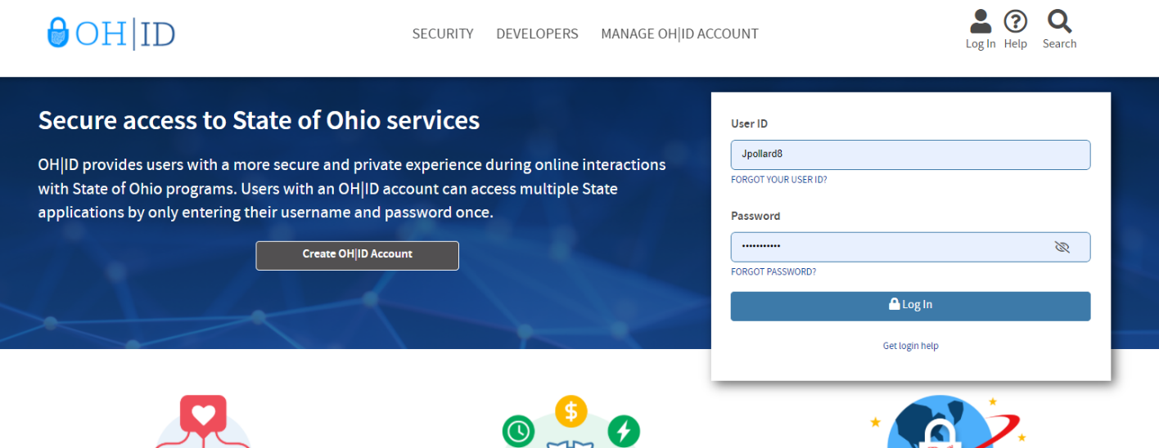

- Go to “App Store” in the navigation bar.

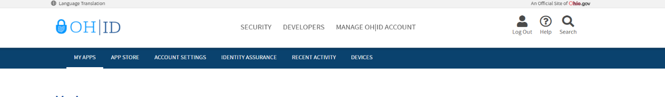

- Scroll down and find the “Ohio Learn” app. Once you find the Ohio Learn App, select “Request Access” (you will receive an email stating you have been granted access).

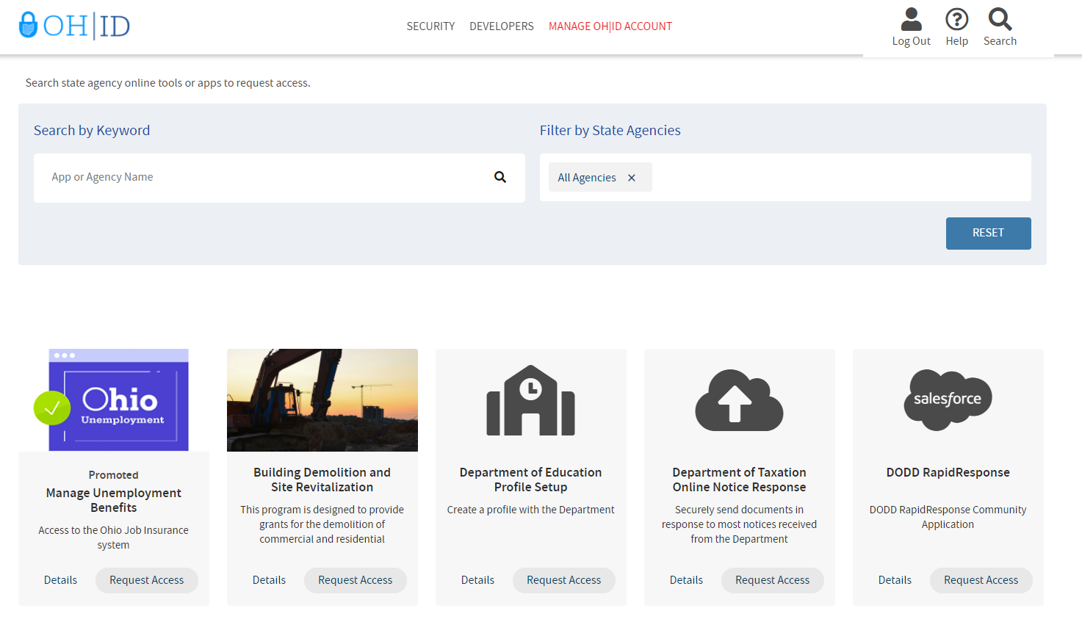
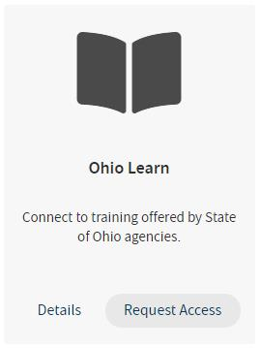

- Next, go to “My Apps” in the navigation bar and Click “Open App.”

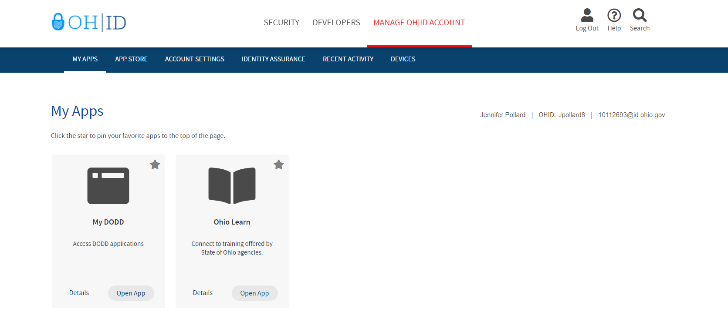

Finding Web-Based Training

- Go to “State of Ohio Training” in the top right hand corner of the screen. In the Drop down menu, select “Opportunities for Ohioans with Disabilities” and then “OOD Catalog.”
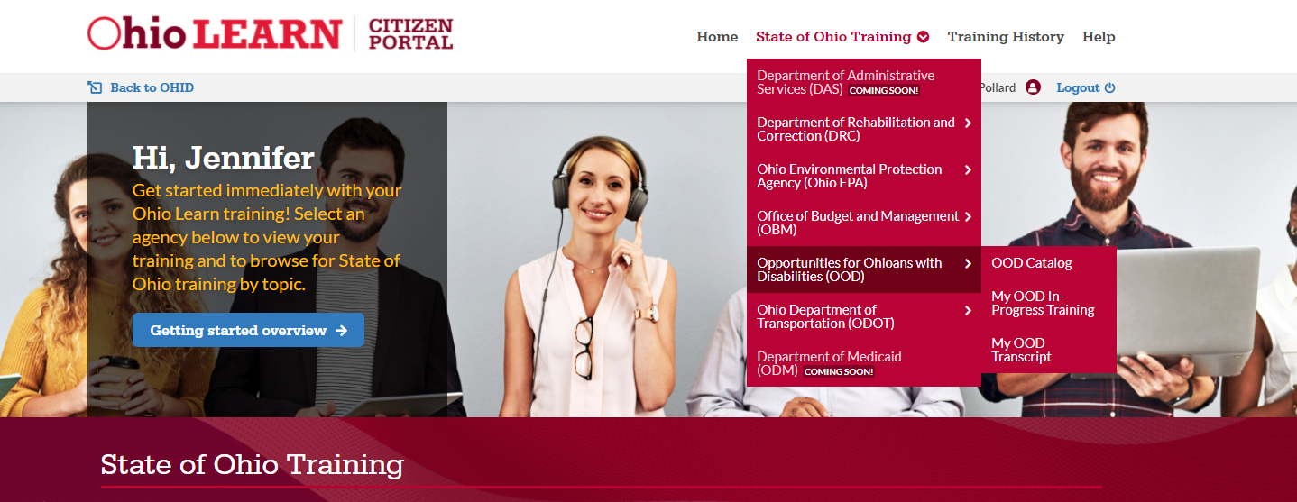

- In the search/find box under the “Search OOD Catalog” heading, enter the title or keywords for the specific training you want to access, and go to the “find” button.

- In the search results, go to “Launch Course” link next to the course you want to access. If using a screen reader, you may find it helpful to navigate by list to jump to the search results list, then then use tab to get to the launch link.
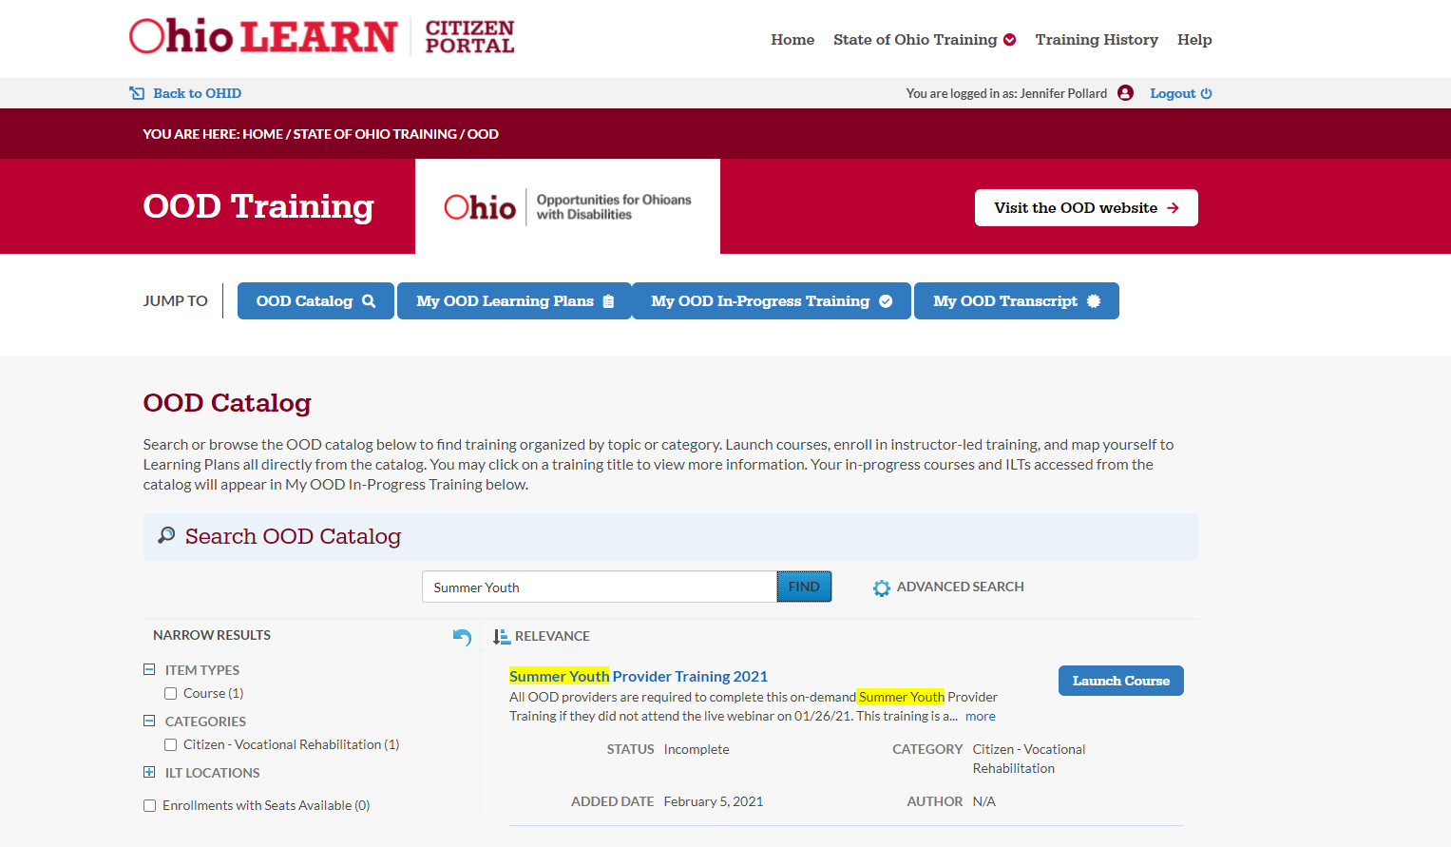

Completing Web-Based Training

- Web-based training will typically open in a new browser tab or window, but some courses may load on the same page as embedded content.
- Follow the instructions in the course to complete the training.
- To view a list of your in-progress OOD training from the Ohio Learn Citizen Portal home page, go to "State of Ohio Training" in the site navigation, choose "Opportunities for Ohioans with Disabilities (OOD)" and then "My OOD In-Progress Training."
- Once completed, a course will move from your in-progress list to your transcript. To access your OOD transcript from the Ohio Learn Citizen Portal home page, go to "State of Ohio Training" in the site navigation, choose "Opportunities for Ohioans with Disabilities (OOD)" and then "My OOD Transcript."
- The transcript contains a list of all completed training, with the most recently completed listed first, by default.

