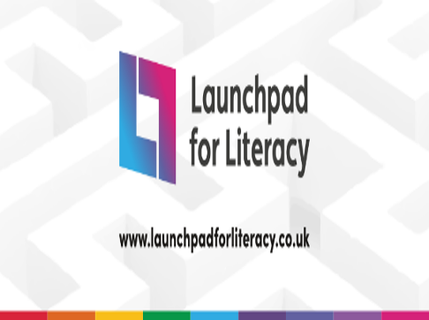

**Kirstie Page: Communication and Language in Early Years**

Wensum English Hub are delighted to be working with Kirstie Page - Speech and Language Therapist and Early Years Consultant, to bring you a series of FREE CPD events.

[**Interaction and Language Enrichment**](https://www.eventbrite.com/e/wensum-english-hub-interaction-and-language-enrichment-webinar-tickets-203111992437)

2nd December 2021 3.30pm – 5.30pm

[**EYFS Reforms: What to consider if children are not on-track.**](https://www.eventbrite.com/e/wensum-english-hub-eyfs-what-to-consider-if-children-are-not-on-track-tickets-203117077647)

20th January 2022 3.30pm-5.30pm

[**Embedding Interventions**](https://www.eventbrite.com/e/wensum-english-hub-embedding-interventions-tickets-203123075587)

10th February 2022 3.30pm – 5.30pm

*Please note you will have to book each session individually.*

Visit our website for more details <https://www.wensumtrust.org.uk/wensumenglishhub>