circular-graphic.emf

Workshop in a Box:

Sustainable Management of Rural and Small Systems Workshops

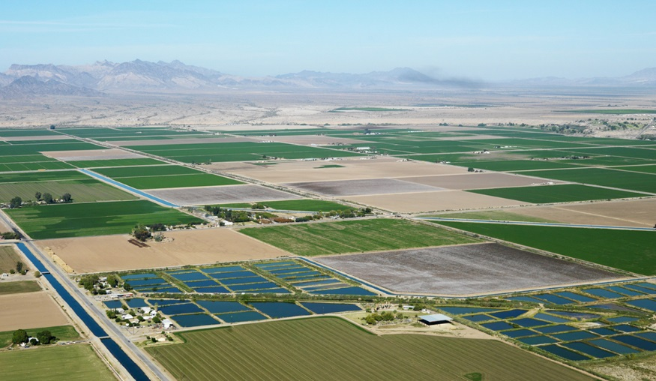

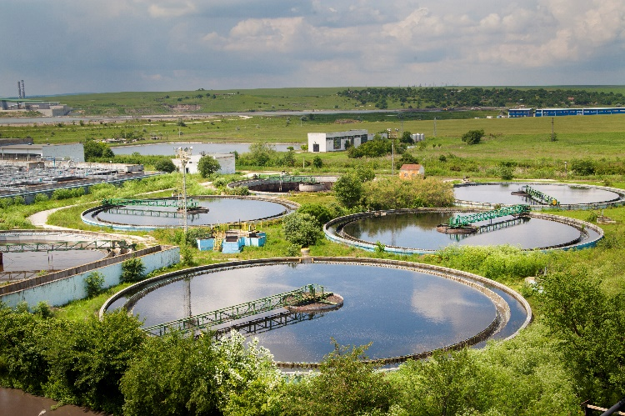





Table of Contents

Introduction 2

Supplemental Materials 4

Checklist: What you need for a Successful Workshop 5

Determining What Type of Workshop you Will Host 6

Workshop Preparation Timeline 9

Creating an Agenda 11

The ‘Working Lunch’ 15

Promoting the Workshop 16

Managing Registration 19

Preparing Materials 20

Executing the Workshop 22

Post-Workshop Follow-Up 28

Acknowledgements 30

Appendix 32

Introduction

## Background & Purpose

Rural and Small Systems Guidebook

The *Workshop in a Box* is accompanied by a companion resource, the *Rural and Small Systems Guidebook to Sustainable Utility Management*. The *Guidebook* provides background information on the key management areas, as well as instruction and assistance on how to conduct the utility assessment process that is used in the workshops. The *Guidebook* and the *Workshop in a Box* support rural and small water and wastewater utilities in their common mission to become more successful and resilient service providers.

This *Workshop in a Box* was developed as a collaborative effort between the United States Department of Agriculture (USDA) and the United States Environmental Protection Agency (EPA). It supports rural and small water and wastewater systems in addressing their unique challenges, and in more effectively providing sustainable services to their communities.

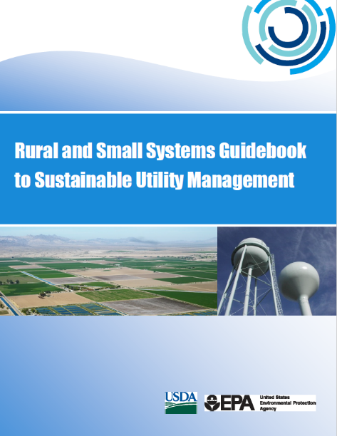The *Workshop in a Box* is a packet that contains a series of materials and instructions for utilities, technical assistance (TA) providers, water sector associations, and trainers. The packet supports conducting workshops based on the ten key management areas of sustainably managed systems (management areas), as described in the *Rural and Small Systems Guidebook to Sustainable Utility Management* (*Guidebook*). The *Guidebook* is included as a resource in this *Workshop in a Box* packet. The *Workshop in a Box* provides guidance for workshop preparations, execution, and copies of all materials to run a successful workshop on sustainable utility management improvement.

The information presented in *Workshop in a Box* draws on the results of four pilot workshops conducted by EPA and USDA, and has been updated based on 300+ workshops conducted by USDA, EPA, trainers and TA providers from across all 50 states. The content also draws on feedback from managers of rural and small systems who attended those workshops, and feedback from the trainers and TA providers who have conducted the workshops. Additionally, several small systems and water systems operations specialists provided input as the packet and guide were developed and revised.

Based on the approaches used and the lessons learned at these workshops, this *Workshop in a Box* is designed to help organizations host their own workshops. The intended audience for this resource includes rural and small systems managers looking to improve their utility outcomes and management practices, as well as associations and organizations who support small systems and seek to host educational events.

At each workshop, participants are given an introduction to the ten key management areas, and then asked to conduct a short self-assessment of their operations in relation to the management areas. Participants also identify management improvement opportunities at their systems based on the assessment. The workshop further provides an opportunity for participants to share experiences from their systems to better understand how to implement improvements and have a basis for working with staff and community members to operate more effectively. Participants are also introduced to a compendium of resources that could help them implement the improvements identified during the assessment.

By making improvements in any of the ten key management areas through methods outlined in the *Workshop in a Box* and the *Guidebook*, at a pace consistent with their most pressing challenges, systems will be able to deliver increasingly efficient, higher-quality services.

## Document Organization and Supplementary Materials

The information in this *Workshop in a Box* is organized in the order in which a workshop would be executed. It begins in the planning stages, moves through the steps of preparation, and concludes with the workshop itself. Supplemental materials are also included as attachments to the main document. These materials are everything needed to conduct the workshop, from promotional brochures and informational emails to presentation slides and worksheets. Many of the materials are presented as templates that the user can customize with specific event dates and other information. The supplemental materials included in the *Workshop in a Box* packet are described on the following page.

Supplemental Materials

The materials listed below have been developed to support the promotion and facilitation of the workshops.

## Templates

Templates are meant to be customized by the user to add event-specific information (such as dates, times, locations, speaker names, etc.). Areas for the user to add information are highlighted in blue.

#### Template 1a: Multi System Workshop Agenda

#### Template 1b: Team Exercise Workshop Agenda

#### Template 2a: Promotional Email for Multi System Workshop

#### Template 2b: Promotional Email for Team Exercise Workshop

#### Template 3: Promotional Brochure

#### Template 4: Sign-in Sheet for Multi System Workshop

#### Template 5: Feedback Form

#### Template 6: Decision Maker Invite Letter

#### Template 7: Decision Maker Invite Flyer

#### Template 8: Workshop Participant Talking Points Handout

## Documents

Documents are materials that are not meant to be modified by the user. These contain specific information that has been modified and developed over time by subject matter experts.

#### ****Document 1a:** Workshop Slides for Multi System Workshop**

#### Document 1b: Workshop Slides for Team Exercise Workshop

#### ****Document 2:** Self-Assessment Worksheet**

#### ****Document 3:** Improving Outcomes Worksheet**

#### ****Document 4a****: Resources Guide for Rural and Small Systems (electronic spreadsheet)

#### Document 4b: Resources Guide for Rural and Small Systems (table for printing)

#### ****Document 5**: Sustainable Management Action Plan Worksheet**

#### ****Document 6**: Rural and Small Systems Guidebook to Sustainable Utility Management**

#### ****Document 7**: Next Steps for Your Utility**

#### ****Document 8**: Next Steps for Workshop Facilitators & Technical Assistance Providers**

#### Document 9a: Financial Viability Buildout

#### Document 9b: Operational Resiliency Buildout

#### Document 9c: Stakeholder Understanding and Support Buildout

#### Document 9d: Infrastructure Stability Buildout

Checklist: What you need for a Successful Workshop

## Agenda

## Facilitator/Instructor

## Promotional Materials

## Registration and Sign-in Materials

## Presentation Slides and Talking Points

## Handouts and Other Meeting Materials:

## Self-Assessment Worksheet

## Improvements Worksheet

## Resources Guide for Rural and Small Utilities

* + Sustainable Management Action Plan Worksheet

## Workshop Evaluation Form

Determining What Type of Workshop you Will Host

This *Workshop in a Box* supports two workshop formats: a Multi System Workshop, and a Team Exercise Workshop. The workshop format dictates how the workshop will be run.

|  |  |  |
| --- | --- | --- |
|  | Multi System Workshop | Team Exercise Workshop |
| Organizer | Association or organization | Individual utility management  (water or wastewater) |
| Attendees | Participants from multiple utilities (water or wastewater), including:   * Utility operators and managers * Decision makers (e.g., mayors, town council members, town managers, utility board members) | Participants directly associated with the utility (potentially including utility staff, board members, community leaders and decision makers, and community stakeholders) |
| Objectives | * Introduce participants to the ten management areas * Equip participants to use the self-assessment exercise * Produce a list of potential improvement opportunities * Equip participants to discuss improvement opportunities within the community | * Educate staff and stakeholders about the ten management areas * Set improvement priorities * Communicate improvement priorities to staff, decision makers, and stakeholders |
| Facilitator | An association/organization staff member or a third-party facilitator (e.g. TA provider) | A utility team leader or a third-party facilitator (e.g. TA provider) |

## Multi System Workshop

A **Multi System Workshop** is typically sponsored and run by an association or organization that lends assistance to utilities. In this format, the sponsor would invite workshop attendees from several different utilities to participate in a group learning exercise.

The target audience for a Multi System Workshop is staff members who have management responsibilities at their utilities, and decision makers who have connection to utility policies and budgets (e.g., mayors, town council members, town managers, utility board members). For very small systems, the appropriate participant may be a manager/operator, and for somewhat larger systems, this may be an executive director. At minimum, a utility participating in this workshop should send staff with cross-operational management responsibilities, but may also choose to send additional staff (such as a certified operator) to participate. Utilities may also choose to have a board member or city manager accompany the participating manger. Decision makers are critical attendees at workshops, because they can help to promote the implementation of new practices and programs following the workshop, based on workshop discussions and results.

Objectives of a Multi System Workshop include:

* Introduce participating utilities to the ten management areas;
* Equip utilities to utilize the self-assessment exercise on their own;
* Develop a list of primary improvement opportunities for utilities;
* Provide an opportunity for participants to share challenges and successes with peer organizations; and
* Provide participants with materials that they can bring back to their decision makers and other leaders to generate motivation for taking action on the improvement opportunities that they identified.

Often, the participants in a Multi System Workshop use the information that they learned at the event to hold a Team Exercise Workshop at their own facility.

## Team Exercise Workshop

A **Team Exercise Workshop** is held within an individual system as an educational and strategic priority-setting exercise.

There are two types of Team Exercise Workshops:

1. ***Team Workshop***, which is attended by only internal staff members of the utility; and
2. ***Team-Stakeholder Workshop***, which is attended by utility staff, and some combination of board members and other community stakeholders.

The target audience of a Team Exercise Workshop is a mix of staff members (and in some cases, board members and community stakeholders) who make up a “cross-functional” team. A cross functional team would represent the range of roles that exist at the utility, and may include staff that have responsibility for engineering, operations, accounting/finance, customer service, and maintenance, recognizing that individual staff members may have responsibility for more than one of these functions, as many small systems do not necessarily have specific departments for each of these functions. The meeting organizer should do his/her best to have as many of these roles represented as possible, based on the capacity of the individual utility.

For a Team-Stakeholder Workshop, the meeting organizer should consider carefully who to invite. (Who will add valuable content to the discussion? Who needs to understand the utility’s priorities and challenges?) Possible participants may include board members, a city manager (or similar position), town council members, or citizens and neighborhood group representatives.

The objective of a Team Exercise Workshop is to educate utility staff and stakeholders about the ten management areas, to use the self-assessment exercise to identify priority areas for performance improvement, and to communicate the priority-setting results to the board and community members. Typically, this workshop would be organized and facilitated by a utility team leader. The team leader would be designated to convene the workshop, make the required presentations, and manage discussions among participants, while also directly participating in the discussions. In this way, the team leader is both a facilitator and a direct participant in the workshop. Alternatively, a utility can reach out to a technical assistance provider to undertake this role. There can be advantages to having an outside party provide this support, including allowing all utility staff to stay focused on direct participation.

Workshop Preparation Timeline

## Multi System Workshop

## Team Exercise Workshop

Creating an Agenda

Materials for this Section

Included in your Workshop in a Box kit are:

***Templates 1a & 1b:*** *Workshop Agenda*

* Use the sample agenda on the following pages as a guideline for your agenda. Your agenda should use the same sessions as the sample agenda, but may have slightly different time allotments, depending on the number of attendees. The sample agenda is built for approximately 25 attendees—add more time for more attendees, and subtract time for fewer attendees.
* Identify roles—Who will facilitate the meeting?
* Find a location—Where will the workshop take place?

HELPFUL HINT: Consider holding your workshop either as a stand-alone event, or the day before a larger event (like a conference or regional workshop).

### Sample Agenda – Multi System Workshop

8:30 Sign-in/Registration

9:00 Introductions and Workshop Objectives

9:15 Session 1: Overview of Key Management Areas – Presentation

9:45 Session 2: Utility ‘Self-Assessment’ Exercise

* Explain ‘Self-Assessment’ (5 minutes)
* Participants conduct Self-Assessment (30 minutes)
  + Rate utility achievements and rank management priorities
  + Plot results: achievements vs. priorities
* Table discussion among participants about results (25 minutes)
  + Where is your utility strong? Why?
  + Where is there the most room for improvement? Why?
  + What are your areas of focus?
    - Why are they a priority?
    - Why is performance low?
      * Technical capacity?
      * Financial capacity?
      * Managerial capacity?
  + What are commonalities and differences among table participants’ achievements, priorities, and challenges?

10:40 Break

*-Continued on following page-*

10:45 Session 3: Plenary Discussion – Self Assessment Results

* Tables report out (30 minutes)
* Synthesize results (30 minutes)

11:45 Working Lunch (Optional)

12:45 Session 4: Table Exercise – Improving Outcomes

* Each table completes an improvement worksheet for one low achievement/high priority management area.
* Discussion questions:
  + What will constitute “high achievement” in this management area?
  + What changes will the utility need to make to improve performance?
  + How could you track your performance progress?
  + What will be the biggest challenges to performance improvement?

1:30 Session 5a: Plenary Discussion – Practices, Tools, and Measures Results

* Table report out
* General discussion of findings

**2:00 Break**

2:15 Session 5b: Plenary Discussion – Practices Results

* Synthesis of table discussion results
* Local assistance available in key management areas
* Presentation of additional tips, tools, and measurement
* Reflections: key lessons learned and near-term steps
* Discuss Sustainable Management Action Plan

3:00 Session 6: Creating an Action Plan

* Workshop participants complete a Sustainable Management Action Plan Worksheet
* Facilitator reviews “Suggested Next Steps for Your Utility” handout

4:00 Session 7: Feedback Session

* Participants Complete Evaluation Form
* Solicit verbal feedback from participants
* Collect evaluation forms

4:30 Adjourn

### Sample Agenda – Team Exercise Workshop

9:30 Introductions and Team Objectives

9:45 Session 1: Overview of Key Management Areas – Presentation

10:20 Break

10:30 Session 2: Utility ‘Self-Assessment’ Exercise

* Team leader explains ‘Self-Assessment’ (5 minutes)
* Team members conduct Self-Assessment (25 minutes)
  + Rate utility achievements and rank by priority
  + Plot results: achievements vs. priorities
* Compile and portray team member assessments – team leader
* Discussion among team members (1 hour)
  + Where are there commonalities and differences among team members? Why?
  + Where is our utility strong? Why?
  + Where is there the most room for improvement? Why?
  + What should be our areas of focus?
    - Why are they a priority?
    - Why is performance low?
      * Technical capacity?
      * Financial capacity?
      * Managerial capacity?

**12:00 Working Lunch (Optional)**

1:00 Session 3: Improving Outcomes

* Assign 2–3 team members to complete an improvement worksheet for one low achievement/high priority management area.
* Team Member Questions:
  + What will constitute “high achievement” in this management area?
  + What changes will we need to make to improve performance?
  + How could we track performance progress?
  + What will be our biggest challenges to performance improvement?
* Team members report findings
* Full team discussion – refine and improve findings

**2:00 Break**

*-Continued on following page-*

2:15 Session 4: Resources and Additional Improvement Ideas

* Presentation of additional tips, tools, and measurement – team leader
* Team reflections: further ideas for improving performance and resources of interest

3:15 Session 5: Creating an Action Plan

* Introduce the Sustainable Management Action Plan Worksheet
* Select management areas for focused, near-term attention
* Make assignments for management area leads to prepare plan and identify improvement resources
* Assign timeframes for completion of next steps, including completing a Sustainable Management Action Plan Worksheet for each management area of focus

3:45 Adjourn

The ‘Working Lunch’

In addition to providing an extra opportunity to add content to the workshop, working lunches can help to keep participants nearby (to ensure that you don’t lose anyone who goes off-site for lunch), and to keep the momentum going (to reduce the likelihood of a post-lunch ‘slump’ in energy). If you choose to utilize a ‘working lunch’ format for your workshop, there are three main options for how to fill the time, which are described below.

## Networking Time

By having the participants remain in the room, they can often benefit greatly from visiting with each other about utility operational issues, either related to the workshop content or separate from the workshop. This is especially useful for Multi System Workshops, where attendees from different systems can trade tips and learn from the experiences of others.

## Working Time

In the event that workshop participants are engaging in in-depth discussions, it is useful to have time set aside at lunch to expand on topics in a less formal setting. This is especially valuable for the self-assessment exercise, which can be as deep of a discussion as you allow it to be—by adding extra time to your agenda for this or other discussions, you will allow participants to get to the “meat” of the issues.

## Guest Speakers

Having guest speakers, such as workshop sponsors or local technical assistance providers, present at lunch provides an opportunity for the sponsors to connect their services directly to management areas of interest that utility participants identified during the self-assessment exercise. Alternatively, presentations by local utility managers on their successes and challenges can also help to ground the management area improvement discussions. The practical context of local, peer utilities can lend substantial credibility and a stronger sense of accessibility to performance improvements.

Promoting the Workshop: Who Should Attend?

Materials for this Section

Included in your Workshop in a Box kit are:

***Templates 2a & 2b:*** *Promotional Email*

***Template 3:*** *Promotional Brochure*

***Template 6:*** *Decision Maker Invite Letter*

***Template 7:*** *Decision Maker Invite Flyer*

## Multi System Workshop

### Target Audience: Utility Operators and Managers

Utility operators and managers typically make up the largest portion of workshop attendees. They are important to have in attendance because they are most familiar with the utility’s day-to-day operations and challenges.

* Send a promotional email or letter to utility operators and managers in your network. The message should include:
  + Time, date, and location of the workshop
  + Information about the sponsoring organization (who is hosting the event?)
  + Information about the purpose of the workshop (what can participants expect to get out of it?)
  + Workshop agenda
  + Instructions on how to register for the event
  + Instructions about what to bring (relevant materials, lunch, etc.)

HELPFUL HINT: If you have a meeting planning committee or team, consider having each member identify potential participants, and then have each member be responsible for reaching out individually to the participants they identified.

* Distribute brochures or any other promotional materials you have developed.
* Track registration in advance of the meeting and send reminders to registered participants.

### Target Audience: Decision Makers and Community Leaders

Decision makers and community leaders are critical attendees at the workshops. They provide policy and budgetary decision support to the utilities. It is helpful to have at least one decision maker or community leader attend with each utility that attends the workshop. They can act as advocates for new practices and programs related to the key management areas following the workshops. Decision makers and community leaders can be a challenging audience to reach. Based on the feedback of utilities and trainers around the country, EPA and USDA have developed specific outreach resources for workshop hosts seeking to reach this important audience.

* Create a list of decision makers and community leaders to target for invitations to the workshop.
* Modify the Decision Maker Invite Letter (Template 6) and the Decision Maker Invite Flyer (Template 7) to include specific information about your workshop (e.g., date, location, time). Send both items to your targeted invite list. The letter can be used as a hard copy cover letter for a mail-out flyer, or as a cover email when distributing electronically.
* A few weeks after your letter and flyer are distributed, make follow-up contact with your targeted invite list, either by phone or email. Explain the importance of the workshop, and how local utilities and their communities will benefit from their attendance.

## 

## Team Exercise Workshop

*At a team workshop, it is helpful to have a mix of operators and managers in attendance. It is equally beneficial to involve decision makers and community leaders at the workshop to help them gain a better understanding of the utility’s strengths and challenges. Some utilities may choose to hold a staff-only workshop and then hold a second workshop that is open to community stakeholders, decision makers, and other community leaders.*

* Announce the workshop to your staff, either at an internal meeting or by email/letter, at least two weeks in advance of the event. Announce the workshop by email/letter to invited stakeholders if you are planning to open the workshop up to external participants. Include information about:
  + Who should plan to attend—all staff members/stakeholder groups, or only specific ones?
  + Time, date, and location of the workshop
  + Information about the purpose of the workshop (what you hope to accomplish)
  + Workshop agenda
  + Instructions on how to register for the event
  + Instructions about what to bring (relevant materials, lunch, etc.)
* Distribute promotional materials to intended participants
* Send reminders to participants one week in advance, and then again the day before the workshop

Tips from Other Workshop Hosts: How to Reach Decision Makers and Community Leaders

*To attract more leaders, we put on our workshop with the Community Loan Fund of New Hampshire, which provides funding for co-ops. They invite decision makers, which helped us get a lot of them there.*

—Donny, NH

*We split our workshop up into two 3-hour evening sessions, which makes it easier for board members and community leaders to attend than an all-day session.*

—Connie, IN

*Find the most popular food establishment in your area and have them cater the meeting – your attendance will go way up!*

—John, MO

*We make personal phone calls and do visits to systems to recruit their leaders to attend workshops.*

—Tony, SC

*We held a workshop for a town on a Saturday so that the council and the mayor could attend.*

—Mark, WY

*We have workshop trainers fill out the Improvement Plan worksheet with the systems that attend the workshop, and then help them come up with a plan to approach their boards, councils, and stakeholders.*

—Gary & Ben, FL

Managing Registration

It is a good idea to collect registration information in advance so that you know how many people will attend. This helps to plan for room capacity, create sign-in sheets, print the right number of meeting materials, and anticipate refreshments needs (if you will be providing them). Pre-registration also allows you to have contact information for attendees to use for sending out meeting reminders and other meeting information.

## Multi System Workshop

At minimum, you should collect the participant’s name, organization, and email. You may want to consider organizing it in a table or spreadsheet (see example below). Other optional information you may want to collect can include: phone number, address, or dietary preferences (if you plan to have food at the event). There are many ways to collect registration information, depending on your organization’s technical capabilities, including:

* Collecting registration by email
* Creating a registration website
* Posting sign-up sheets or a registration phone number at central community locations

### Sample Registration Tracking Table

|  |  |  |  |
| --- | --- | --- | --- |
| Last Name | First Name | Organization | Email |
| Anderson | Mary | Village Loop Water | manderson@villageloop.com |
| Johnson | Mike | Lost Lake Sewer District | Mike.johnson@llsd.com |
| Smith | Joe | City Public Utilities | joesmith@city.gov |

## Team Exercise Workshop

When hosting a workshop at your own utility, it is still important to track who will be attending the event to ensure that you will have the right mix of people (appropriate staff members, and board/community members if you plan to invite them). Creating a simple internal RSVP list is an easy way to track this (see example below).

### Sample RSVP List

|  |  |  |  |
| --- | --- | --- | --- |
| Last Name | First Name | Representing | RSVP – Yes/No? |
| Alvarez | Steve | Staff (financials) | Yes |
| King | Anne | Board Member | No |
| Kelly | Jennifer | Stakeholder (Citizens for Clean Water) | Yes |

Preparing Materials

Materials for this Section

Included in your Workshop in a Box kit are:

***Templates 1a & 1b:*** *Workshop Agenda*

***Template 4:*** *Sign-in Sheet*

***Template 5:*** *Feedback Form*

***Document 1:*** *Workshop Slides*

***Document 2:*** *Self-Assessment Worksheet*

***Document 3:*** *Improving Outcomes Worksheet*

***Document 4b:*** *Resources Guide for Rural and Small Systems (Table for Printing)*

***Document 5:*** *Sustainable Management Action Plan Worksheet*

***Document 6:*** *Rural and Small Systems Guidebook to Sustainable Utility Management*

***Document 7:*** *Next Steps for Your Utility Handout*

One of the last steps in preparing for your meeting is to finalize the meeting materials, which can be adapted from the resources provided in your *Workshop in a Box* packet. Materials should be printed for all attendees to allow everyone to follow along easily. The materials you will need include:

Agenda

Make sure to add the following information to the agenda template before printing:

* Start and end time, date, and location
* Roles (facilitator, speakers)
* Times for each session

Sign-in Sheet(s) and Name Tags

These should be pre-populated with the names that you gathered during your registration/attendance tracking process, with extra spaces on the sign-in sheet and blank tags for day-of registrants/walk-ins.

Presentation Slides

Printing slides for participants is optional, but can be useful for note-taking purposes. At minimum, the slides should be projected and visible to the whole room, with a printed copy for the facilitator to speak from.

Hand-Outs

For both Multi System and Team Exercise workshops, participants should receive a set of handouts to support their participation in the workshop. The table below indicates which handouts should be provided to participants in each type of workshop.

Key: ✓ Must include * Recommended to include, but optional

| Handouts | Multi System Workshop | Team Exercise Workshop |
| --- | --- | --- |
| Agenda | ✓ | ✓ | |
| Self-Assessment Worksheet | ✓ | ✓ | |
| Improving Outcomes Worksheet | ✓ | ✓ | |
| Sustainable Management Action Plan Worksheet | ✓ | ✓ | |
| Resources Guide for Small and Rural Utilities | * | ✓ | |
| Workshop Slides as handout | * | * | |
| *Rural and Small Systems Guidebook to Sustainable Utility Management* (preferable to include in hard copy, but at minimum should receive an electronic copy after the workshop) | * | * | |
| Workshop Feedback Form | ✓ | * | |
| Next Steps for Your Utility Handout | ✓ | ✓ | |

Executing the Workshop

## Room Set-Up

The room should ideally be set up in ‘round table’ style to allow for interaction among workshop participants. If you are conducting a Multi System Workshop, it is best to get a variety of participants at each table (e.g., if a utility has sent more than one representative to the workshop, ask them to sit at different tables—this will help everyone learn from each other and get the most out of the experience). Multi System Workshop table groups should target between 6−8 participants per table. If you are holding a Team Exercise Workshop with board members or outside stakeholders present, you should ask them to spread out and sit at tables with utility staff members. Team Exercise Workshops are typically comprised of 3−15 participants. For fewer than 8 participants, all should be seated at the same table; for more than 8, break up into two tables.

### Sample Room Configuration for Multi System Workshop

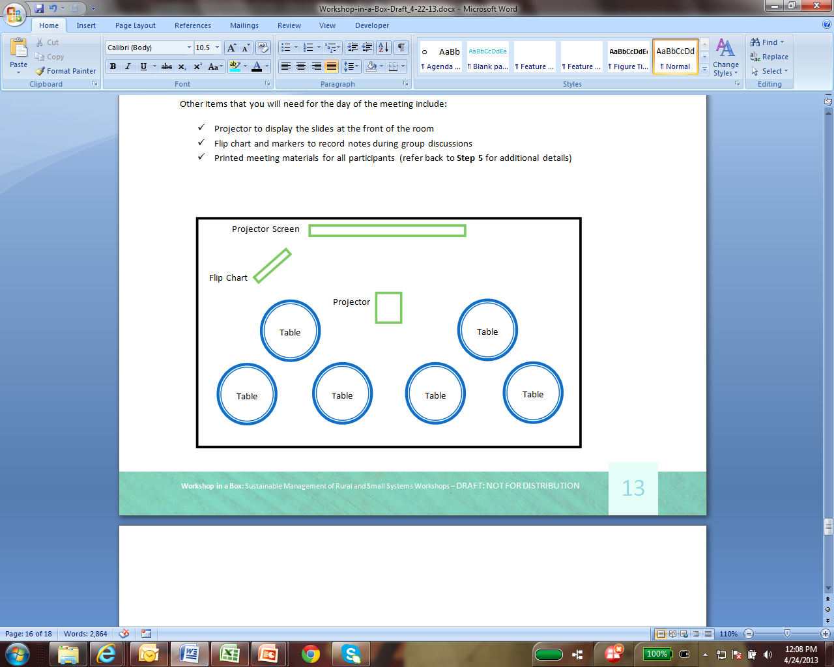

Other items that you will need for the day of the meeting include:

* Projector to display the slides at the front of the room
* Flip chart and markers to record notes during group discussions
* Printed meeting materials for all participants (refer back to the **Preparing Materials** section for additional details)

## Presenting Workshop Material

Materials for this Section

Included in your Workshop in a Box kit are:

***Document 1:*** *Workshop Slides*

***Document 2:*** *Self-Assessment Worksheet*

***Document 3:*** *Improving Outcomes Worksheet*

***Document 4a:*** *Resources Guide for Rural and Small Systems (Electronic Spreadsheet)*

***Document 4b:*** *Resources Guide for Rural and Small Systems (Table for Printing)*

***Document 5:*** *Sustainable Management Action Plan Worksheet*

***Document 6:*** *Rural and Small Systems Guidebook to Sustainable Utility Management*

While walking through the workshop sessions and slides, the ***facilitator should refer to the talking points and helpful presentation tips*** that are included in the slides. These points were developed and modified based on what worked well (and what did not work well) during discussions at the pilot workshops. They can be found in the “Notes” section of the presentation (see example below). Please note that we’ve collected facilitation techniques and optional tips from professionals and trainer practitioners who have hosted several of these workshops. See **Appendix I** for a full list of *Optional Tips from Workshop Hosts*.

***HELPFUL HINT: Prior to the meeting, the facilitator should consider going through the slides to identify any areas that may not make sense to include, or additional points that should be made based on their specific audience.***

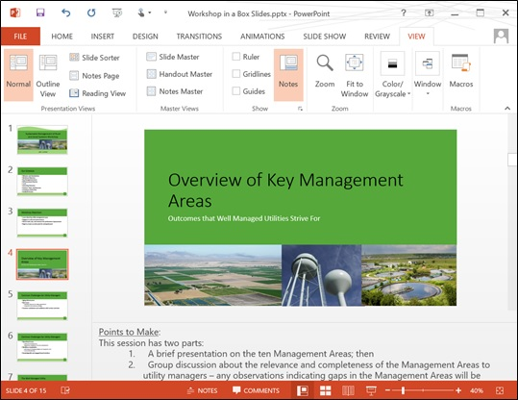

***Presentation Tips & Talking Points***

### Introductions & Workshop Objectives

Use slides 1-5 in Workshop Slides

The purpose of this session is for the facilitator to introduce himself/herself, and to have the other participants in the room introduce themselves to each other. The facilitator will also use this session to thank sponsors (if applicable), review the printed meeting materials that each participant has in front of him/her, and outline the meeting schedule and objectives (i.e., what should participants expect the workshop to look like).

### Overview of Key Management Areas (Session 1)

Use slides 6-20 in Workshop Slides and refer to pages 4−6 in the Rural and Small Systems Guidebook

During this session, the facilitator (or another presenter) will describe the challenges faced by many rural and small system managers, and the ten key management areas that can help address these challenges. The facilitator will then provide an overview of each of the management areas, using the slides that have been created to describe each area. This session is primarily for the education of participants, and will help to inform the discussions throughout the remainder of the workshop (see Optional Tip 1 in Appendix I for optional facilitation techniques).

At the end of the session, the facilitator should take questions from participants to explore the relevance of the management areas to those in the room (e.g., do these management areas relate to what you are doing?). Note that a critical aspect of the success of the previously conducted workshops was the dialog among participants throughout each session. Participant feedback indicated this was a key aspect of the workshop learning process, and it is up to the workshop facilitator to engender this dialog by asking questions and prompting all participants to engage in discussion.

### Utility ‘Self-Assessment’ Exercise and Results

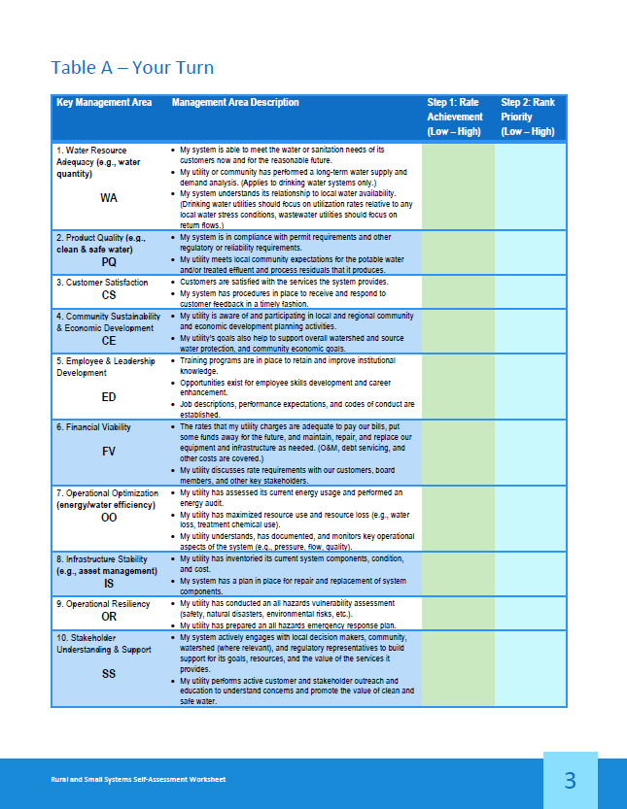 Use slides 21-32 in Workshop Slides, the Self-Assessment Worksheet, and refer to pages 7−11 and Appendix I in the Rural and Small Systems Guidebook

The Self-Assessment is the most important session of the workshop. During this session, the facilitator will provide instructions for how the exercise is to be completed (refer to slides 22-31), and the objectives of the exercise. The approach taken for the Self-Assessment exercise differs between the two types of workshops.

#### Multi System Workshop (Session 2 & Session 3)

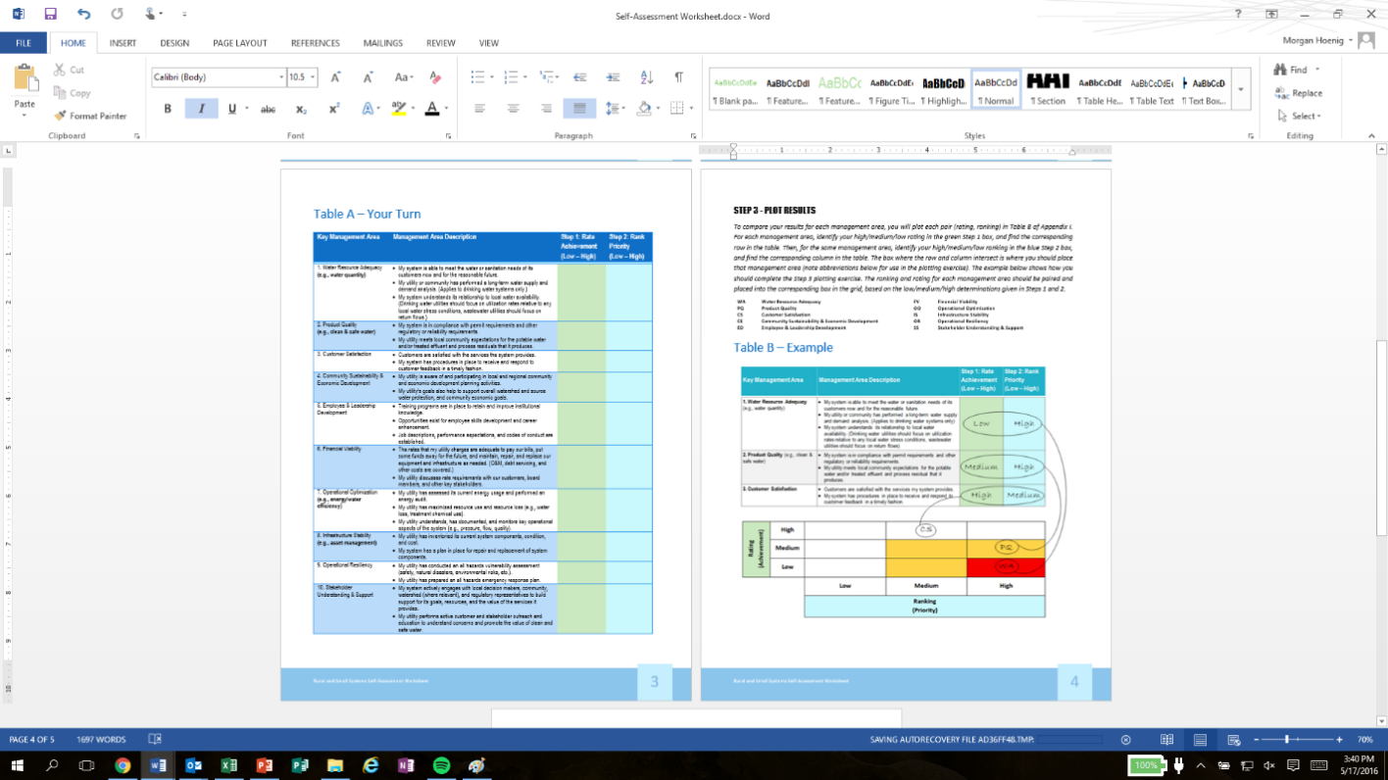For a Multi System Workshop, each individual participant will complete the Self-Assessment Worksheet (Document 2) with his/her own utility in mind. Once all participants have completed their worksheets, the table groups will convene to discuss their results (see Optional Tips 2 and 3 in Appendix I for helpful tips on this exercise). Table groups should discuss the questions on slide 32 on their own for approximately 25 minutes (during this time, it helps to assign a ‘table captain’ to keep the discussion moving and on-topic). After table groups have discussed the questions, the entire group of workshop participants will reconvene for the facilitator to lead a discussion about the questions. This discussion will help draw out common themes from each table. As themes emerge, the facilitator should ask participants how they have dealt with relevant challenges to help participants learn from each other’s experiences, successes, and mistakes.

#### Team Exercise Workshop (Session 2)

In the context of an individual utility running a Team Exercise Workshop, the Self-Assessment will be more of a full-group exercise. After the team leader has explained how to complete the worksheet, each meeting participant will fill out the worksheet on his/her own for approximately 30 minutes. Using a ‘master copy’ of the worksheet, the team leader will then compile the results of all worksheets and lead a discussion with the entire group to come to agreement on where the utility’s improvement efforts should be focused based on the worksheet results. Based on the compiled responses, this group discussion should be guided by (but not limited to) the questions found on slide 32. At the end of the session, the group should be able to answer the question, “What are our priority areas to focus on as we move forward?” (Try to limit this to no more than three management areas to begin with.) See Optional Tip 4 in Appendix I for an optional technique past facilitators have used for this session.

### Improving Outcomes

A screenshot of a cell phone

Description generated with very high confidenceUse slides 33-35 in Workshop Slides and the Improving Outcomes Worksheet and refer to pages 12−17 in the Small Systems Guidebook

The purpose of this session is to build on the results of the Self-Assessment Worksheet exercise and focus on how to improve outcomes in the key management areas that were identified as highest priority and lowest areas of achievement (i.e., the management areas that were in the yellow or red boxes in the plotting exercise).

#### Multi System Workshop (Session 4)

In the Multi System Workshop context, each table will be assigned a different management area. These management areas should be chosen based on the Self-Assessment results (the areas that were the most common for needing improvement among table participants). Each table group will address the questions on slide 35 (which correspond with the bolded questions in the “Improvements Worksheet”) for their respective management area. As the table group discusses as a whole, each participant should be recording notes about answers to the questions on his/her worksheet.

#### Team Exercise Workshop (Session 3)

For a Team Exercise Workshop, the management areas that were identified as priorities in the Self-Assessment discussion should be assigned to groups of 2−3 members (or more, depending on your team size). Each group should spend approximately 75 minutes addressing the questions on slide 35 for their respective management areas. After the groups have answered the questions, the team leader should bring everyone back together to hold a full team discussion. During this discussion, each group should report on their discussions, and other team members should be given the chance to weigh in on the areas that they did not participate in.

### Multi System Workshop only: Practices, Tools, and Measures Results (Session 5)

Use slides 36-61 in Workshop Slides, the Resources Guide, and refer to Appendix III in the Rural and Small Systems Guidebook

Session 5a: To build on the discussions in Session 4 about improving outcomes, the facilitator should ask each table group to share their responses to the questions on slide 35. After each table has reported out, the group will have a facilitator-led discussion of the findings. (What do the findings tell us about the challenges and improvement options for each of the areas? What are the similar and different approaches that systems take to address the challenges that they face?). This session is a critical peer-to-peer learning opportunity. The session facilitator should be sure to engage all workshop participants in the discussion and ask them to share their ideas for how to improve, what they have done previously to improve, and what types of challenges they have faced.

Session 5b: To begin this portion of the session, the facilitator should recap the results of the group discussion in Session 5a. In response to the challenges discussed in Session 5a, the facilitator will present resources that EPA and USDA identified for rural and small systems that relate to the management areas. These resources can be found on slides 40-55. These When addressing the Resources Guide, the facilitator should note that there are two versions of the document: a printer-friendly version (which should be included in the materials given to participants), and a more in-depth electronic version (which should be emailed to participants after the meeting). The more in-depth version has a filter function that allows the user to sort the resources by management area. Finally, the facilitator should introduce the attendees to the Sustainable Management Action Plan worksheet, which will be a useful resource for them to use at their individual systems when identifying improvement activities.

Note that “buildouts” were created for the four most common priority management areas: Financial Viability, Operational Resiliency, Stakeholder Understanding and Support, and Infrastructure Stability. These buildouts are shown on slide 55, and included in Appendix III of the Rural and Small Systems Guidebook.

### Team Exercise Workshop only: Resources and Additional Improvement Ideas (Session 4)

Use slides 36-61 in Workshop Slides, the Resources Guide, and refer to Appendix III in the Rural and Small Systems Guidebook

In response to the discussions from Session 3 about improving outcomes and challenges that the utility faces, the team leader will present the tips, tools, and resources that EPA and USDA have compiled for rural and small systems to use when making improvements in the management areas. This information can be found in slides 56-61. The team leader should also walk participants through the Resources Guide, making sure to note that there are two versions of the document: a printer-friendly version (which should be included in the materials given to participants), and a more in-depth electronic version (which should be made available after the meeting). The more in-depth version has a filter function that allows the user to sort the resources by management area.

Following the team leader’s presentation, the team should have a full-group discussion about any additional ideas that may have been sparked about improving performance in the management areas, and any resources that they would like to explore further.

### A screenshot of a cell phone Description generated with very high confidenceCreating an Action Plan

Use slide 62-69 in Workshop Slides, the Sustainable Management Action Plan worksheet, and refer to pages 18−21 and Appendix II in the Rural and Small Systems Guidebook

#### Multi System Workshop (Session 6)

To close out the day, the participants should regroup to discuss what next steps will be taken to move forward with making improvements in the management area that was identified as a priority. Each participant or each team of participants from a single utility should fill out a Sustainable Management Action Plan worksheet to plan next steps. It is crucial to communicate with participants the importance of sharing this information and the Self-Assessment results with their managers and decision makers to help gain support for taking action as they move forward.

#### Team Exercise Workshop (Session 5)

To close out the day, the team should regroup to discuss what next steps will be taken to move forward with making improvements in the management areas that were identified as priorities. With the team leader leading the discussion, the group should confirm the management areas that it will focus on, make assignments for who will take the lead in each area, and assign time frames for completing the next steps in the improvement process. The Sustainable Management Action Plan worksheet is a useful resource when conducting this exercise.

### Multi System Workshop only: Participant Feedback (Session 7)

Use slide 70 in Workshop Slides and the Participant Feedback Form

As part of closing out the day, it is important to get feedback from participants about how they thought the workshop went. This is especially true if you are planning to run a similar event in the future, so that you can modify your approach as needed. The facilitator should thank the group for their participation, explain the feedback form, give any information about follow-up (electronic distribution of meeting materials, etc.), and close out the day by letting participants know that they are free to leave once they’ve completed their forms (try to give them approximately 15−30 minutes to do so).

Post-Workshop Follow-Up

## Multi System Workshop

Workshop Participant Talking Point Handout

Template 8, included in the *Workshop in a Box*, is a handout for workshop participants to use in communicating about the workshop with their managers and decision makers (e.g., board members). Workshop participants should receive this handout at the end of the day to equip them to talk about what they learned at the workshop and why it is important to take action in the priority management areas identified during their self-assessment.

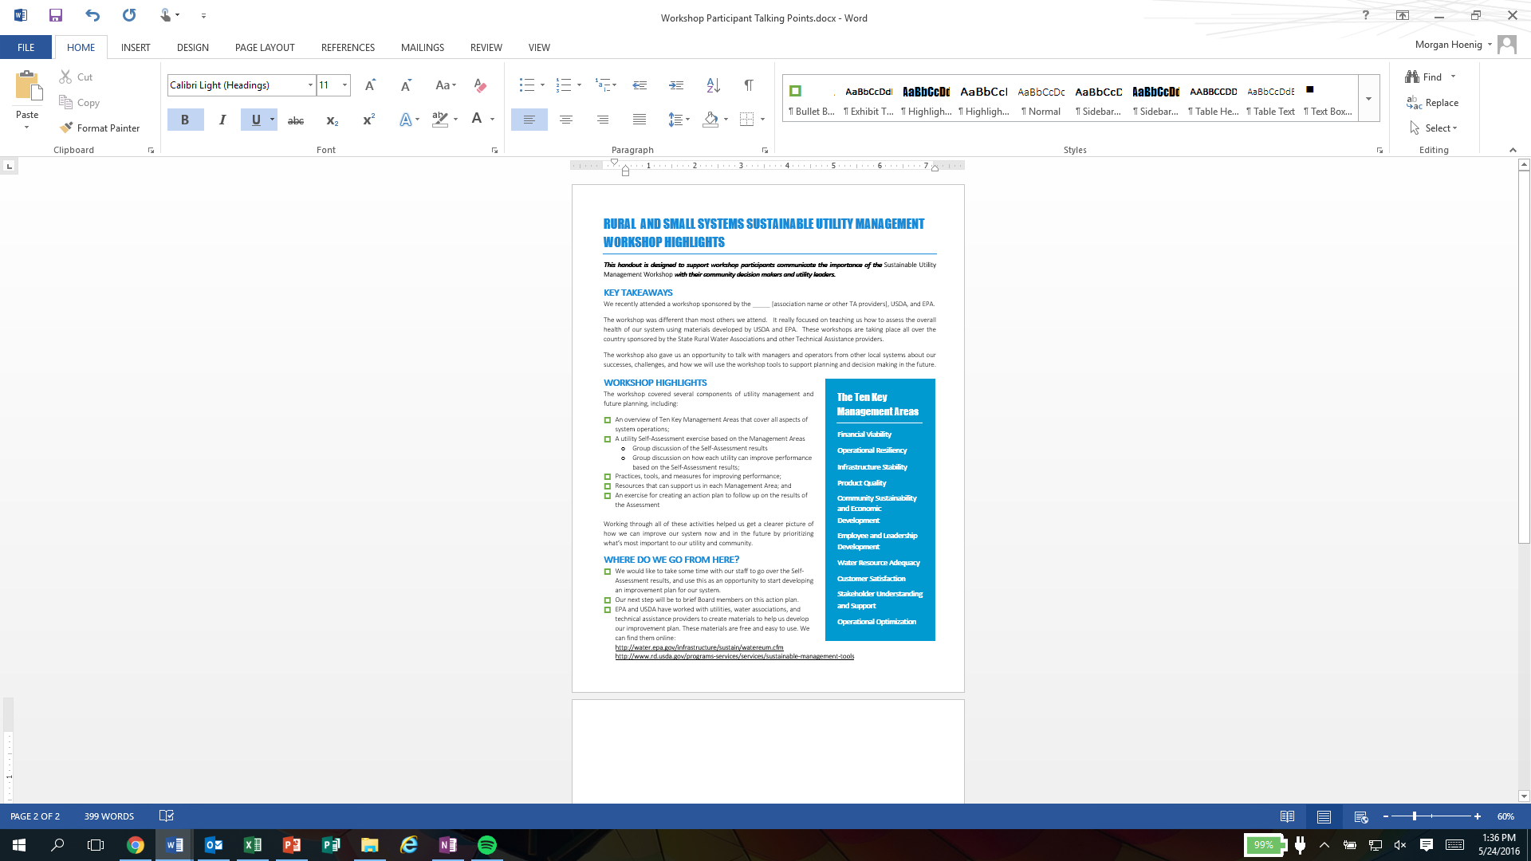

At the end of the workshop:

* **Review the ‘Next Steps for Your Utility’** handout and talk again about the importance of an action plan;
* **Review the ‘Workshop Participant Talking Points’** handout that provides workshop participants with highlights to share with their utility leaders, board members, and other community decision makers;
* **Do a materials check:** Double check that all participants have a copy of the Self-Assessment Worksheet and the Sustainable Management Action Plan Worksheet and let them know where they can find these online; and
* **Share contact information:** Make sure you provide participants with your contact information, and make sure to get the contact information for at least one participant from each utility (this should also be collected as a part of workshop registration).

In the days and weeks following your meeting, there are a few additional steps that need to be completed. Make sure that you address these items in particular, as well as any others that came up during your workshop:

* Send a follow-up message to participants, thanking them for attending, and providing any meeting materials that you may have promised, such as the electronic version of the Resource Guide. Use this message as an opportunity to schedule follow-up appointments with participants and prompt them to complete the steps in the Next Steps for Your Utility handout.
* Review feedback given on Feedback Forms—What went well? What could be improved? If you are planning on hosting another workshop, make a plan for modifying your approach based on the feedback you received.
* Refer to the **Next Steps for Workshop Facilitators and Technical Assistance Providers** handout for a complete timeline of suggested next steps for following up with workshop participants. It is critical that workshop 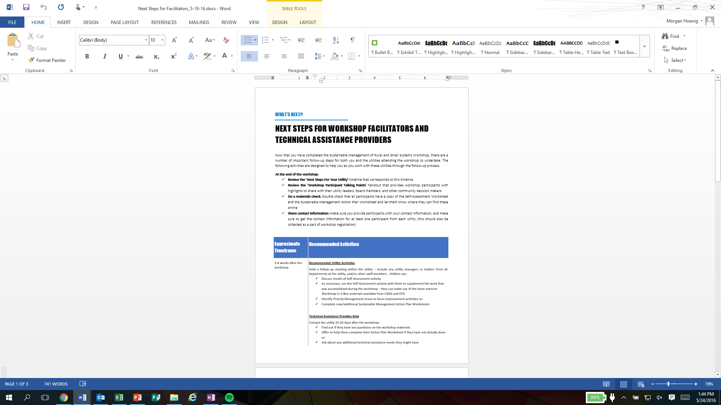participants begin to work on their action plans following the workshop, and you are a key part of encouraging that work.

## Team Exercise Workshop

Now that your team is on the path to making improvements in the management areas, it is important to follow up immediately after the meeting (let no more than a day or two pass before doing this) so that you can keep the momentum going. Make sure that you address these items in particular, as well as any others that came up during your workshop:

* 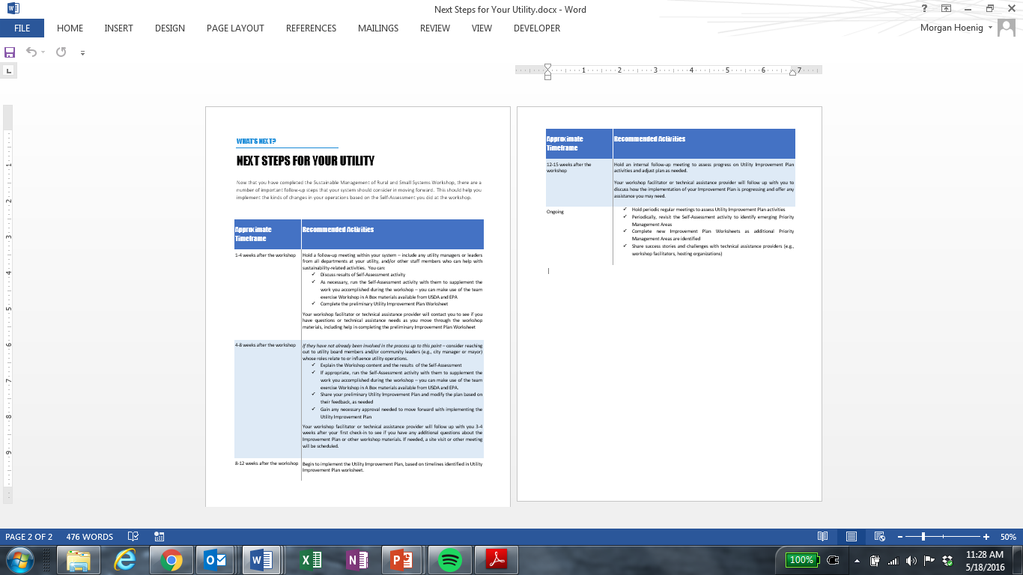Follow up on the list of action items that you came up with at the end of the meeting (immediate next steps, identifying resources and guides that will help you with your priority management areas, etc.).
* Brief any staff members who may have missed the event.
* Schedule a follow-up meeting for a few weeks or a month later to check in on progress made on the action items that were identified.

The **Next Steps for Your Utility** handout can also be a helpful resource to guide your activities after the team workshop is complete.

### Congratulations! You have completed the *Workshop in a BOX* FOR the Sustainable Management of Rural and Small Systems Workshops!

Appendix I: Optional Tips

### Optional Tip #1:

Don’t pass out the Rural and Small Systems Guidebook to Sustainable Utility Management (“Guidebook”) to participants at the beginning of the workshop.

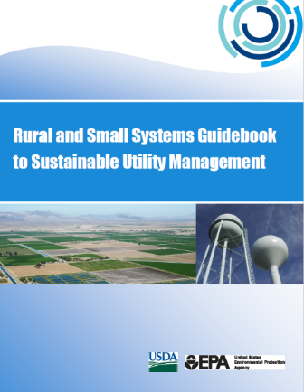Some facilitators suggest waiting to pass out the Guidebooks until the Self-Assessment exercise. In this case, the facilitator begins the workshop by asking participants to share what they think of as the most common management issues, and then writes these on a flip chart or white board in the front of the room (*Note: workshop facilitators have suggested these will end up looking much like the 10 key management areas).*

The facilitator will then move through the agenda and slides until arriving at the rating/ranking portion of the Self-Assessment Worksheet exercise. At this time, the facilitator will pause again to ask participants to share some management challenges their utility is facing. The facilitator may choose to create a new list of these next to the original list or common management areas, or simply place checkmarks or stars next to the original list when a management area is mentioned.

When it is time to rate, rank, and plot, the facilitator should pass out the Guidebooks for participants to use during this exercise. This facilitation approach allows the facilitator to anchor the management area discussion and self-assessment in the observations made by participants rather than having the management area discussion supported solely by the material presented in the guidebook.

Benefits to this approach:

* Starting the day off with an interactive exercise can serve as an “ice breaker” to get the group talking.
* Once participants see that their commonly held management challenges look very similar to the guidebook’s ten management areas, it reinforces that peer utilities contributed substantially to the preparation of the workshop content.

### Optional Tip #2:

Print the Self-Assessment Worksheet on single-sided pages (rather than front-to-back) to help with the plotting exercise.

In the Guidebook, the Self-Assessment Worksheet is formatted so it prints front-to-back. This can make the plotting exercise more challenging for participants, since they have to continually flip over the page. Facilitators have found that printing the worksheet on single-sided paper makes it logistically easier for participants to plot their results of the Self-Assessment exercise.

Benefits to this approach:

* Simplifies the plotting exercise for participants.
* Enables facilitators to use Optional Tip #3 (see below).

### Optional Tip #3:

If the Self-Assessment Worksheet has been printed on single-sided pages, the facilitator can then ask participants to fold Page 3 (Table A) between Steps 1 and 2 to reinforce the importance of completing the rating exercise before moving on to complete the ranking exercise.

To help break down the steps of the Self-Assessment exercise for participants, some facilitators have found it helpful to ask participants to fold Table A lengthwise in between the green column (Step 1: Rating), and the blue column (Step 2: Ranking). *(Note: this only works if you have printed the worksheet out on single-sided pages).* This helps participants stay focused on completing the rating exercise for each management area first, before moving on to the ranking exercise. Participants do the rating exercise first, discuss, then unfold the page to complete the ranking exercise.

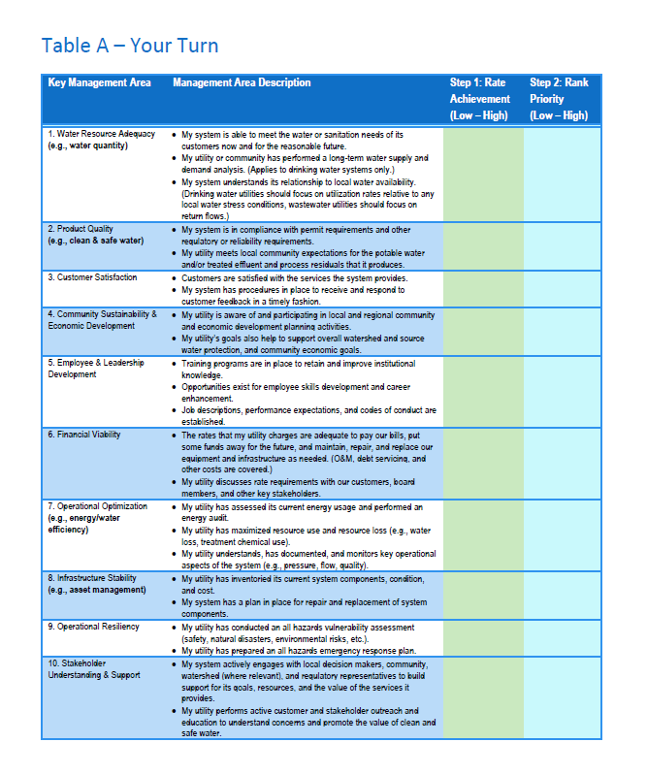

Benefits to this approach:

* Helps participants fully grasp the concepts of both the rating and ranking exercises.
* Reinforces the importance of completing the rating exercise before moving on to complete the ranking exercise.

### Optional Tip #4:

Once participants complete their own plotting for the Self-Assessment exercise, ask participants to share their results by posting the outcomes to flipcharts.

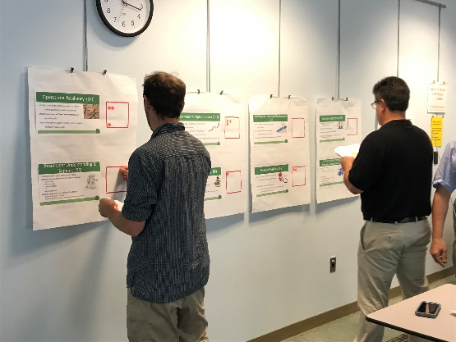Some facilitators have added a group plotting activity following the Self-Assessment exercise. To do this, facilitators place flipcharts or posters around the room, one for each Management Area. The facilitator then hands out yellow and red stickers to each participant, and asks them to place the red stickers on their high-priority management areas and yellow stickers on their medium-priority management areas, as determined by the Self-Assessment exercise. The facilitator can use this visualization to see what the common priority management areas are, which can help guide discussions about priority management areas and improving outcomes.

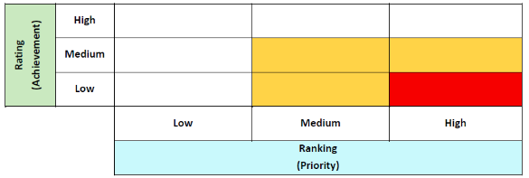

Benefits to this approach:

* This group exercise provides a visualization for all participants to see what the common priority management areas are.
* It also provides an opportunity to get participants up and moving.

Acknowledgements



In 2011, The United States Environmental Protection Agency (EPA) and United States Department of Agriculture (USDA) signed a Memorandum of Agreement (MOA) to support a series of activities to help small and rural water and wastewater systems address challenges they face and to more effectively provide sustainable services to the communities they support. Through this MOA, EPA and USDA have sponsored the development of this *Workshop in a Box* material.

## Content Contributors

|  |  |
| --- | --- |
| Jim Horne *U.S. EPA* | **Jacqueline Ponti-Lazaruk**  *USDA* |
| **LaVonda Pernell**  *USDA* | **Leslie Corcelli**  *U.S. EPA* |
| **Rob Greenwood**  *Ross Strategic* | **Morgan Torres** *Ross Strategic* |

**This product was originally developed in 2016 and updated in 2019, with assistance from Rob Greenwood, Morgan Torres, and Heather Martin with** [**Ross Strategic**](http://www.rossstrategic.com)**.**

circular-graphic.emf

***USDA is an equal opportunity provider, employer, and lender.***