Imtech UK & Ireland
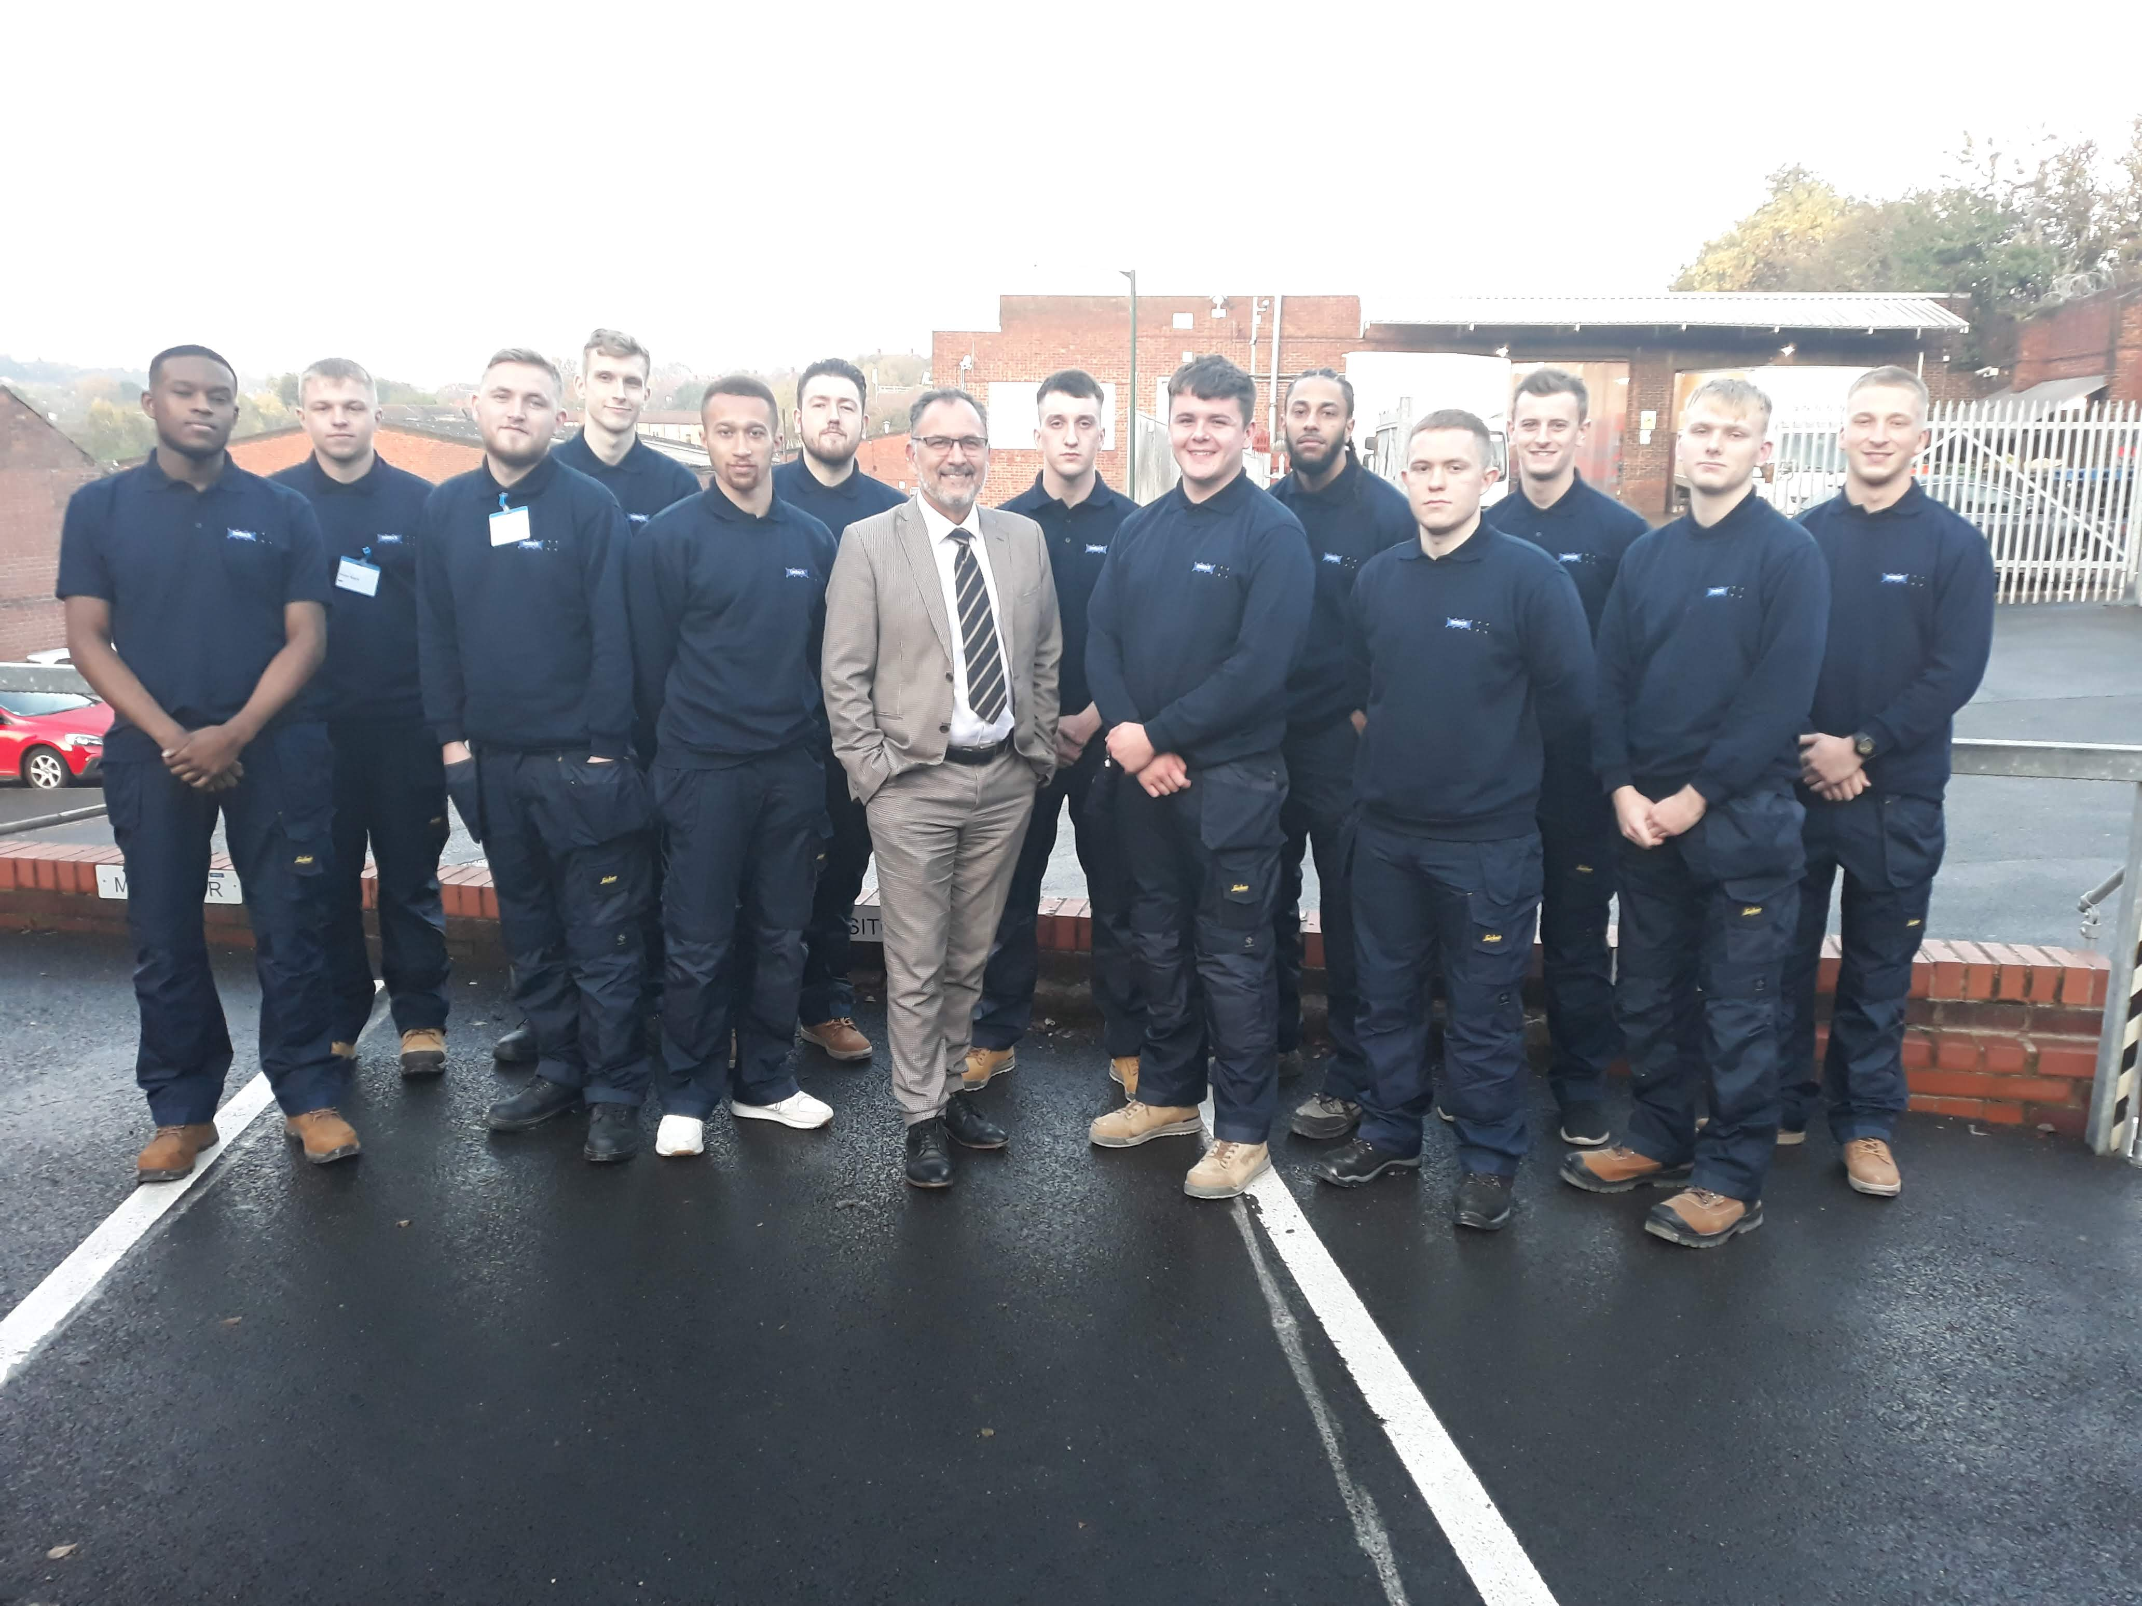

Apprentice training scheme – Electrical and Plumbing – JIB/HVCA Rates
As one of the UK’s leading engineering services companies, we provide electrical and mechanical engineering services on major industrial, commercial and public sector new build and refurbishment projects. Our reputation for high quality work and first class performance has been established through longstanding relationships with major contractors across sectors. Substantial investment in training shapes our future and ensures we have a “home grown” workforce that is not only trained to industry standards but has a full understanding of our internal processes and procedures.

We want you to grow, to be challenged, and to succeed. We are offering an award winning Industry Standard Apprenticeship Training Scheme. After a four year training period including block release or day release at college you will become an industry graded Electrical or Mechanical Plumber/Fitter, all funded by us.

As an apprentice you will be given a broad range of invaluable experience and knowledge in a variety of structured placements. You’ll have the opportunity to work on a variety of projects in the field with our on-site teams, including industrial and commercial project on interesting and exciting buildings, including schools, stadiums, hospitals, warehouses, student accomadation and prisons.
Starting with an induction, with all of the apprentice intake across the UK, we will give you an insight into our business, our values, the way we work, and how you’ll fit in. Then you’ll be ready to start your apprenticeship on site in between either day release or block release at a local college. On site you will be provided with a “buddy” who will show you ropes of site life and give you an insight into how it all works and you will receive regular visits from your training provider and Imtech management team to ensure you a progressing developing your skills.

So what do you need to apply? To join the Apprentice Training Scheme you will need the drive and ambition we’re looking for, you’ll also have the desire to work hard and have a flexible approach to working hours, location of work across the uk (including lodging away from home in some instances) and a willingness to learn, combined with this, we’re looking for candidates with a minimum of:
- 3 GCSE grade C or above which will include Maths, English and Science
- To live within a 10 mile radius of pick up location
- Work can be across the UK but recruited in the following areas this year – Nottingham, Birmingham, Newcatle and Manchester
- Be 18 years old in September this year due to site safety requirements

You’ll need to have the right to work in the UK and a real enthusiasm for starting off your lifelong career in this challenging and ever-evolving industry.

To request an application pack please email: recruitment.central@imtech.co.uk

Closing date for requests for application packs: 31st MAY 2021. - If shortlisted interviews and tests will take place during June AND jULY.

