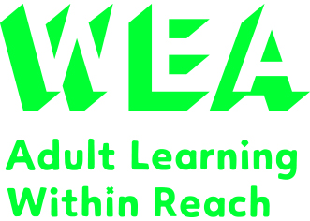**

Sessions to run for two days a week Thursday / Friday 10:30 -13:30, total of 3 weeks.

**Starting 24th June 2021**  
 **Course fee**: Free (subject to status)

For more information, please email **manchesterskills@wea.org.uk** or call **0161 696 5474 and quote ref C3846145**

**Are you struggling during this lockdown? Would you like to improve your own wellbeing and resilience?**

How about a **Level 1 Award in Mental Health Awareness**

**Self-Care**

Wherever you are, the WEA is there with you.

The WEA is a charity registered in England and Wales   
(no. 1112775) and in Scotland (no. SC039239).

**wea.org.uk**

Learn how to improve your own wellbeing and resilience in challenging times, to support others with their mental wellbeing or to gain a valuable qualification, and developing new skills to take the first steps into voluntary or paid work in the mental health field. This course is available for everybody who wants to learn how to combat the stresses of the current pandemic.