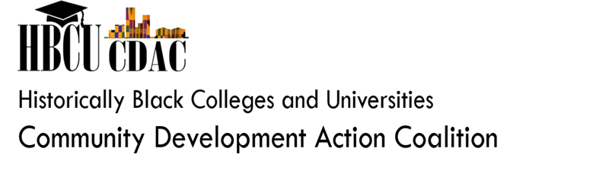
Mark your calendars!

The Historically Black Colleges and Universities Clean Energy Initiative
Expanding the Baltimore Solar Initiative to HBCU Campuses and Communities
Regional Roundtable Discussion
Wednesday, July 25, 2018
Morgan State University
Earl Richardson Library Boardroom
1700 E Cold Spring Lane, Baltimore, MD 21251
11:00AM – 1:00PM

Registration: Email – hbcucleanenergycoalition@gmail.com

