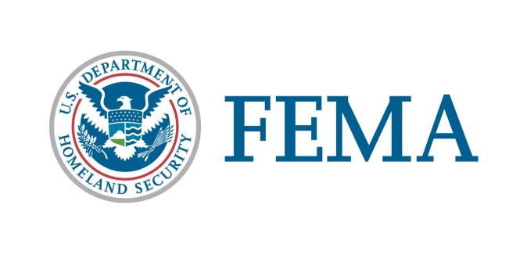
U.S. Department of Homeland Security
Federal Emergency Management Agency
Office of External Affairs

January 8, 2020

Stakeholder Advisory

FEMA Continues to Monitor Impacts from Puerto Rico Earthquake

- On Tuesday, Jan. 7, President Trump approved Puerto Rico’s request for an emergency declaration allowing direct federal assistance for emergency measures to protect lives, property and public health after the recent series of earthquakes. This assistance is for all 78 municipalities in the Commonwealth of Puerto Rico.
- Acting FEMA Administrator Pete Gaynor is in constant communication with the governor and Commonwealth officials.
- Disaster response is a whole community effort and most effective when it is locally executed, state managed and federally supported. It takes everyone being prepared and neighbor helping neighbor.
- Aftershocks are expected to continue. Those in the affected areas should follow instructions from local officials and monitor local radio, TV stations or official social media accounts for updated emergency information.

Local Officials are Leading the Response
- Follow instructions from your local officials. If you are in a damaged building, go outside and quickly move away from the building. Do not enter damaged buildings.
- Local government officials will provide guidance when it is safe to re-enter your home – not FEMA.
- FEMA is working closely with the impacted municipalities to address emergency needs such as water and power. Those needing assistance or resources should contact local officials for information on how to access needed help.
- For a list of shelters and other important information from local officials, visit http://www.manejodeemergencias.pr.gov or call the Puerto Rico Emergency Management and Disaster Administration Bureau at 787-724-0124 to find your nearest shelter.

FEMA and Other Federal Agencies are Ready to Assist
- FEMA’s National Incident Management Assistance Team (IMAT) and the Region II IMAT are on the ground in Puerto Rico, working with officials to ensure they have everything they need to respond to the series of earthquakes.
- FEMA is working with local government representatives to determine the extent of impacts on individuals and public facilities, and the types of federal assistance that may be needed.
- FEMA’s National Response Coordination Center and Region II’s Regional Response Coordination Center are both conducting 24-hour operations.
- FEMA has deployed an Urban Search and Rescue Incident Management Team and additional communications personnel through its Mobile Emergency Response Support (MERS) capabilities.
- Puerto Rico Governor Wanda Vázquez Garced has declared a state of emergency and activated Puerto Rico’s National Guard to assist with response efforts.
- Staff from the Centers for Disease Control and Prevention are in Puerto Rico coordinating with local partners to assess conditions.
- Eight Disaster Medical Assistance Teams are on alert, ready to support Commonwealth officials, if needed and requested. DMATs are staffed with medical professionals and para-professionals who can help area health systems respond by providing expert patient care.
- FEMA has prepositioned life sustaining commodities, including meals and water throughout Puerto Rico. The stock levels of these commodities are well above what was in place on-island in 2017, including water and meals, generators, as well as tarps and other necessities.
- FEMA has 290 generators available in Puerto Rico to assist with temporary power, if requested.

Potential for Response on Top of Ongoing Recovery
- When natural disasters such as Tuesday’s earthquake strike, the first responders are local emergency and public works personnel, volunteers, humanitarian organizations and numerous private sector groups. They provide emergency assistance required to protect the public's health and safety and to meet immediate human need.
- FEMA continues to support the government of Puerto Rico with their complex and ongoing recovery efforts from hurricanes Irma and Maria and to ensure everyone is better prepared for disasters that could impact the island, at all levels.
- As a result of the 2017 hurricanes, the vast majority of infrastructure throughout Puerto Rico was significantly damaged. Permanent restoration efforts are ongoing, and repairs are being made to meet current industry standards wherever possible.
- While repaired systems are in a more resilient condition than they were prior to the 2017 hurricanes, there is still more work to be done.

Earthquake Safety
- Those in the areas affected by the earthquake are encouraged to monitor local radio, TV stations or official social media accounts for updated emergency information.
  - Expect aftershocks. These secondary shockwaves are usually less violent than the main quake but can be strong enough to do additional damage to weakened structures and can occur in the first hours, days, weeks, or even months after the quake.
- During an earthquake, Drop, Cover and Hold On. Minimize your movements to a few steps to a nearby safe place.
- If you are indoors, stay there until the shaking has stopped and you are sure exiting is safe. Cover your head and neck with your arms or a pillow until the shaking stops.
- People with mobility disabilities who cannot drop, should still cover and hold on. People who use wheelchairs should lock their wheels and not try to transfer during shaking.
- Help injured or trapped persons if it is safe for you to do so. Check on neighbors who may require assistance such as infants, children, older adults, people with disabilities and others with access and functional needs.
- Use the telephone only for emergency calls. Cellular and land line phone systems may not be functioning properly. The use of text messages to contact family is the best option, when it is available.
- Check for gas leaks. If you smell gas or hear blowing or hissing noise immediately move away from the area. If you know how to turn the gas off, do so and report the leak to your local fire department and gas company.
- Additional earthquake safety and preparedness information is available at Ready.gov and Listo.gov.

If you have any questions, please contact FEMA Office of External Affairs, Congressional and Intergovernmental Affairs at (202) 646-3444 or at FEMA-IGA@fema.dhs.gov.

####

FEMA's mission is to help people before, during and after disasters.
Follow FEMA online, on Twitter @FEMA or @FEMAEspanol, on FEMA's Facebook page or Espanol page and at FEMA's YouTube account. Also, follow Acting Administrator Pete Gaynor’s activities @FEMA_Pete.

