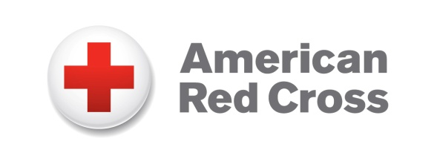
Online Guide
For Red Cross Partners
COVID-19 Severe Blood Shortage

For use March 17-April 30, 2020

The American Red Cross now faces a severe blood shortage due to an unprecedented number of blood drive cancellations during this coronavirus outbreak. Healthy individuals are needed to donate now to help patients counting on lifesaving blood. The messages and graphics below are for use on social networks and may be used to guide online conversations in your own words.

Twitter:

Post 1:
The @RedCross now faces a severe blood shortage due to an unprecedented number of blood drive cancellations during this #coronavirus outbreak. Healthy individuals are urged to donate now to help patients counting on lifesaving blood. Make an appt: rcblood.org/appt #COVID19

Post 2:
While public health officials work to limit the spread of the #coronavirus (#COVID19), we're asking for your help with another potential public health issue: a severe shortage of blood for patients. Healthy donors are urged to make an appt w/ the @RedCross rcblood.org/appt

Post 3:
A #coronavirus side effect you might not have considered: Canceled blood drives & fewer available blood donors. We're urging healthy, eligible individuals to schedule a @RedCross blood donation appointment to help overcome a severe blood shortage: rcblood.org/appt #COVID19

Post 4:
You can help ensure we don’t have another healthcare crisis on top of the #coronavirus by giving blood. A blood shortage could impact patients who depend on lifesaving blood to survive. If you are healthy, schedule a @RedCross blood donation appointment: rcblood.org/appt

Facebook:

Post 1:
Spread the word: The American Red Cross now faces a severe blood shortage due to an unprecedented number of blood drive cancellations in response to the coronavirus outbreak. Healthy individuals are needed now to donate to help patients counting on lifesaving blood. Make an appointment at rcblood.org/appt.

Post 2:
The American Red Cross is facing a severe blood shortage as the coronavirus outbreak threatens the availability of the nation’s blood supply. Healthy individuals are urged to help restock the shelves for patients who need surgery, victims of car accidents and other emergencies, or patients suffering from cancer. Please make an appointment: rcblood.org/appt.

Social Graphics
The social graphics below are available for download via Hightail and may be used to accompany sample posts above.

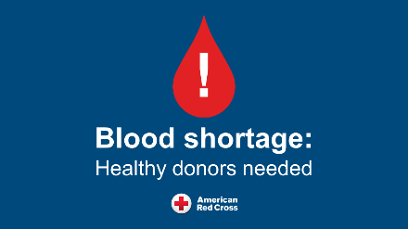 | 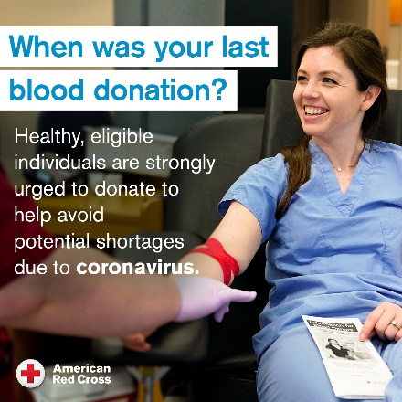 | 